Words | 1st try | 2nd try | 3rd try | 4th try
wrap
wrist
write
wrote
wreck
wrong
small
walk
talk
chalk
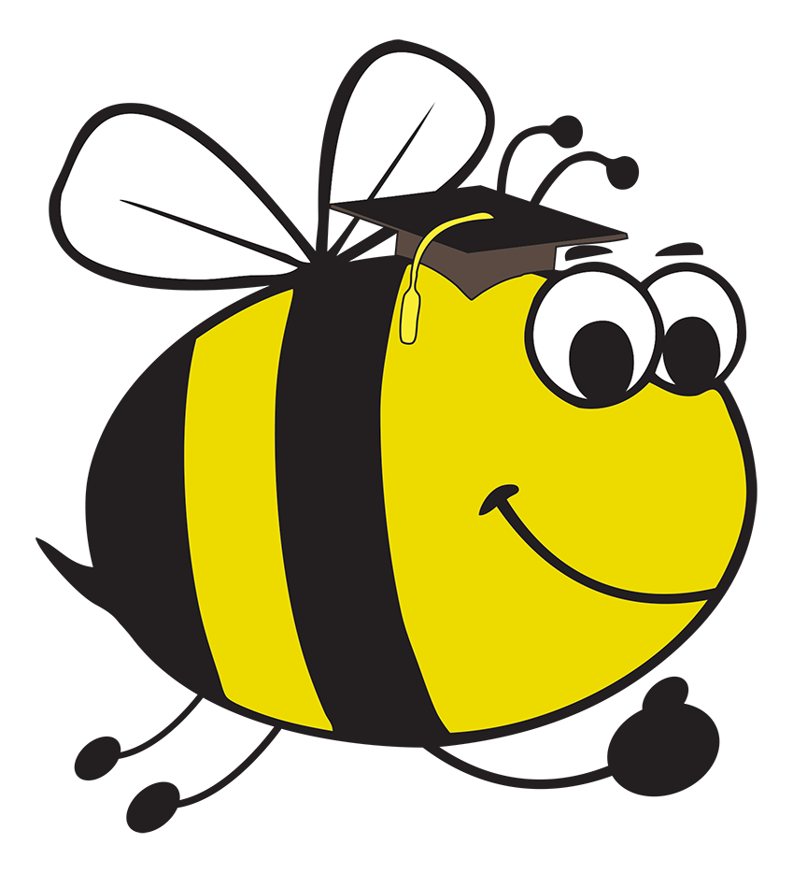 Spelling Bee: Look, say, cover and write

Look and say the word in the column on the left. Then cover and write out the words in the other columns.

