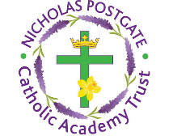
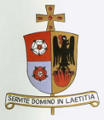
Science Curriculum Overview

Rights Articles: 1, 12, 13, 15, 17, 23, 28, 29
Global Goals: 3, 4, 6, 7, 10, 13, 14, 15
Year Group | Topic 1 | Topic 2 | Topic 3 | Topic 4 | Topic 5 | Topic 6
EYFS | All about me  Human Body  Keeping Healthy | Shadows  Stars | Plants  Keeping Teeth Healthy | Changing State (Ice-Water)  Floating / sinking |  | Electricity
1 | Working Scientifically  Humans  Seasons – Summer to Autumn | Working Scientifically  Materials  Seasons – Autumn to Winter | Working Scientifically  Carnivores, herbivores, omnivores  Seasons – Winter | Working Scientifically  Plants  Seasons – Winter to Spring  Animals |  | Working Scientifically  Seasons – Spring to Summer
Year 1 - Suggested Linked Texts (Reading Across the Curriculum)
 | Tree: Seasons Come, Seasons Go  (Patricia Hegarty and Britta Teckentrup)  One Year with Kipper  (Mick Inkpen)  After the Storm  (Nick Butterworth)  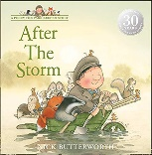  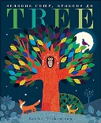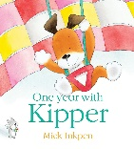 | The Great Paper Caper  (Oliver Jeffers)  Who Sank the Boat  (Pamela Allen)  The Story of Cinderella  (Walt Disney)  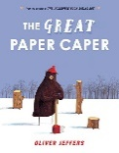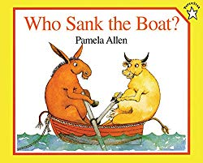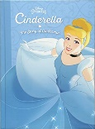 | RSPB: My First Book of Garden Birds  (Mike Unwin and Sarah Whittley)  Snail Trail  (Ruth Brown)  Superworm  (Julia Donaldson & Axel Scheffler)  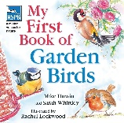  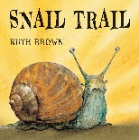  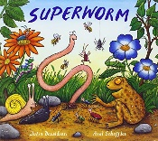 | A Little Guide to Wild Flowers  (Charlotte Voake)  The Things That I LOVE about TREES  (Chris Butterworth)  Harry’s Hazelnut  (Ruth Parsons)  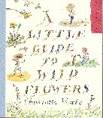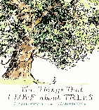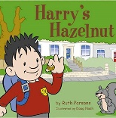
2 | Working Scientifically  Living Things and Their Habitats |  | Working Scientifically  Materials |  | Working Scientifically  Animals Including Humans | Working Scientifically  Plants
Year 2 - Suggested Linked Texts (Reading Across the Curriculum)
 | Jack and the Beanstalk  (Richard Walker)  Ten Seeds  (Ruth Brown)  A Seed Is Sleepy  (Dianna Aston)  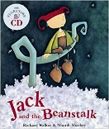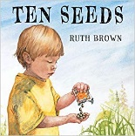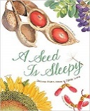 |  | The Tin Forest  (Helen Ward)  Traction Man  (Mini Grey)  Three Little Pigs  (Lesley Sims)  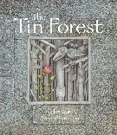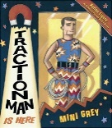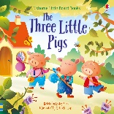 |  | The Gruffalo  (Julia Donaldson)  Meerkat Mail  (Emily Gravett)  No Place Like Home  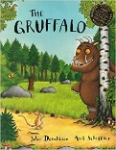  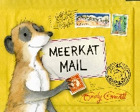  (Jonathon Emmett) | Jack and the Beanstalk  (Richard Walker)  Ten Seeds  (Ruth Brown)  A Seed Is Sleepy  (Dianna Aston)
3 | Working Scientifically  Forces  Suggested People:  William Gilbert  (Theories on Magnetism)  Andre Marie Ampere  (Founder of Electro-Magnetism) | Working Scientifically  Rocks and Soils  Suggested People:  Mary Anning  (Discovery of Fossils)  Inge Lehmann  (Earth’s Mantle) | Working Scientifically  Plants  Suggested People:  Jan Ingenhousz  (Photosynthesis)  Joseph Banks  (Botanist) | Working Scientifically  Animals incl Humans  Suggested People:  Adelle Davis  (20th Century Nutritionist)  Marie Curie  (Radiation / X-Rays) | Working Scientifically  Light  Suggested People:  James Clerk Maxwell  (Visible and Invisible Waves of Light) | Working Scientifically
Year 3 - Suggested Linked Texts (Reading Across the Curriculum)
 | The Iron Man  (Ted Hughes)  Mrs Armitage: Queen of the Road  (Quentin Blake)  Mr Archimedes’ Bath  (Pamela Allen)  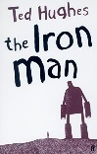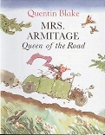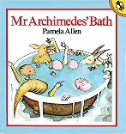 | The Pebble in My Pocket  (Meredith Hooper)  Stone Girl, Bone Girl  (Laurence Anholt)  The Street Beneath My Feet  (Charlotte Guillain & Yuval Zommer)  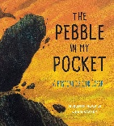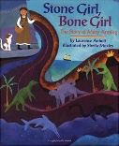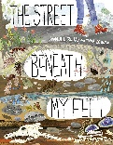 | The Story of Frog Belly Rat Bone  (Timothy Basil Ering)  The Hidden Forest  (Jeannie Baker)  George and Flora’s Secret Garden  (Jo Elworthy)  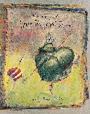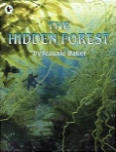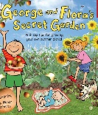 | Funnybones  (Janet and Allan Ahlberg)  I Will Never Not Ever Eat a Tomato  (Lauren Child)  Goldilocks and the Three Bears  (Samantha Berger)  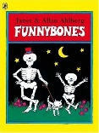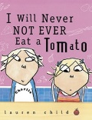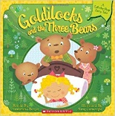 | The Owl Who Was Afraid of the Dark  (Jill Tomlinson)  The Dark  (Lemony Snicket)  The Firework-Maker's Daughter  (Philip Pullman)  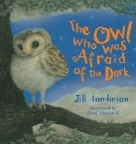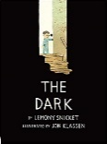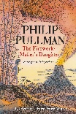
4 | Working Scientifically  Electricity  Suggested people:  Joseph Swan  (Incadesecant Light Bulb) | Working Scientifically  Animals Including humans  Suggested people:  Ivan Pavlov  (Digestive System Mechanisms)  Joseph Lister  (Discovered Antiseptics) | Working Scientifically  Living things and their Habitats  Suggested people:  Cindy Looy  (Environmental Change and Extinction)  Jaques Cousteau  (Marine Biologist) | Working Scientifically  Sound  Suggested people:  Aristotle  (Sound Waves)  Gailileo Galilei  (Frequency and Pitch of Sound Waves)  Alexander Graham Bell  (Invented the Telephone) |  | Working Scientifically  States of matter  Suggested people:  Anders Celcius  (Celcius Temperature Scale)  Daniel Fahrenheit  (Fahrenheit Temperature Scale / Invention of the Thermometer)
Year 4 - Suggested Linked Texts (Reading Across the Curriculum)
 | Until I Met Dudley  (Roger McGough)  Oscar and the Bird: A Book about Electricity  (Geoff Waring)  Electrical Wizard: How Nikola Tesla Lit Up the World  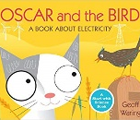  (Elizabeth Rusch)  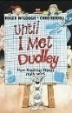  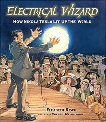 | Human Body Odyssey  (Werner Holzwarth)  Crocodiles Don't Brush Their Teeth  (Colin Fancy)  Wolves  (Emily Gravett)  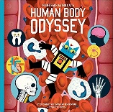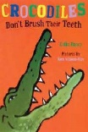 | The Vanishing Rainforest  (Richard Platt)  The Morning I Met a Whale  (Michael Morpurgo)  Journey to the River Sea  (Eva Ibbotson)  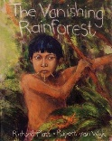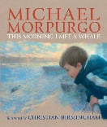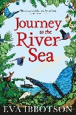 | Horrid Henry Rocks  (Francesca Simon)  Moonbird  (Joyce Dunbar)  The Pied Piper of Hamelin  (Natalia Vasquez)  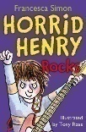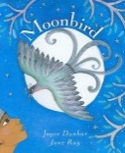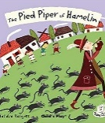 |  | Charlie and the Chocolate Factory  (Roald Dahl)  Once Upon a Raindrop: The Story of Water  (James Carter)  Sticks  (Diane Alber)  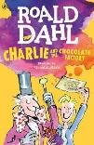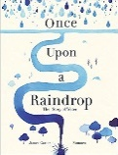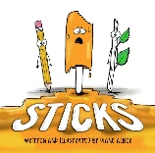
5 | Working Scientifically  Properties and changes of materials  Suggested people:  Spencer Silver,  Arthur Fry and Alan Amron  (Post-It Notes)  Ruth Benerito  (Wrinkle-Free Cotton) | Working Scientifically  Earth and Space  Suggested people:  Claudius Ptolemy and Nicolaus Copernicus  (Heliocentric vs Geocentric Universe)  Neil Armstrong  (First man on the Moon)  Helen Sharman  (First British astronaut)  Tim Peake  (First British ESA astronaut) | Working Scientifically  Forces  Suggested people:  Galileo Galilei  (Gravity and Acceleration)  Archimedes of Syracuse  (Levers) | Working Scientifically  Living things and their habitats  Suggested people:  David Attenborough  (Naturalist and Nature Documentary Broadcaster)  James Brodie of Brodie  (Reproduction of Plants by Spores) |  | Working Scientifically  Animals including humans  Suggested people:  Thomas Young  (Wave Theory of Light)  Ibn al-Haytham (Alhazen)  (Light and our Eyes)
Year 5 - Suggested Linked Texts (Reading Across the Curriculum)
 | Itch  (Simon Mayo)  Kensuke's Kingdom  (Michael Morpurgo)  The BFG  (Roald Dahl)  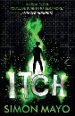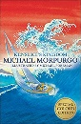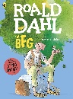 | The Skies Above My Eyes  (Charlotte Guillain & Yuval Zommer)  George’s Secret Key to the Universe  (Lucy and Stephen Hawking with Christophe Galfard)  The Way Back Home  (Oliver Jeffers)  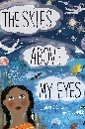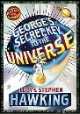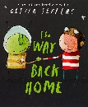 | The Enormous Turnip  (Katie Daynes)  Leonardo's Dream  (Hans de Beer)  The Aerodynamics of Biscuits  (Clare Helen Welsh)  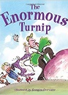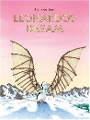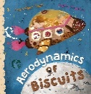 | Charlotte’s Web  (E.B. White)  The Land of Neverbelieve  (Norman Messenger)  Mummy Laid an Egg  (Babette Cole)  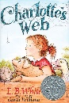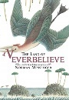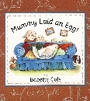 |  | Letters from the Lighthouse  (Emma Carroll)  The Gruffalo’s Child  (Julia Donaldson)  The King Who Banned the Dark  (Emily Haworth-Booth)  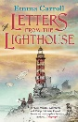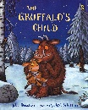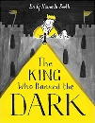
6 | Working Scientifically  Light  Suggested people:  Isaac Newton  (Light) | Working Scientifically  Electricity  Suggested people:  Thomas Edison  (Light bulb) | Working Scientifically  Living Things and Their Habitats  Suggested people:  Charles Darwin and Alfred Russel Wallace  (Theory of Evolution by Natural Selection) | Working Scientifically  Animals including humans/  Evolution and inheritance  Suggested people:  Charles Darwin and Alfred Russel Wallace  (Theory of Evolution by Natural Selection)  Jane Goodall  (Chimpanzees) |  | Working Scientifically  Circulation  Suggested people:  Justus von Liebig  (Theories of Nutrition and Metabolism)  Sir Richard Doll  (Linking Smoking and Health Problems)  Leonardo Da Vinci  (Anatomy)
Year 6 - Suggested Linked Texts (Reading Across the Curriculum)
 | The Dark  (Lemony Snicket) | One Smart Fish  (Christopher Wormell)  The Molliebird  (Jules Pottle)  Our Family Tree  (Lisa Westberg Peters)  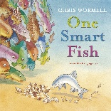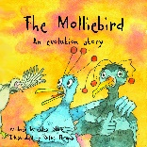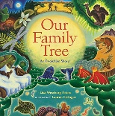 | Beetle Boy  (M G Leonard)  Insect Soup  (Barry Louis Polisar)  Fur and Feathers  (Janet Halfmann)  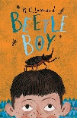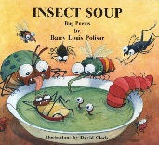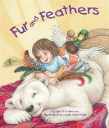 | Hair in Funny Places  (Babette Cole)  Giant  (Kate Scott)  You're Only Old Once!  (Dr. Seuss)  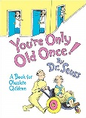  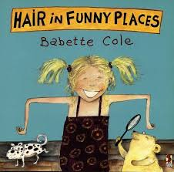  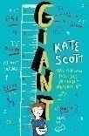 |  | Pig-Heart Boy  (Malorie Blackman)  Skellig  (David Almond)  A Heart Pumping Adventure  (Heather Manley)  