Useful website links for children

There are many websites that your child can access to develop their skills in Computing. Please ensure that your child is using the internet safely and that you know which sites they are on. If you do not have access to the internet at home, there are many libraries in Middlesbrough, which can provide you with internet access as a member. It is free to use.

At St Augustines, the children have access to Purple Mash. https://www.purplemash.com/sch/sacred-ts1
Each child has their own login and password, and this can be accessed at home and at school. Please encourage your child to use this, as this links to their learning in school.

The children are encouraged to use the search engine ‘Bing’ https://www.bing.com/?FORM=Z9FD1 so that they can search for and access content, which is education friendly.

BBC Bitesize KS1
https://www.bbc.co.uk/bitesize/subjects/zyhbwmn
BBC Bitesize KS2
https://www.bbc.co.uk/bitesize/subjects/zvnrq6f
This site explains the terminology used in the Computing in KS1 using simple animated videos. There is also a link to KS2.

Scratch
https://scratch.mit.edu/
This is a great website which can help children learn how to build anything they want to. It is useful for ages 8 and older.

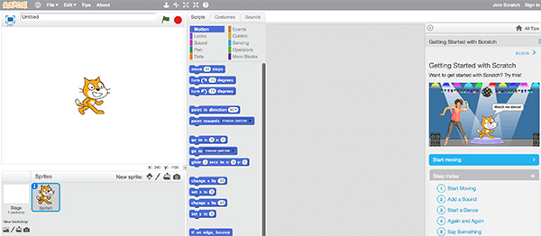
Blockly
https://blockly.games/
This website teaches programming in a series of puzzles.
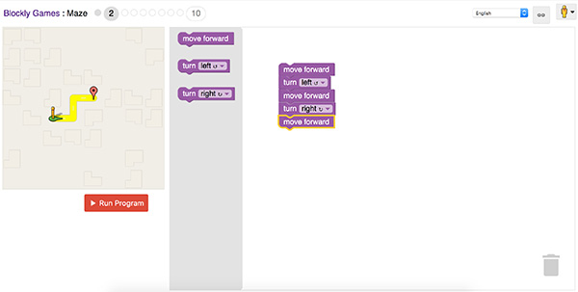

Code.org
https://studio.code.org/courses
Children can enjoy learning code in whichever language they wish, with the availability of one-to-one tutorials.
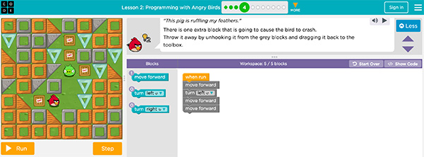
Useful website links for parents

A Prezi presentation on ‘Primary Digital Parenting’ by Ralph.

https://prezi.com/5mmh91hvjxuj/primary-digital-parenting/

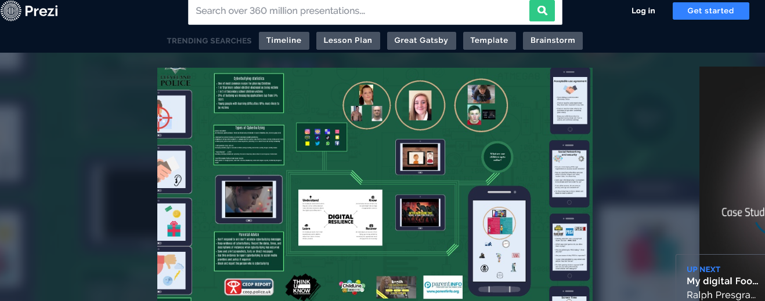

Goldilocks: A fairy tale for the digital age
https://www.vodafone.co.uk/mobile/digital-parenting/goldilocks

A story you can download for free to watch and read with your child and a downloadable activity sheet.
