Words | 1st try | 2nd try | 3rd try | 4th try
gnaw
gnat
knot
knee
kneel
knock
know
knew
knight
knife
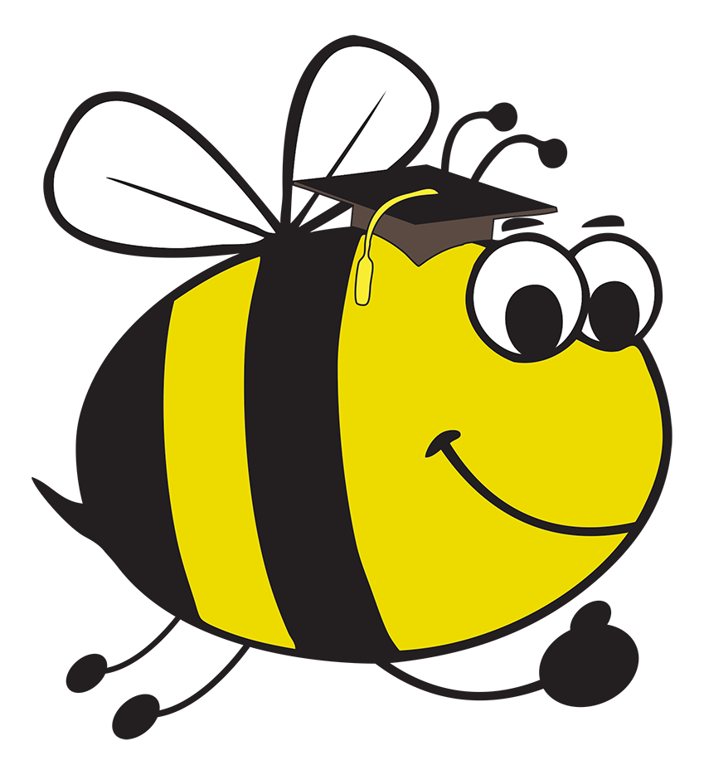 Spelling Bee: Look, say, cover and write

Look and say the word in the column on the left. Then cover and write out the words in the other columns.

