

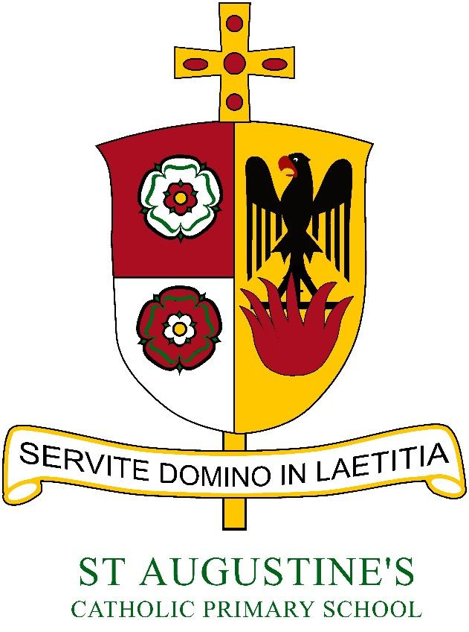

# Art and Design Policy

# 2020

*“Serve the Lord in Gladness”*

Art and Design Co-Ordinator: Mrs McKeown

‘Serve the Lord in Gladness’

At St Augustine’s we recognise every child’s right to develop their talents and abilities (see Article 29). Our art policy sets out a framework within which teaching staff are able to support pupil’s development, skills and understanding to impact on their achievement in all the art forms.

The arts cross many areas of the curriculum and there are many different art forms. Through the core and foundation subjects of the National Curriculum, children at St. Augustine’s Primary School are introduced to four art form areas, drama/ performing arts, music, dance and art and design.

A high-quality art and design education should engage, inspire and challenge pupils, equipping them with the knowledge and skills to experiment, invent and create their own works of art, craft and design. As pupils progress, they should be able to think critically and develop a more rigorous understanding of art and design. They should also know how art and design both reflect and shape our history, and contribute to the culture, creativity and wealth of our nation.

The Art and Design Curriculum is organised through the Cornerstones Curriculum. Topics are varied across school and incorporate art within the other subjects. Mastery of the core skills and craftsmanship are to be taught through a variety of ways to enable children to use them in other areas.

Foundation stage pupils follow a predominantly skills based curriculum within their topic. Throughout the school, children will develop and practice particular skills and knowledge through the making of paintings, drawings or other practical tasks. Children will work as individuals and in groups and class teaching will be used where appropriate.

Art is also used where appropriate to support and extend teaching and learning activities in other curriculum subjects. This can be achieved by paintings, drawings, sculpture, collage, print making, digital media, textiles or other outcomes.

Aims

The National Curriculum for art and design aims to ensure that all pupils:

* Produce creative work, exploring their ideas and recording their experiences;
* Become proficient in drawing, painting, sculpture and other art, craft and design techniques;
* Evaluate and analyse creative works using the language of art, craft and design;
* Develop knowledge, understanding and enjoyment of art and design;
* Develop the pupils’ ability to observe, learn and record from the world around them;
* Use a variety of creative materials, tools and processes, including ICT, safely, experimentally and with increasing confidence, technical control and skills;
* Develop the pupils’ ability to express their own responses, feelings and ideas using visual, tactile, verbal and written means where appropriate;
* Recognise the contribution that art makes to learning in other subjects such as literacy, numeracy and the spiritual and moral dimensions of life;
* Develop an increasing knowledge and understanding of the contribution of artists, designers and craftspeople to this and other cultures, past and present;
* Develop the ability to discuss and evaluate their own work and that of others in a constructive, but critical manner, developing a specialist vocabulary;
* Develop the ability to recognise different kinds of art, craft and design and why and how they are different;
* Develop aesthetic sensibilities so that they can respond sensitively and thoughtfully;
* Develop the pupils’ ability to improve their own unique and personal ideas, working with increasing independence.

Curriculum

**Key Stage 1**

Pupils should be taught:

* To use a range of materials creatively to design and make products;
* To use drawing, painting and sculpture to develop and share their ideas, experiences and imagination;
* To develop a wide range of art and design techniques by using colour, pattern, texture, line, shape, form and space;

**Key Stage 2**

Pupils should be taught to develop their techniques, including how to control and use different materials, with creativity, experimentation and an increasing awareness of different kinds of art, craft and design.

Pupils should be taught:

* To create sketch books to record their observations and use them to review and revisit ideas;
* To improve their mastery of art and design techniques, including drawing,
* Painting and sculpture with a range of materials [for example, pencil, charcoal, paint, clay]

Teaching and Learning

The class teacher teaches all pupils art and design. All pupils should experience a variety of materials and processes in two and three dimensions, including drawing, painting and other media (e.g. collage, print making, digital media, textiles, sculpture). The three main starting points for work are first-hand observation, experience (memory) and imagination. Pupils are encouraged to evaluate and talk about their own work during and after they have made it. Pupils develop their knowledge and understanding of colour, pattern, texture, line, tone, shape, form and space through the making of images and objects and through talking about and studying the work of other artists, craftspeople and designers. Pupils are encouraged to work in collaboration when making large-scale work.

Monitoring and Assessment

At St Augustine’s we recognise assessment as an integral part of the teaching and learning process. We aim to share and discuss pupils’ ideas. We appreciate responses made by pupils and do not impose our likes and dislikes. When assessing work we consider both the process undertaken and the end product. Aims and objectives identified will form part of our assessments. When compiling pupil records teachers will consider attitudes, e.g. confidence, enthusiasm and flexibility.

* Assessment of skills to be recorded on the tracking system and maintained every term.
* Progression in Art and Design is shown through the different expectations at each key stage of the National Curriculum.
* Assessment relates to the learning objectives for each art activity.
* Assessment procedures can include some of the following:
* A common task at the beginning or end of each school year, an observational drawing of a plant, person or object;
* Individual art portfolios containing selected, dated, annotated pieces;
* Individual sketchbooks containing dated, annotated pieces;
* A whole class discussion about work at the end of each stage of its development.
* Examples of children’s work to be evident in their sketch books and topic books;
* Sketch books to be used as a starting point for creating their art;
* Assessment should record pupil’s ideas, developments and at points in their study their evaluations. These evaluations can be recorded through discussion, reflective notes or the child’s peer and own written feedback. Examples of work (portfolios) will be kept as evidence for pupils. Pupils will use a sketch book in which progression can be seen and skills reflected upon.

Sketchbooks

All children in key stage two are required to use a sketchbook:

* For recording, exploring and storing visual and other information, for example notes, which can be used as reference;
* For working out ideas, plans and designs;
* For reference as they develop ideas;
* For looking back at and reflecting on their work, reviewing and identifying their progress;
* For revisiting ideas;
* To further develop their ideas, skills and understanding;

Health and Safety

Please refer to the school’s Health and Safety policy.