Whist school closures are in place, your child will be able to access ‘Google Classroom’ via the school website to access and complete work set by their teacher(s).
Please follow the instructions below to access the Google classroom that has been set up by your child’s class teacher(s).
Google Classroom Access
- Login to school website: https://staugustines.npcat.org.uk
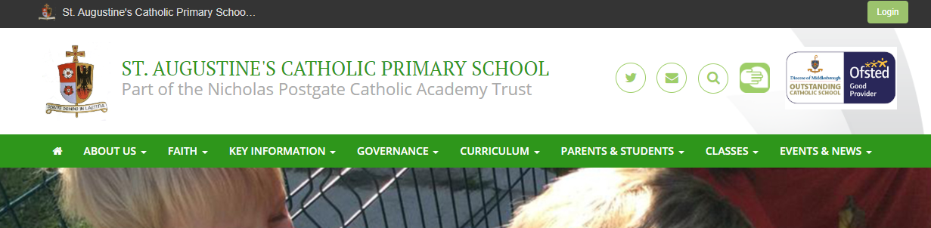

Your child’s login details are as follows:
Username: child’s email address or username

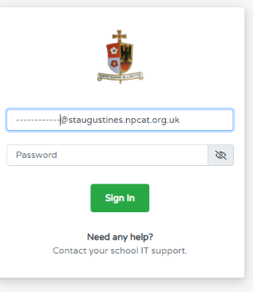
Password: your child has set their own password. If you need to reset this password, please contact your child’s class teacher

- Click on the Google Classroom Icon.

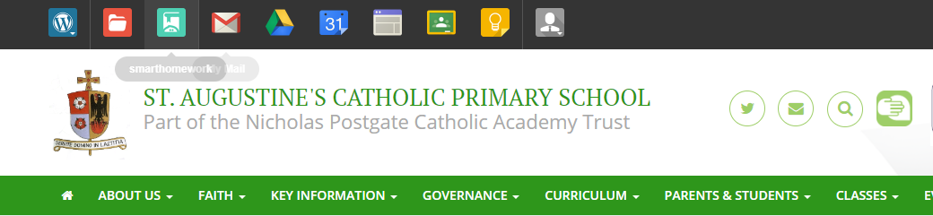

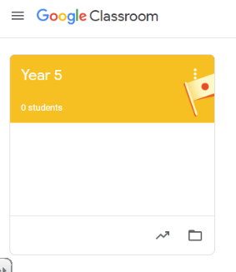

- Click on the classroom to enter it. Your child’s work will be found here.

