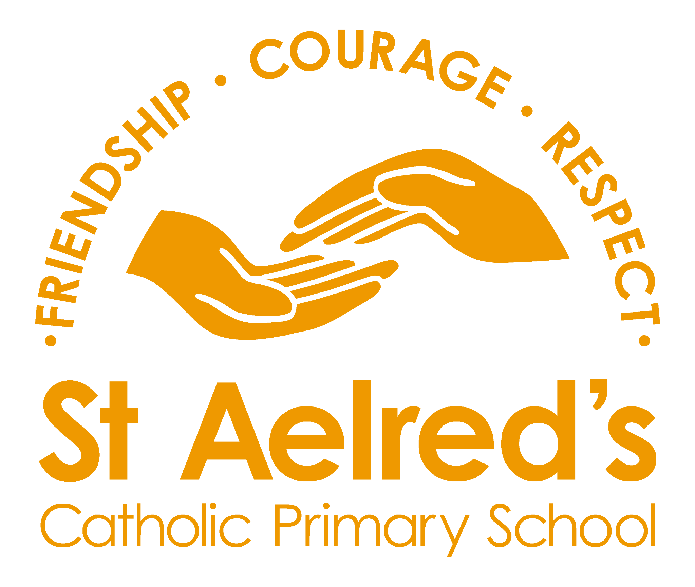


SUPPLEMENTARY INFORMATION FORM FOR ADMISSION TO ST AELRED’S RC PRIMARY SCHOOL, YORK

The school to which you are applying is a Catholic school. The school is designated as a school with a religious character and as such is permitted to give priority to applicants who are of the faith of the school.

The governing body has responsibility for admissions to the school. In order to apply the school’s oversubscription criteria the governing body requires additional information that is not collected on the local authority’s Common Application Form. This information must be supplied by completing this Supplementary Information Form. Copies of the form are also available in your chosen school and a form must be returned to each Catholic School you apply to.

You must return a copy of this completed form to all of the Roman Catholic schools you have requested to the individual schools’ address.

Failure to complete this form would indicate that you are not applying under any of the religion criteria and will affect the oversubscription criteria in which your child is placed.

Roman Catholic School to which you are applying
Full name of child (including surname)
Gender (please indicate Y/N) | Male Female
Date of birth
Child’s permanent address including postcode
Contact telephone number(s)
Religion of child
Looked after Child  Please indicate Y/N if the child  is or has ever been in the care of the Local Authority | Dates

Name of Nursery (or)
Name of School currently attending and year group.
Full name(s) of parent(s)/carer(s) | Relationship to child
1.
2.

If, at the time of admission, you will have other children attending this school, please provide details below:
Full name(s) | Date(s) of birth

CATHOLIC CHILDREN

Date of baptism  (Please attach proof of baptism i.e. baptism certificate) |  | Place of baptism
Parish in which you live
Address of your church
Name of your priest
(to whom reference may be made)

NON-CATHOLIC CHILDREN

Are you a member of a religious community? (Please indicate Y/N) | Yes |  | No
Place of worship (including address) (reference may be made to the person named below at this address)
Name of your religious minister
(Please attach a letter from a minister of religion or an appropriate religious leader supporting this application.)

Signature of parent/carer completing the application
Please print name
Date form completed | I have included proof of Baptism or Christening Certificate
Date form completed | I have included a letter from my minister

Please return a copy of this completed form and certificates to all of the Roman Catholic schools you have requested to the individual schools’ address.

Please note you must also complete the Local Authority’s application form to apply for a school place. This form is to collect supplementary information only.

