
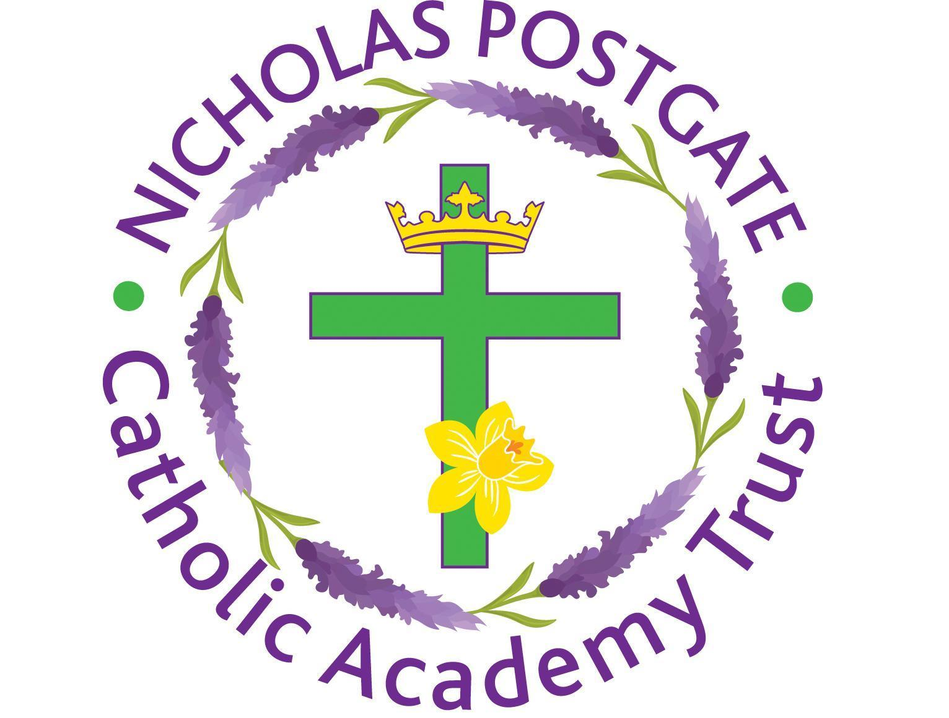

Dear Parents and Carers,

Following the announcement late this evening that a full national lockdown will be implemented immediately, we can confirm that all NPCAT schools will be closed and only open to pupils of critical workers and vulnerable children from tomorrow morning.

Please see guidance below detailing the list of critical workers:
https://www.gov.uk/government/publications/coronavirus-covid-19-maintaining-educational-provision/guidance-for-schools-colleges-and-local-authorities-on-maintaining-educational-provision

Please note this provision is intended to offer support to families only when both parents need to leave the family home to attend work and there is no alternative childcare available. You may be required to provide evidence of your employment.

As of tomorrow morning, all other pupils will have access to remote learning from the Google Classroom platform.

For pupils who are normally in receipt of a free school meal, a lunch will be made available for your child/children and school staff will be in touch with further information sometime tomorrow morning.

Further information will be circulated to you tomorrow morning regarding any additional individual school arrangements and considerations.

Thank you for your support during these ever changing times.

Yours sincerely

Hugh Hegarty CEO
NPQH | M.Sc. | PGCCGC | B.Ed. Hons.| CTC
Nicholas Postgate Catholic Academy Trust

