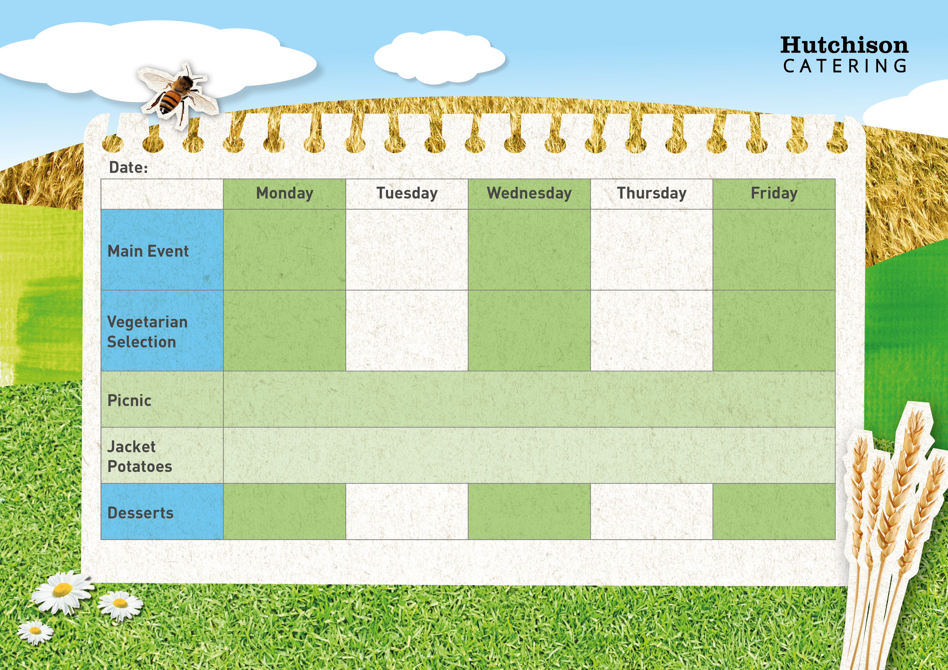

**Spring Week 1 W.C 19th Feb, 11th March, 1st April, 22nd April, 13th May, 3rd June, 24th June, 15th July**

**Freshly Prepared Sandwich, Wrap or Baguette, with Mixed Salad, Healthy Snack,**

**Dessert of the Day or Fresh Fruit**

**Crispy Baked Jacket Potato with a Choice of Fillings, Mixed Salad**

**Dessert of the Day or Fresh Fruit**

**Available Daily:** Fresh Bread, Water, Fresh Fruit and Yoghurt

Fruit & Ice cream

Orange Cake

Summer Berry Jelly

Strawberry Shortbread

Australian Crunch

Quorn Burger with Chips & Baked Beans or Peas

Veggie Tikka Masala with Rice, Naan Bread

& Sweetcorn

Quorn Fillet with Crispy Roast Potato, Yorkshire Pudding, Carrots & Gravy

Plant Based Meatballs in Tomato Sauce with Mash Potato & Broccoli

Vegetable Fajitas with Rice & Peas

“Meat Free Monday”

Macaroni Cheese with Garlic Bread and Peas

Pork Sausage & Creamy Mash Potato with Gravy & Broccoli

Roast Chicken with, Crispy Roast Potato, Yorkshire Pudding, Carrots & Gravy

Chicken Tikka Masala with Rice, Naan Bread & Sweetcorn

Fish Fingers with Chips & Baked Beans or Peas