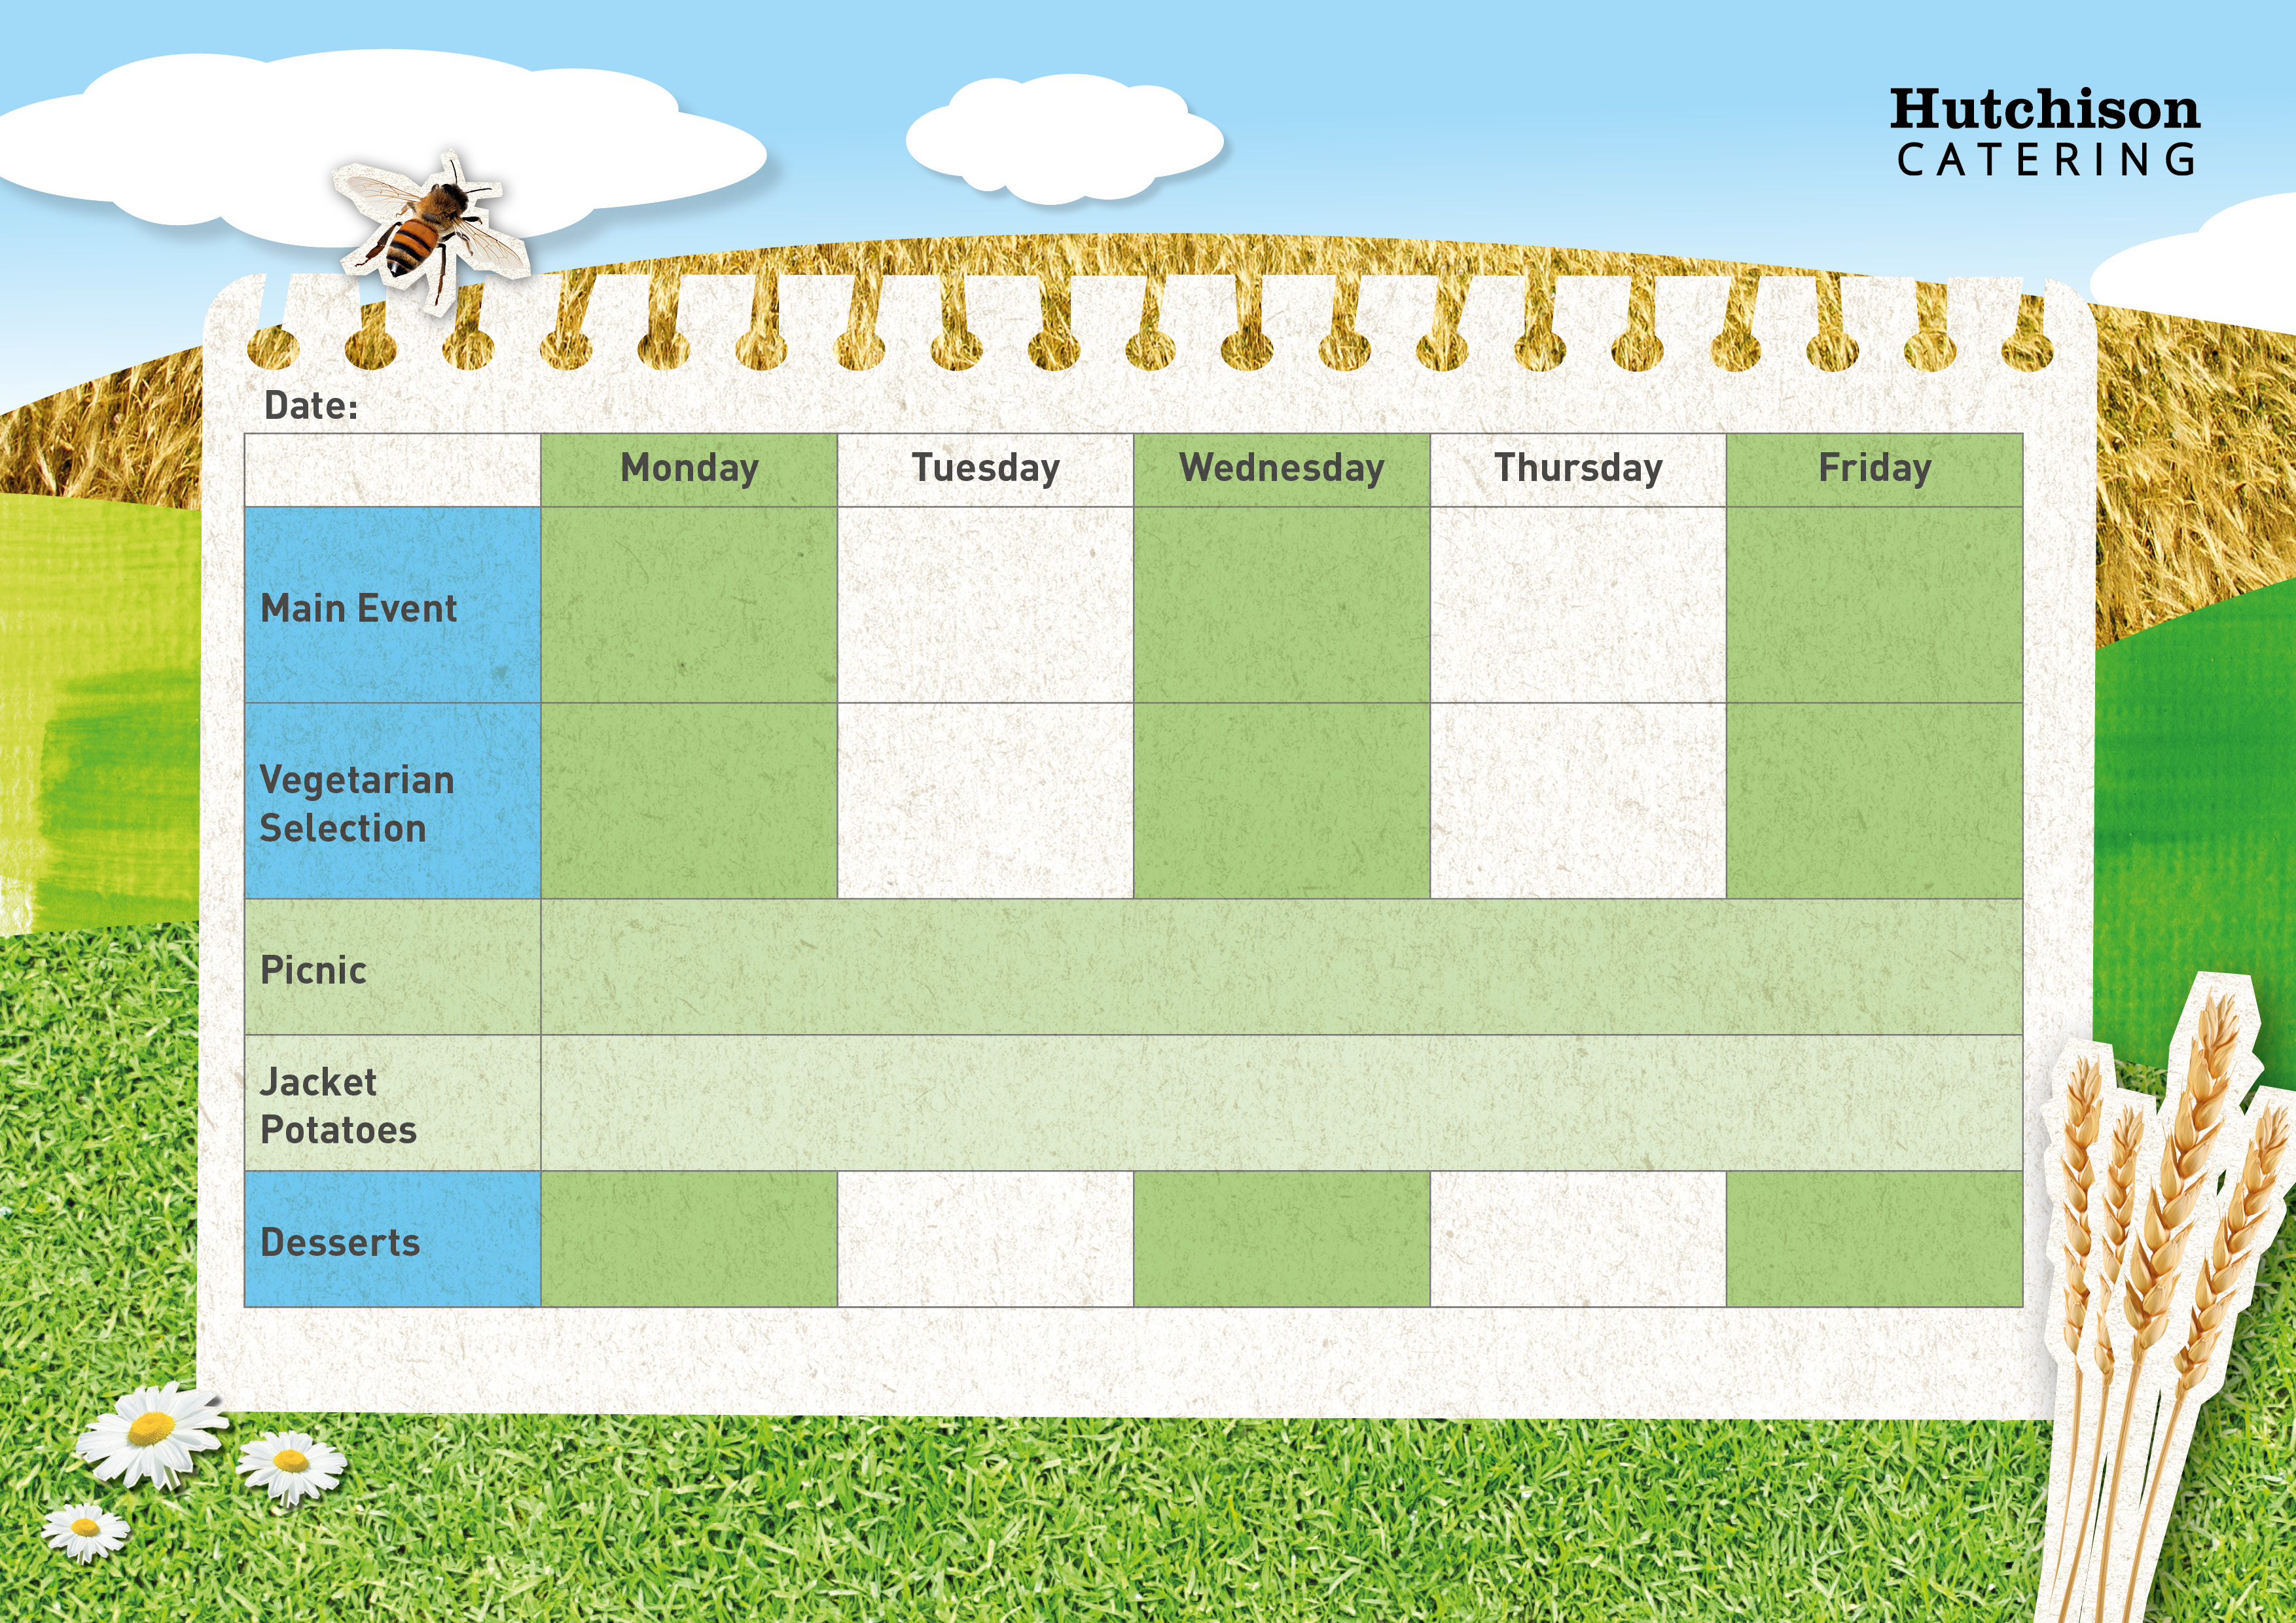

**Spring Week 2 26th Feb, 18th March, 8th April, 29th April, 20th May, 10th June, 1st July**

Veggie Bolognaise

Pasta Bake with Salad

**Freshly Prepared Sandwich, Wrap or Baguette, with Mixed Salad, Healthy Snack,**

**Dessert of the Day or Fresh Fruit**

Chocolate Orange Biscuit with Fruit

Homemade Pasta Bolognaise with Garlic Bread & Sweetcorn

BBQ Chicken with Rice & Salad

Tomato & Mascarpone Pasta with Garlic Bread & Sweetcorn

**Available Daily:** Fresh Bread, Water, Fresh Fruit and Yoghurt

Ice Cream Roll

Banoffee Cake

Strawberry Whip with Fruit

Jam Filled Oaty Bars

**Crispy Baked Jacket Potato with a Choice of Fillings, Mixed Salad**

**Dessert of the Day or Fresh Fruit**

Quorn Vegan Dippers with Chips & Baked Beans or Peas

Quorn Fillet with Crispy Roast Potatoes, Carrots & Gravy

Spanish Omelette with Potato Wedges & Peas

Oven Baked Fish Fingers with Chips & Baked Beans or Peas

Roast Chicken with Crispy Roast Potatoes, Carrots & Gravy

“Meat Free Mondays”

Margherita Pizza with Potato Wedges & Peas