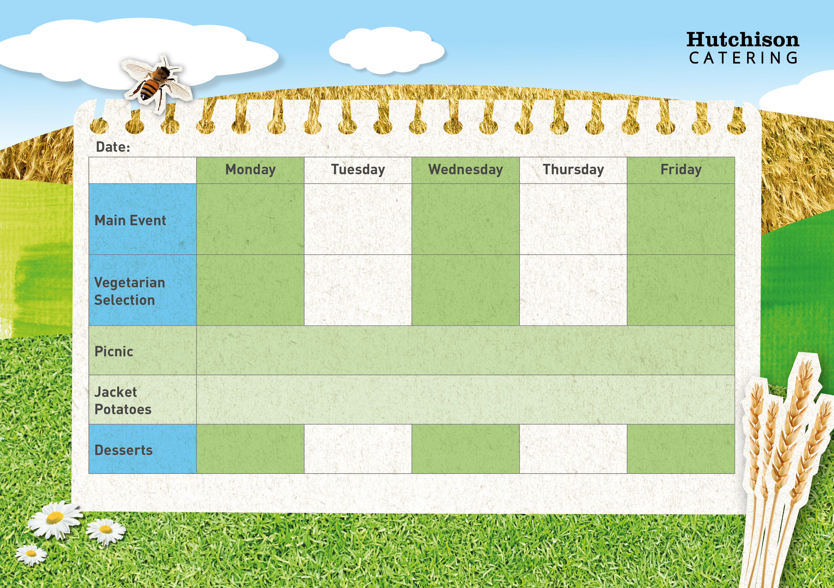

**Spring Week 3 4th March, 25th March, 15th April, 6th May, 27th May, 17th June, 8th July**

**Freshly Prepared Sandwich, Wrap or Baguette, with Mixed Salad, Healthy Snack,**

**Dessert of the Day or Fresh Fruit**

Tomato & Basil Pasta

with Broccoli

Sweet and Sour Quorn with Rice & Peas

Meatballs with Pasta & Broccoli

Lasagne with Salad

Veggie Chilli with Rice & Salad

**Available Daily:** Fresh Bread, Water, Fresh Fruit and Yoghurt

Ice cream

Lemon Muffin

Fruit in Jelly

Carrot Cake

Date crunch

**Crispy Baked Jacket Potato with a Choice of Fillings, Mixed Salad**

**Dessert of the Day or Fresh Fruit**

Cheese & Bean Wrap with Chips & Peas

Veggie Sausage with Gravy, Mash Potatoes & Carrots

Crispy Battered Fish with Chips & Baked Beans or Peas

Roast Gammon with, Mash Potatoes, Carrots & Gravy

“Meat Free Mondays”

Margarita Pizza with Potato Wedges & Peas