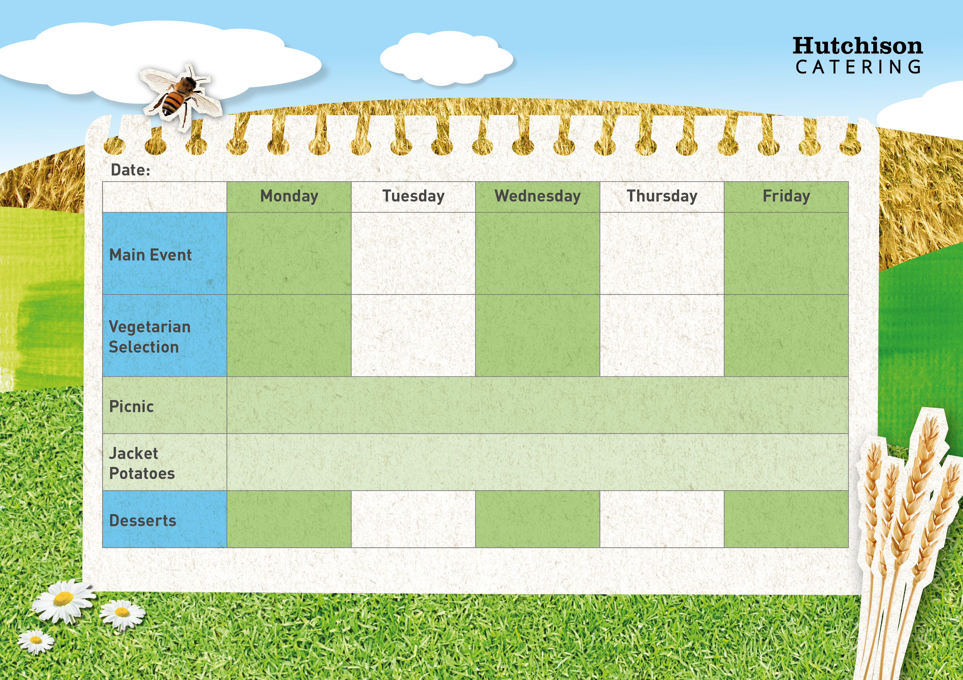

Cheese & Onion Pie with Broccoli

Mexican Chilli with Rice & Sweetcorn

Meatballs in a Homemade Tomato Sauce with Pasta with Sweetcorn

Chicken Tikka Masala with Rice & Broccoli

Vanilla Custard Cookies with Fruit

**Available Daily:** Fresh Bread, Water, Fresh Fruit and Yoghurt

Chocolate & Vanilla Marble Cake

Fruit Sponge

Ice Cream Cups

Fruity Flapjack

**Crispy Baked Jacket Potato with a Choice of Fillings, Mixed Salad**

**Dessert of the Day or Fresh Fruit**

**Freshly Prepared Sandwich, Wrap or Baguette, with Mixed Salad, Healthy Snack,**

**Dessert of the Day or Fresh Fruit**

Quorn Burger with Chips & Peas

Vegetarian Toad in the Hole with Crispy Roast Potatoes, Carrots & Gravy

Autumn Vegetable Pasta Bake & Vegetable Sticks

Oven Baked Fish Fingers with Chips & Baked Beans or Peas

Roast Chicken with Yorkshire Pudding, Crispy Roast Potatoes, Carrots & Gravy

“Meat Free Mondays”

Margherita Pizza with Potato Wedges & Vegetable Sticks

**Autumn Week 2**