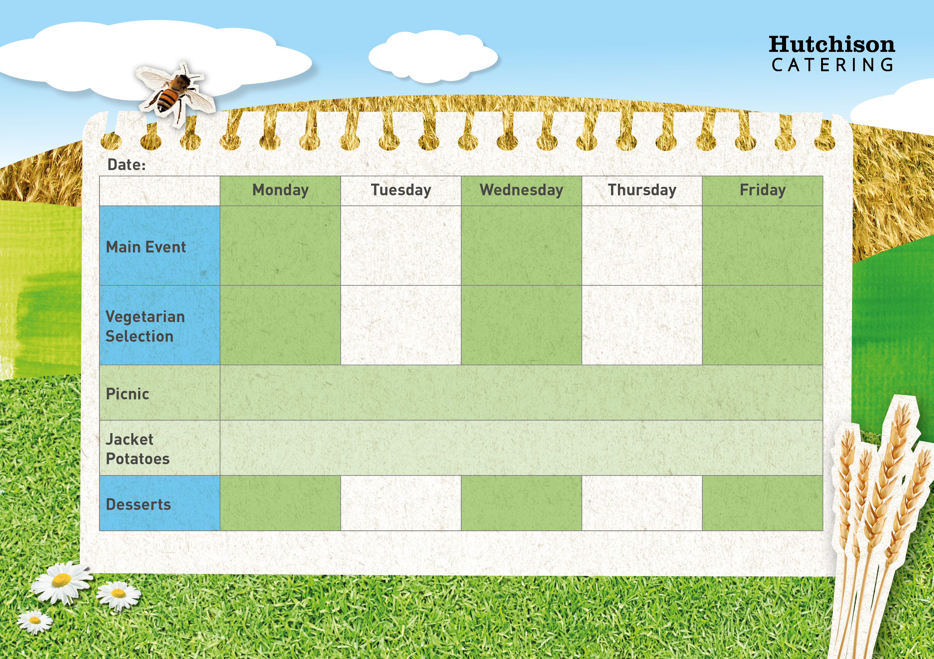

Vegetarian Enchiladas & Broccoli

Cheese & Tomato Quiche with Herby Diced Potatoes & Sweetcorn

Spaghetti Bolognaise with Broccoli

Chicken Korma with Rice & Peas

Tomato & Basil Pasta with Peas

**Available Daily:** Fresh Bread, Water, Fresh Fruit and Yoghurt

Chocolate Shortbread

Ginger Biscuit with Fruit

Fruit in Jelly

Sticky Toffee Pudding

Jam doughnut muffins

**Crispy Baked Jacket Potato with a Choice of Fillings, Mixed Salad**

**Dessert of the Day or Fresh Fruit**

**Freshly Prepared Sandwich, Wrap or Baguette, with Mixed Salad, Healthy Snack,**

**Dessert of the Day or Fresh Fruit**

Quorn Nuggets with Chips & Baked Beans

Creamy Vegetable Pie with Puff Pastry Top, Mash Potatoes & Carrots

Crispy Battered Fish with Chips & Baked Beans

Roast Chicken with, Mash Potatoes, Carrots & Gravy

“Meat Free Mondays”

Margarita Pizza with Herby Diced Potatoes & Sweetcorn

**Autumn Week 3**