Monday 11th October 2021
Dear Parents/Carers,
Re: Year 1 Parent Meeting
I would like to invite you to a meeting to discuss the expectations for your child this coming year.
Parents of Year 1 children – Thursday 21st October 2021
At this meeting you will be informed about:
- End of year expectations in reading, writing and maths
- The teaching of phonics in school
- Year 1 Phonics Testing
- How you can support your child at home.
The meeting will start at 9am. Please drop your child off at school as usual and come to the main office to sign in.
If you are unable to make this meeting, please see your child’s current class teacher for an information pack after the meeting.
Thank you in advance for your attendance and support,
M.McCarthy
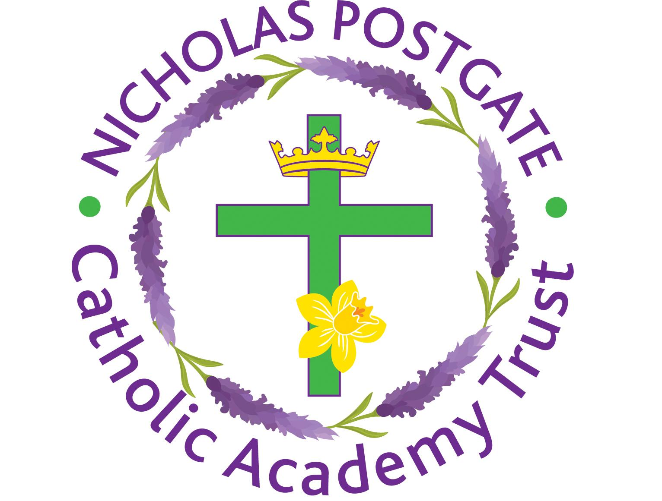
Miss McCarthy
Key stage 1 and phonics lead

