Reading

• Read some common irregular words.
• Use phonic knowledge to decode regular words & read aloud accurately.
• Identify rhymes.
• Join in with rhyming patterns.
• Read & understand simple sentences.
• Demonstrate understanding when talking with others about what they have read.
• Make basic predictions.
• Identify start and end of a sentence.

Writing

• Write simple sentences which can be read by themselves & others.
• Use capital letters and full stops to demarcate sentences.
• Write demarcated sentences.
• Use correct pencil grip.
• Write name (correct upper & lower
case).
• Use correct letter formation for
familiar words.



Mathematics

• Count reliably to 20.
• Order numbers 1 – 20.
• Say 1 more/1 less to 20.
• Add & subtract two single digit numbers.
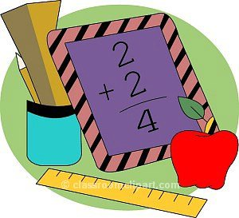• Count on/back to find the answer.
St.Margaret Clitherow’s Primary School



End of Year Expectations for Reception

T his booklet shows the minimum end of year expectations for children in Reception.
All the objectives are taught throughout the year and will be the focus of direct teaching. If you have any questions about how you can support your child at home with these objectives, please talk to your child’s class teacher.

