Reading

• Comment on the way characters relate to one another.
• Know which words are essential in a
sentence to retain meaning.
• Draw inferences such as inferring characters’ feelings, thoughts and motives from their actions.
• Recognise how commas are used to give more meaning.
• Recognise inverted commas
• Recognise:
o plurals
o pronouns and how used
o collective nouns
o adverbs
• Explain the difference that the precise
choice of adjectives and verbs make.
Writing

• Use conjunctions (when, so, before, after, while, because).
• Use adverbs (e.g. then, next, soon).
• Use prepositions (e.g. before, after, during, in, because of).
• Experiment with adjectives to create impact.
• Correctly use verbs in 1st, 2nd and 3rd
person.
• Use perfect form of verbs to mark relationships of time and cause.
• Use inverted commas to punctuate direct speech.
• Group ideas into basic paragraphs.
• Write under headings and sub-headings.
• Write with increasing legibility, consistency and fluency.

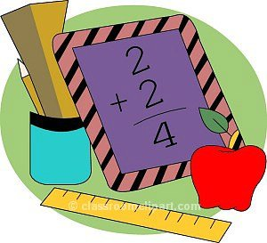
Mathematics

• Compare & order numbers up t o 1000.
• Read & writ e all numbers t o 1000 in digit s and words.
• Find 10 or 100 more/less t han a given number.
• Count from 0 in mult iples of 4, 8, 50 and 100.
• Recall & use mult iplicat ion & division fact s for 3, 4, 8 t ables.
• Recognise place value of any 3-digit number.
• A dd and subt ract :
o 3-digit nos and ones
o 3-digit nos and t ens
o 3-digit nos and hundreds
• A dd and subt ract :
o Numbers wit h up t o 3-digit s using the column method.
• Est imat e and use inverse t o check.
• Mult iply:
o 2-digit by 1-digit
• Count up/down in t ent hs.
• Compare and order fract ions wit h same denominat or.
• A dd and subt ract fract ions wit h same denominat or wit h whole.
• T ell t ime using 12 and 24 hour clocks; and using Roman
numerals.
• T ell t ime t o nearest minut e.
• Know number of days in each mont h and number of seconds in a minut e.
St.Margaret Clitherow’s Primary School



End of Year Expectations for Year 3

T his booklet shows the minimum end of year expectations for children in Year 3.
All the objectives are taught throughout the year and will be the focus of direct teaching. If you have any questions about how you can support your child at home with these objectives, please talk to your child’s class teacher.

