Reading

• Apply knowledge of sounds to decode and blend words.
• Recognise simple recurring language in stories.
• Read ahead to help with fluency and expression.
- Read most Y2 common exception words.
- Read words with common suffixes (e.g. words ending in ‘ing’ or ‘ed)
• Comment on plot, setting & characters in familiar & unfamiliar stories.
• Retell stories and recite poems.
- Predict what might happen in a story.
- Ask and answer questions about a text.

Writing

• Write different kinds of sentence: statement, question, exclamation, command.
• Use expanded noun phrases to add description and specification (e.g. a big, fluffy dog).
• Write using subordination (when, if, that, because) and co-ordination (or, and, but).
• Correct and consistent use of present tense &
past tense.
• Correct use of verb tenses.
• Write with correct and consistent use of:
o capital letters
o full stops
o question marks
o exclamation marks
• Use commas in a list.
• Use apostrophe to mark omission (e.g. can’t) and
possession (e.g. the girl’s hair) in nouns.
• Write under headings.
• Form lower case and capital letters.
• Begin to join letters.



Mathematics

• Compare and order numbers up t o 100 and use <
> =.
• Read and write e all numbers t o 100 in digit s &
words.
• Say 10 more/less than any number t o 100.
• Count in steps of 2, 3 & 5 from zero and in 10s from any number (forwards and backwards).
• Recall and use multiplication & division facts for 2,
5 & 10 tables.
• Recall and use +/- fact s t o 20.
• Derive and use related fact s t o 100.
• Recognise place value of any 2-digit number.
• Add & subtract:
o 2-digit numbers & ones
o 2-digit numbers & tens
o two 2-digit numbers
o three 1-digit numbers
• Recognise and use inverse (+/-).
• Calculate and writ e multiplication & division calculations using multiplication tables.
• Recognise, find, name and writ e 1/3; 1/4; 2/4; 3/4.
• Writ e and recognise equivalence of simple fractions.
• Tell time t o five minutes, including quarter past /t o.
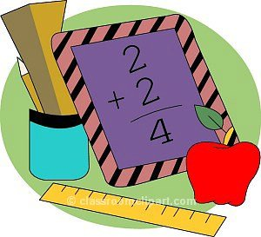
St.Margaret Clitherow’s Primary School



End of Year Expectations for Year 2

T his booklet shows the minimum end of year expectations for children in Year 2.
All the objectives are taught throughout the year and will be the focus of direct teaching. If you have any questions about how you can support your child at home with these objectives, please talk to your child’s class teacher.

