Reading
Word reading
- Recognise 40+ sounds in Read, Write Inc.
- Use my Read, Write Inc. sounds to segment and blend unfamiliar words.
- Read aloud with fluency.
- Read words with apostrophes.
- Read most Y1 common exception words.

Attitudes and responses
- Recognise and join in with predictable phrases.
- Relate reading to own experiences.
- Re-tell with considerable accuracy.

Comprehension
- Re-read if reading does not make sense.
- Discuss significance of title and events.
- Make predictions on basis of what has been read.
- Make inferences on basis of what is being said and done.
- Explain texts that I have read or what has been read to me.
Writing

- Write simple sentences with finger spaces between my words.
- Use ‘and’ to join ideas.
- Write a sequence of sentences to form a short narrative.
- Read and talk about what I have written.
- Use:
  - capital letters
  - full stops
  - question marks
  - exclamation marks
- Use capital letters for names and personal
- pronoun ‘I’.
- Write Year 1 common exception words and days of the week.
- Form all letters (including capital letters) and numbers correctly.


Mathematics

- Count to and across 100, forwards & backwards from any number.
- Read and write numbers to 20 in numerals & words.
- Read and write numbers to 100 in numerals.
- Say 1 more/1 less to 100.
- Count in multiples of 2, 5 & 10.
- Use addition and subtraction facts to 20.
- Add & subtract:
  - 1 digit & 2 digit numbers to 20, including zero.
- Solve one-step multiplication and division using objects, pictorial representation and arrays.
- Recognise half and quarter of object, shape or quantity.
- Sequence events in chronological order.
- Use language of day, week, month and year.
- Recognise the value of notes and coins.
- Tell time to hour & half past.
- To recognize and name 2D and 3D shapes.
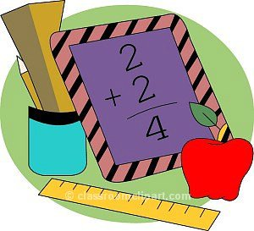
St.Margaret Clitherow’s Primary School



End of Year Expectations for Year 1

T his booklet shows the minimum end of year expectations for children in Year 1.
All the objectives are taught throughout the year and will be the focus of direct teaching. If you have any questions about how you can support your child at home with these objectives, please talk to your child’s class teacher.

