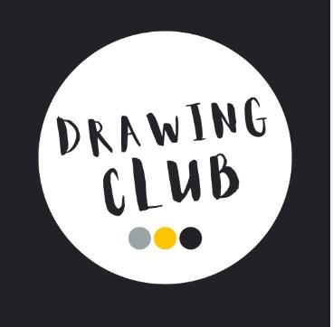

Drawing Club is an initiative that integrates drawing activities into the learning curriculum, particularly aimed at young children in Early Years. It leverages the natural inclination of children to express themselves through art, using this as a bridge to develop their writing skills. Here’s how a Drawing Club at has been adapted at St Joseph’s Primary School from EYFS.

Structure of a Drawing Club
Regular Sessions: Scheduled weekly sessions where children come together to draw.
Thematic Focus: Each session can have a theme, such as a story, an event, or a topic they are learning about.
Guided Drawing: Provide guidance through prompts or instructions but allow creativity and freedom.
Discussion Time: After drawing, have a session where children talk about their drawings.
Drawing to Writing Transition: Encourage children to write a few sentences about their drawings.

How Drawing Club Helps Develop Writing Skills
- Enhances Creativity and Imagination:
- Drawing stimulates creativity, which is essential for imaginative writing.
- Children can translate the scenes and stories from their drawings into words.

Improves Fine Motor Skills:
The physical act of drawing helps develop fine motor skills, crucial for handwriting.

Builds Narrative Skills:
- Children often create stories with their drawings, which helps them understand narrative structure.
- Discussing their drawings encourages them to articulate their thoughts and ideas coherently.

Increases Vocabulary:
- As children describe their drawings, they learn new words and phrases.
- Teachers can introduce relevant vocabulary during the sessions.

Encourages Expression and Confidence:
- Drawing provides a non-verbal way to express ideas, which can then be translated into writing.
- Sharing their drawings and stories builds confidence in expressing themselves.

Develops Sequencing Skills:
- Creating a sequence of drawings (a comic strip, for example) helps children understand the flow of a story.
- They can then practice writing about the sequence, improving their ability to organize thoughts logically.

Provides Context for Writing:
- Drawing gives a visual context that makes writing tasks more concrete and less abstract.
- Children are more likely to write enthusiastically about something they have created visually.

Implementation at St Joseph’s Primary School.
Integration with Curriculum:
- Align the Drawing Club themes with the current curriculum topics.
- Use drawings to supplement lessons in literacy, history, science, etc.
Teacher Involvement:
- Teachers can participate by providing prompts and guidance.
- They can help children make the connection between their drawings and writing.
Parental Engagement:
- Involve parents by encouraging drawing and writing at home.
- Share children’s progress and creations with parents to foster a supportive environment.
Resources and Materials:
- Provide ample drawing materials like paper, crayons, markers, etc.
- Have a dedicated space for the Drawing Club sessions.
- Bank of word mats, number mats and sound mats to support independence.
Assessment and Feedback:
- Regularly assess children’s progress in both drawing and writing.
- Provide positive feedback and constructive suggestions to encourage improvement.
By integrating a Drawing Club into the EYFS curriculum at St Joseph’s Primary School, children can develop their writing skills in an engaging, supportive, and creative environment. This approach not only makes writing more enjoyable but also reinforces the connection between visual and verbal expression.
EYFS The Principles:
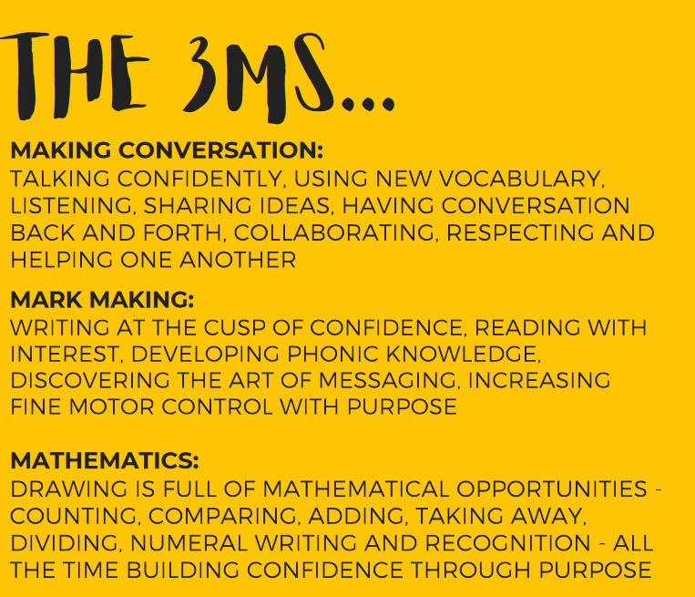

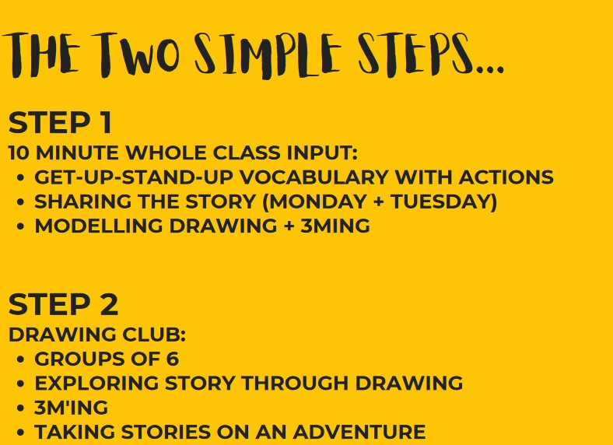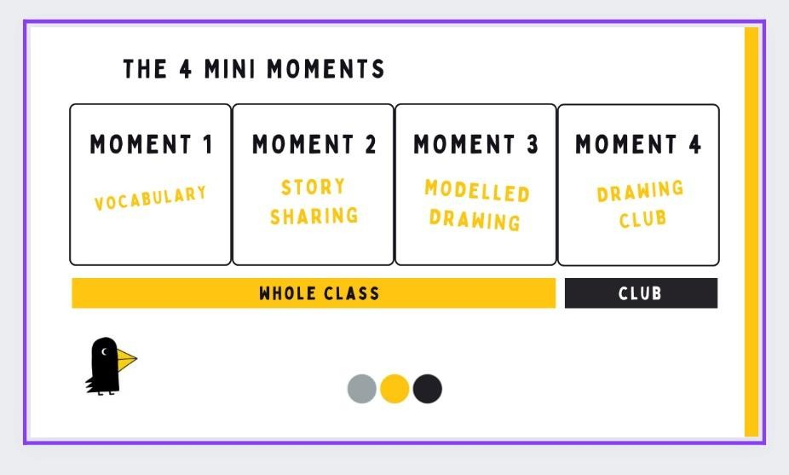

‘Codes’
Alongside drawings, the children are encouraged to write a ‘code word’. These codes make ‘magical’ things happen to their drawings.
As the children draw, they chat about what their ideas are and what they want to happen to their drawing. This makes it joyful and motivating for the children.
Codes can be anything the children want it to be: single letters or phonemes, words, phrases or sentences. They give meaning to these codes and the magic happens. Magical things may include: ‘it grows wheels and then drives around’, ‘they change size’, ‘transform into a rocket’ etc…
Examples:

Here are some examples of models that the teacher may demonstrate in their modelled drawing:
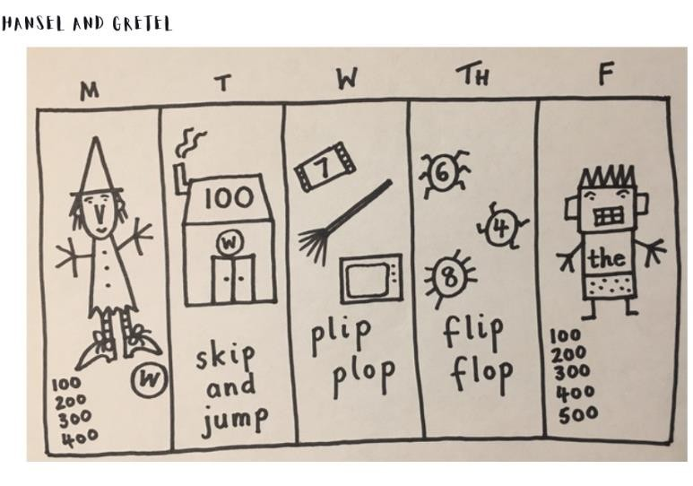

 | Reception Structure
 | Day 1 | Day 2 | Day 3
Mini  Moment 1 | Vocabulary (2 mins) with actions | Vocabulary (2 mins) with actions
Mini  Moment 2 | Share the story (5 minutes) | Share the story (5 minutes) | No story
Mini  Moment 3 | Adult models drawing (3  mins)  THE CHARACTER OR  SETTING | Adult models drawing (3 mins)  ADVENTURE TIME 1 | Adult models drawing (3 mins)  ADVENTURE TIME 2
Mini  Moment 4 | Independent mark making at Writing Table in Continuous Provision | Children’s turn – adult led writing task in books (5-10 mins) | Children’s turn – adult led writing task in books (5-10 mins)

EYFS Drawing Club Texts:
In EYFS, we like to encourage a mastery approach to stories. We feel that by re-reading familiar books this helps to build up their confidence in vocabulary, word reading, fluency, comprehension and enjoyment. Our Pre-school will introduce a text at a basic level and produce 1 piece of adult-led mark-making each week based on this. Our Reception will reintroduce the same text at a deeper level, with more skills development and produce 2-3 pieces of writing per week.

Term  Text Types  Story  Traditional Tales  Animation | Autumn 1  7weeks | Autumn 2  7weeks | Spring 1  5weeks | Spring 2  5weeks | Summer 1  8weeks | Summer 2  7weeks
Week 1 | Settling in | Trapdoor | Hungry Caterpillar | Jack and Beanstalk | Banana Man | 100 Decker Bus
Week 2 | The Colour Monster | NURSERY RHYME WEEK | Chicken Licken | Rosie’s Walk | Little Red Hen | Billy Goats Gruff
Week 3 | The Hairy Toe | Popeye | Chinese New Year – Great Race | Tom & Gerry | Tiger who came to tea | Wacky Races
Week 4 | Pink Panther | Gingerbread Man | Roadrunner | Enormous Turnip | Six Dinner Sid | Whatever Next
Week 5 | The Three Little Pigs | Gruffalo / Gruffalo Child | Easter Story | Handa’s Surprise | Hansel & Gretel | Little Red Riding
Week 6 | Pumpkin Soup | Nativity Story |  |  | Handa’s Surprise | Rainbow Fish
Week 7 | Room on Broom | CHRISTMAS |  |  | Rosie & Jim | Dear Zoo
Week 8 |  |  |  |  | Poetry - PoeTREE

EYFS Planning:
