SEN Information Report

St. Joseph’s RC Primary School, Pickering.

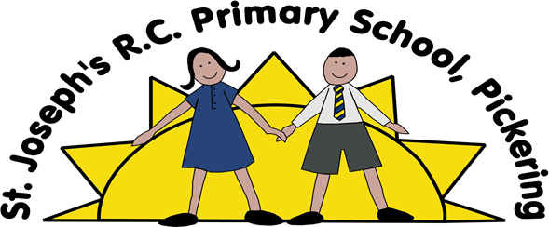

Publication Scheme: | Autumn 2023
Next Review Date: | Summer 2024

Contents

Purpose 3
1. What types of SEN does the school provide for? 3
2. Which staff will support my child, and what training have they had? 3
3. What should I do if I think my child has SEN? 4
4. How will the school know if my child needs SEN support? 4
5. How will the school measure my child’s progress? 5
6. How will I be involved in decisions made about my child’s education? 5
7. How will my child be involved in decisions made about their education? 6
8. How will the school adapt its teaching for my child? 6
9. How will the school evaluate whether the support in place is helping my child? 7
10. How will the school resources be secured for my child? 7
11. How will the school make sure my child is included in activities alongside pupils who don’t have SEND? 7
12. How does the school make sure the admissions process is fair for pupils with SEN or a disability? 7
13. How does the school support pupils with disabilities? 8
14. How will the school support my child’s mental health and emotional/ social development? 8
15. What support will be available for my child as they transition between classes or settings or in preparing for adulthood? 8
16. What support is in place for looked-after and previously looked-after children with SEN? 8
17. What should I do if I have a complaint about my child’s SEN support? 9
18. What support is available for me and my family? 9
Glossary of terms 10

.

Purpose

The aim of this information report is to explain how we implement our SEND policy. We want to show you how SEND support works in our school. If you want to know more about our arrangements for SEND, please read the NPCAT SEND policy. You can find it on our website in the Policies section.

Note: If there are any terms we’ve used in this information report that you’re unsure of, you can look them up in the Glossary at the end of the report.

What types of SEN does the school provide for?
Our school provides for pupils within four categories of needs:
- Communication and Interaction
- Cognition and Learning
- Social, Emotional and Mental Health difficulties
- Sensory and/or Physical

Which staff will support my child, and what training have they had?
SENCO
Our special educational needs co-ordinator, or SENCO is: Miss Emma Hughes
She is new to role and will be working towards achieving the National Award in Special Educational Needs Coordination in the upcoming months.
Class teachers
All of our teachers receive in-house SEN training, and are supported by the SENCO to meet the needs of pupils who have SEN.
Training has included:
Essential Letters and Sounds (ELS) phonics training
Plus 1 maths
Makaton
North Yorkshire Locality Board Training
Teaching assistants (TAs)
We have a team of 4 TAs, including 2 higher-level teaching assistants (HLTAs) who are trained to deliver SEN provision.
Training has included:
Essential Letters and Sounds (ELS) phonics training
Plus 1
Sand Therapy
Makaton
External agencies and experts
Sometimes we need extra help to offer our pupils the support that they need. Whenever necessary we will work with external support services to meet the needs of our pupils with SEN and to support their families. These include:
- Speech and language therapists
- Educational psychologists
- Occupational therapists
- GPs or paediatricians
- School nurses
- Child and adolescent mental health services (CAMHS)
- Social services and other LA-provided support services
- Voluntary sector organisations

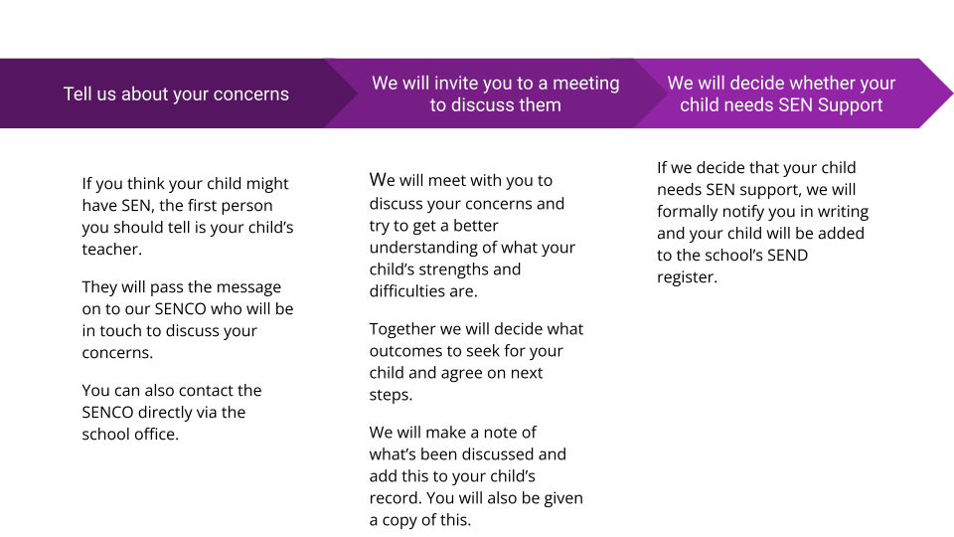
What should I do if I think my child has SEN?

How will the school know if my child needs SEN support?

At St. Joseph’s we believe that every teacher is a teacher of SEND. All our class teachers are aware of SEN and are on the lookout for any pupils who aren’t making the expected level of progress in their schoolwork or socially.

If the teacher notices that a pupil is falling behind, they try to find out if the pupil has any gaps in their learning. Pupils who don’t have SEN usually make progress quickly once the gap in their learning has been filled. We will use the NPCAT High Quality Teaching toolkit to inform any possible strategies.
If the pupil is still struggling to make the expected progress, the teacher will talk to the SENCO, and will contact you to discuss the possibility that your child has SEN.
The SENCO will work with the class teacher to see what their strengths and difficulties are. They will have discussions with your child’s teacher/s, to see if there have been any issues with, or changes in, their progress, attainment or behaviour. They will also compare your child's progress and development with their peers and available national data.
The SENCO will ask for your opinion and speak to your child to get their input as well. They may also, where appropriate, ask for the opinion of external experts such as a speech and language therapist, an educational psychologist, or a paediatrician.
Based on all of this information, the SENCO will decide whether your child needs SEN support. You will be told the outcome of the decision in writing.
If your child does need SEN support, their name will be added to the school’s SEN register, and the SENCO will work with you to create a SEN support plan for them.

How will the school measure my child’s progress?
We will follow the ‘graduated approach’ to meeting your child’s SEN needs. The graduated approach is a 4-part cycle of assess, plan, do, review.
As a part of the planning stage of the graduated approach, we will set outcomes that we want to see your child achieve.
Whenever we run an intervention with your child, we will assess them before the intervention begins. This is known as a ‘baseline assessment’. We do this so we can see how much impact the intervention has on your child’s progress.
We will track your child’s progress towards the outcomes we set over time and improve our offer as we learn what your child responds to best.
This process will be continual. If the review shows a pupil has made progress, they may no longer need the additional provision made through SEN support. For others, the cycle will continue and the school's targets, strategies and provisions will be revisited and refined.

How will I be involved in decisions made about my child’s education?
We will provide annual reports on your child's progress. Your child’s class teacher will meet you three times a year to:
- Set clear outcomes for your child’s progress
- Review progress towards those outcomes
- Discuss the support we will put in place to help your child make that progress
- Identify what we will do, what we will ask you to do, and what we will ask your child to do
The SENCO may also attend these meetings to provide extra support.
We know that you’re the expert when it comes to your child’s needs and aspirations. So we want to make sure you have a full understanding of how we’re trying to meet your child’s needs, so that you can provide insight into what you think would work best for your child. We also want to hear from you as much as possible so that we can build a better picture of how the SEN support we are providing is impacting your child outside of school.
If your child’s needs or aspirations change at any time, please let us know right away so we can keep our provision as relevant as possible. After any discussion we will make a record of any outcomes, actions and support that have been agreed. This record will be shared with all relevant staff, and you will be given a copy.
If you have concerns that arise between these meetings, please contact your child’s class teacher.

How will my child be involved in decisions made about their education?
The level of involvement will depend on your child’s age, and level of competence. We recognise that every child is unique, so we will decide on a case-by-case basis, with your input.
We may seek your child’s views by asking them to:
- Attend meetings to discuss their progress and outcome
- Discuss their views with a member of staff who can act as a representative during the meeting

How will the school adapt its teaching for my child?
Your child’s teacher is responsible and accountable for the progress and development of all the pupils in their class.
High-quality teaching is our first step in responding to your child’s needs. We will make sure that your child has access to a broad and balanced curriculum in every year they are at our school.
We will use adaptive teaching to suit the way the pupil works best. There is no '1 size fits all’ approach to adapting the curriculum, we work on a case-by-case basis to make sure the adaptations we make are meaningful to your child.
These adaptations include:
- Explicit instruction
- Cognitive and meta cognitive strategies
- Scaffolding
- Flexible Grouping
- Use of technology.
- Use of additional adult support when required.
We may also provide the following interventions:
Sensory Circuit
Draw and Talk
Keep up not catch up (ELS Phonics)
Precision Grid
Additional Reading (Blending)
Fine Motor activities & Write from the Start
Plus 1 (maths intervention)
Phonics/Language for EAL

How will the school evaluate whether the support in place is helping my child?
We will evaluate the effectiveness of provision for your child by:
- Reviewing their progress towards their goals each term
- Reviewing the impact of interventions
- Using pupil questionnaires
- Monitoring by the SENCO
- Holding an annual review (if they have an education, health and care plan (EHCP)

How will the school resources be secured for my child?
The school budget that is received from the Local Authority includes money for supporting pupils with SEN. The Headteacher and School Business Manager then decide on the budget for SEN in consultation with school governors and based on the needs of pupils in the school. The school may receive an additional amount of ‘top-up’ high needs funding for pupils with higher level needs.

We use our SEN funding in the most appropriate way to support your child. This support may include some individual or small group support, for example, small intervention groups. Funding may also be used to pay for support from outside services or to purchase specialist teaching equipment and resources as needed, which may include additional staff. There are regular meetings to monitor the impact of interventions and SEN provision.

How will the school make sure my child is included in activities alongside pupils who don’t have SEND?
All of our extra-curricular activities and school visits are available to all our pupils, including our before and after-school clubs. No pupil is ever excluded from taking part in these activities because of their SEN or disability and we will make whatever reasonable adjustments are needed to make sure that they can be included.

How does the school make sure the admissions process is fair for pupils with SEN or a disability?
Our admission arrangements for pupils with SEND are the same as for every child in school. However, if special provision needs to be made (for example due to a physical or medical need) then a meeting with parents (and specialist services if appropriate) will be sought in the first instance to ensure that school is fully prepared to meet the child’s needs. If a child with an Education Health Care Plan (EHCP) is transferring to us, then we will seek advice from other professionals and consult with the Local Authority SEND Team to ensure our school can fully meet their needs.

How does the school support pupils with disabilities?
- Accessibility plan (DDA) available to view via our website https://shn.npcat.org.uk/policies/
- Individual Pupil Support Plans
- Medical Risk Assessments
- Training to support specific conditions such as diabetes and allergy issues.

How will the school support my child’s mental health and emotional/ social development?

We provide support for pupils to progress in their emotional and social development in the following ways:

TA intervention sessions through Sand Therapy.
Local Hub provision where appropriate.

What support will be available for my child as they transition between classes or settings or in preparing for adulthood?
Between years
To help pupils with SEND be prepared for a new school year we:
- Ask both the current teacher and the next year’s teacher to attend final meeting of the year when the pupil’s SEN is discussed
- Schedule lessons with the incoming teacher towards the end of the summer term
Between schools
When your child is moving on from our school, we will ask you and your child what information you want us to share with the new setting.
Between phases
The SENCO of the secondary school will come into our school for a meeting with our SENCO. They will discuss the needs of all the children who are receiving SEN support.

What support is in place for looked-after and previously looked-after children with SEN?
Mr Gerard Eddy will work with Miss Emma Hughes, our SENCO, to make sure that all teachers understand how a looked-after or previously looked-after pupil’s circumstances and their SEN might interact, and what the implications are for teaching and learning.
Children who are looked-after or previously looked-after will be supported much in the same way as any other child who has SEND. However, looked-after pupils will also have a personal education plan (PEP). We will make sure that the PEP and any SEN support plans or EHC plans are consistent and complement one another.

What should I do if I have a complaint about my child’s SEN support?
If you feel unhappy with the provision your child is getting or have concerns, we encourage you to come into school and speak to our SENCO, or our Head Teacher. A detailed copy of our complaints procedure is highlighted in our complaints policy found on our website. We would like to assure parents that we only want the best for our children with SEND and so if you do have any concerns/complaints please do come and speak to us ASAP.
Contact details:
 01751 473102
admin@sjp.npcat.org.uk
To see a full explanation of suitable avenues for complaint, see pages 246 and 247 of the SEN Code of Practice.
If you feel that our school discriminated against your child because of their SEND, you have the right to make a discrimination claim to the first-tier SEND tribunal. To find out how to make such a claim, you should visit: https://www.gov.uk/complain-about-school/disability-discrimination

What support is available for me and my family?
If you have questions about SEND, or are struggling to cope, please get in touch to let us know. We want to support you, your child and your family.
To see what support is available to you locally, have a look at North Yorkshire’s local offer. https://www.northyorks.gov.uk/children-and-families/send-local-offer
SENDIASS North Yorkshire is a service for parents and carers of young people aged 0-25 with special educational needs and /or disabilities (SEND) as well as young people themselves. It is impartial, which means it is not biassed and gives confidential information, advice and support that is arms length to the Local Authority. https://sendiassnorthyorkshire.co.uk/

Glossary of terms

Access arrangements | Special arrangements to allow pupils with SEND to access assessments or exams.
Annual review | An annual meeting to review the provision in a pupil’s EHC plan
Area of need | The 4 areas of need describe different types of needs a pupil with SEND can have. The 4 areas are communication and interaction; cognition and learning; physical and/or sensory; and social, emotional and mental health needs.
CAMHS | Child and adolescent mental health services.
Differentiation | When teachers adapt how they teach in response to a pupil’s needs.
EHC needs assessment | The needs assessment is the first step on the way to securing an EHC plan. The local authority will do an assessment to decide whether a child needs an EHC plan.
EHC Plan | An education, health and care plan is a legally-binding document that sets out a child’s needs and the provision that will be put in place to meet their needs.
First-tier tribunal/SEND tribunal | A court where you can appeal against the local authority’s decisions about EHC needs assessments or plans and against discrimination by a school or local authority due to SEND
Graduated approach | An approach to providing SEN support in which the school provides support in successive cycles of assessing the pupil’s needs, planning the provision, implementing the plan, and reviewing the impact of the action on the pupil.
Intervention | A short-term, targeted approach to teaching a pupil with a specific outcome in mind.
Outcome | Target for improvement for pupils with SEND. These targets don't necessarily have to be related to academic attainment.
Local offer | Information provided by the local authority which explains what services and support are on offer for pupils with SEN in the local area.
Reasonable adjustments | Changes that the school must make to remove or reduce any disadvantages caused by a child’s disability.
SENCO | The special educational needs co-ordinator.
SEN(D) | Special educational needs (and disabilities).
SEND Code of Practice | The statutory guidance that schools must follow to support children with SEND.
SEN support | Special educational provision which meets the needs of pupils with SEN.
Transition | When a pupil moves between years, phases, schools or institutions or life stages.

