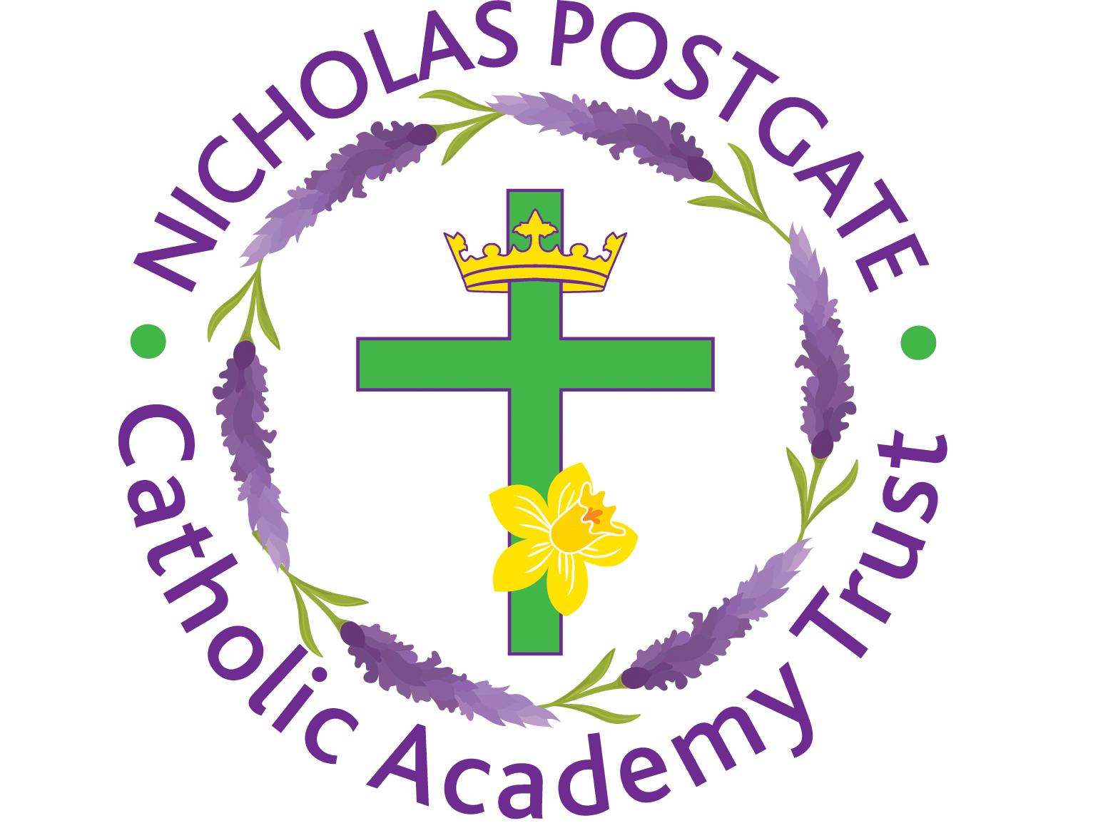
Nicholas Postgate Catholic Academy Trust

COVID-19 Testing Privacy Statement for staff in Primary Schools

Ownership of the Personal Data
To enable the Covid-19 testing to be completed at Sacred Heart Catholic Primary School we need to process personal data, including the sharing of personal data where this is allowed under data protection legislation. Sacred Heart Catholic Primary School is the Data Controller for the data required for the management of tests and implementing local arrangements in the event of a positive test.
We will process personal data relating to staff under article 6.1(f) of the UK GDPR – it is necessary in the legitimate interest of the data controller. We will process special category personal data under the provisions of article 9.2(i) of the UK GDPR, and Part 1 of Schedule 1(3) of DPA 2018 where it is in the public interest on Public Health Grounds to ensure we can minimise the spread of COVID in a timely manner and enable us to continue to deliver education services as safely and securely as possible. This data is processed under the obligations set out in Public Health legislation (Regulations 3(1) and (4) of the Health Service (Control of Patient Information) Regulations 2002 (COPI)) which allows the sharing of data for COVID related purposes and where it is carried out by someone who owes an equivalent duty of confidentiality to that data.
Ownership of the Personal Data you share with DHSC
Every time you use a lateral flow test you must report the results. More details can be found here - Report a COVID-19 test result - GOV.UK (www.gov.uk). The Department for Health and Social Care (DHSC) is the data controller for the information that you transfer to them about you and your test results. For more information about what the DHSC do with your data please see their COVID-19 Privacy Notice
The school remains the Data Controller for the data we retain about you for the management of tests and implementing local arrangements in the event of a positive test.
You should read both this Privacy Notice and the DHSC COVID-19 Privacy Notice to understand how your personal data is used prior to taking a test.
Personal Data involved
The following personal data is processed by the school in relation to your test:
• Name
• Unique code assigned to each individual test and which will become the primary reference number for the tests.
• Test result
For more information about what the DHSC do with your data please see their COVID-19 Privacy Notice

How we store your personal information
The school will maintain a test kit log which will record against your name details of the testing kit which has been provided to you. The school may also record Personal Data about you in its internal COVID-19 results register (the school’s COVID-19 results register will not be shared with DHSC). This information will only be stored securely in the school’s MIS with appropriate access controls in schools and will only be accessible to personnel involved in the management of tests and implementing local arrangements in the event of a positive test.
The school will retain its test kit log and COVID-19 results register for a period of twelve (12) months from the date of the last entries made by the school into them.
For more information about what the DHSC do with your data please see their COVID-19 Privacy Notice
Processing of Personal Data Relating to Positive test results
We will use this information to enact our own COVID isolation and control processes without telling anyone who it is that has received the positive test.
For more information about what the DHSC do with your data please see their COVID-19 Privacy Notice
This information will be kept by the school for a period of twelve (12) months by the school and by the NHS for eight (8) years.
Processing of Personal Data Relating to Negative and Void test results
We will record a negative and void result for the purpose of stock controls of tests and general performance of the testing process.
Data Sharing Partners
The personal data associated with test results will be shared with
• DHSC, NHS, PHE – to ensure that they can undertake the necessary Test and Trace activities and to conduct research and compile statistical information about Coronavirus.
• Your GP – the NHS may share the information you provide with your GP to maintain your medical records and to offer support and guidance as necessary. Any data you provide to the school will not be shared with your GP.
• Local Government to undertake local public health duties and to record and analyse local spreads.
Personal Data in the school’s test kit log will be shared with DHSC to identify which test kit has been given to which individual in the event of a product recall. The school will not share its internal COVID-19 results register with DHSC.
Your Rights
Under data protection law, you have rights including:
Your right of access - You have the right to ask us for copies of your personal information.
Your right to rectification - You have the right to ask us to rectify personal information you think is inaccurate. You also have the right to ask us to complete information you think is incomplete.
Your right to erasure - You have the right to ask us to erase your personal information in certain circumstances.
Your right to restriction of processing - You have the right to ask us to restrict the processing of your personal information in certain circumstances.
Your right to object to processing - You have the right to object to the processing of your personal information in certain circumstances.
Your right to data portability - You have the right to ask that we transfer the personal information you gave us to another organisation, or to you, in certain circumstances.
You are not required to pay any charge for exercising your rights. If you make a request, we have one month to respond to you.
Please contact us at
enquiries@sacredheartcp.npcat.org.uk
if you wish to make a request.
How to complain
If you have any concerns about our use of your personal information, you can make a complaint to us at [Insert your organisation’s contact details for data protection queries].
You can also complain to the ICO if you are unhappy with how we have used your data.
The ICO’s address:
Information Commissioner’s Office
Wycliffe House
Water Lane
Wilmslow
Cheshire
SK9 5AF
Helpline number: 0303 123 1113

