1. Open a web browser (such as Safari on an iPad, internet explorer or Google Chrome) and search for Google classroom. Click on the link ‘Google Classroom’

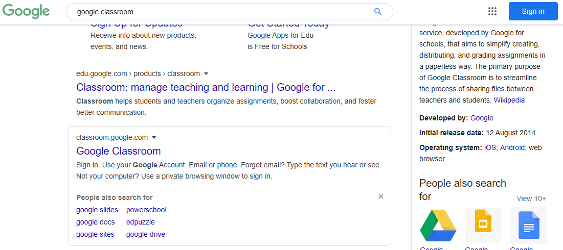
2. This will open a page like the one shown below. Click on the link that says ‘Go to Classroom’.

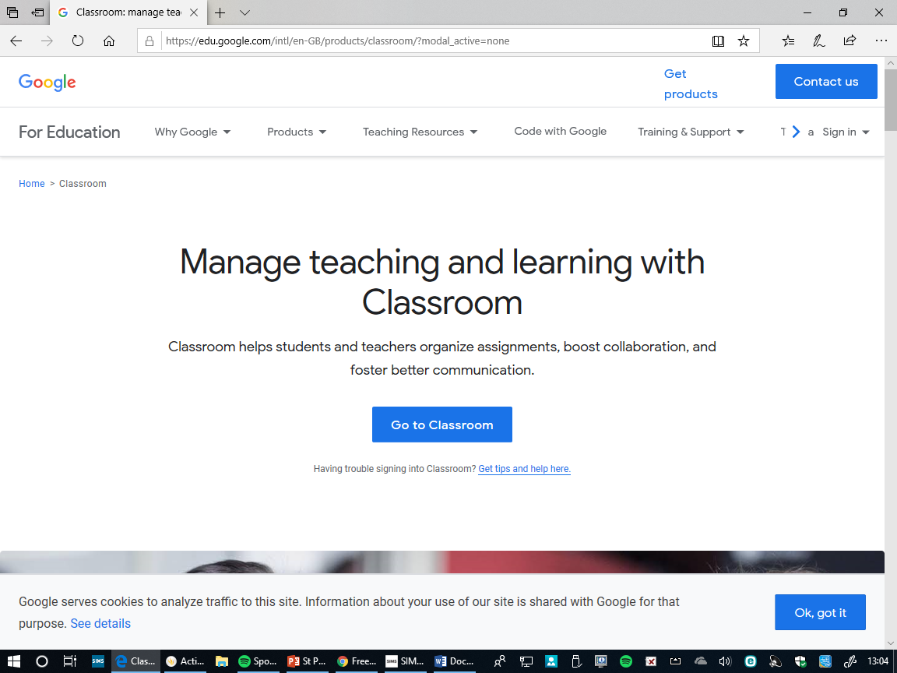

3. This will ask for the children’s email address to access their account.
The email address will be similar to as follows:
21.a.smith@ctking.npcat.org.uk
The number is the year that the child leaves primary school in Year 6, then their first initial and surname

The number at the beginning will be:
26 for year 1
25 for Year 2
24 for Year 3
23 for Year 4
22 for Year 5
21 for Year 6

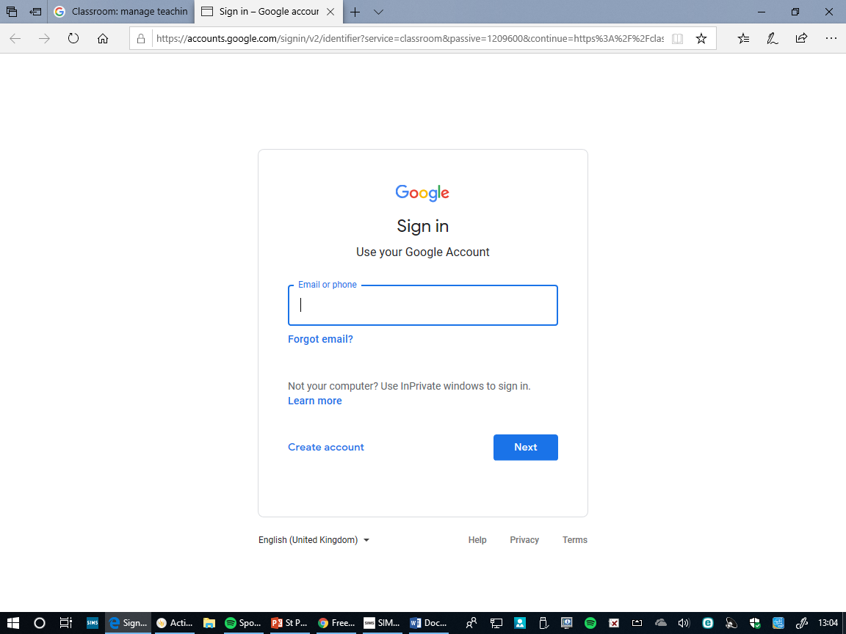

4. Enter the email address into the email box and then click ‘Next’.

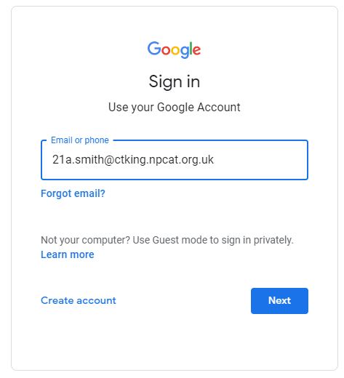

5. This will bring a screen similar to the one shown below.

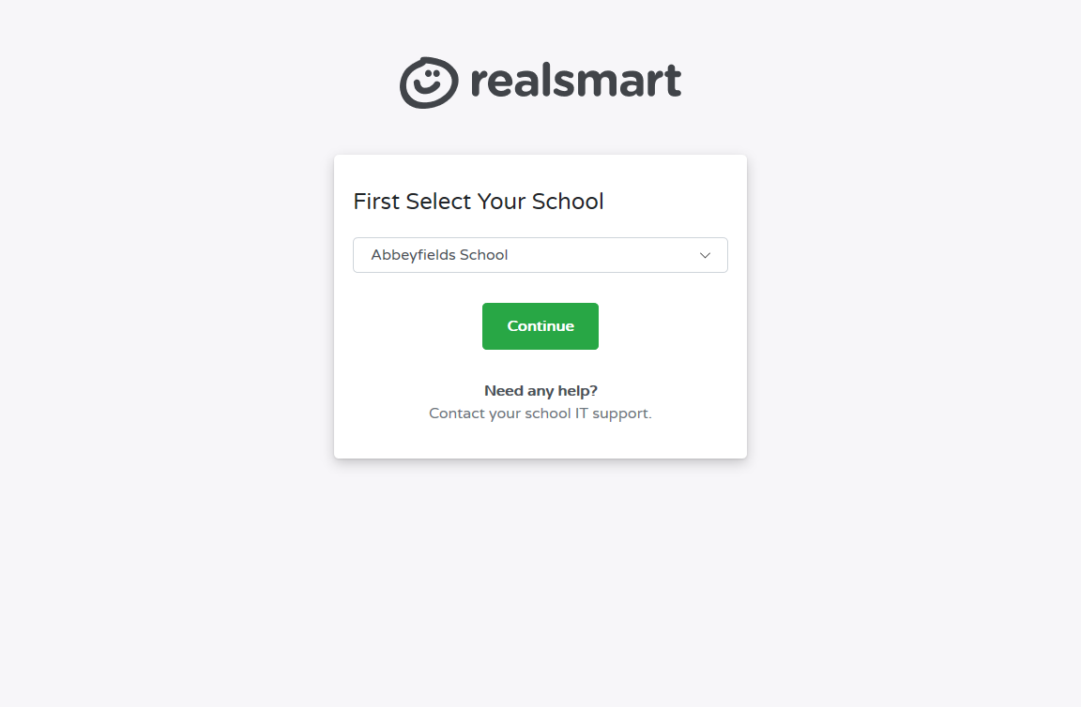
6. From the options pick NPCAT – Christ the King Catholic Primary School, Then, click the continue button.
Some devices will remember this step, so that you do not need to do this every time.

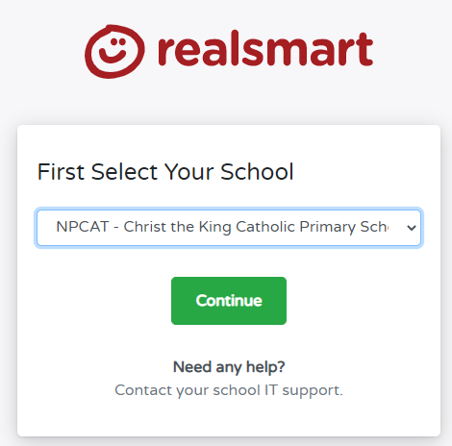

7. Then, enter the child’s email address again and enter the password that your child’s teacher has provided you.

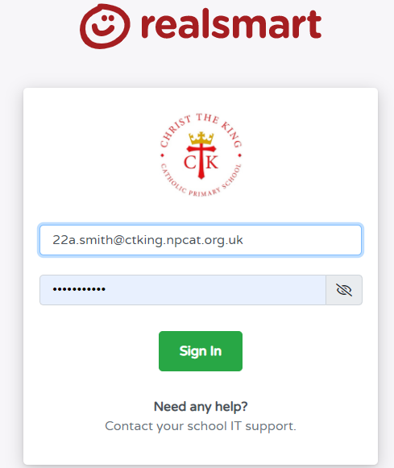

9. The children will have been assigned to a Class or Group. This will show up on their profile as soon as they have logged in. Click on the box to access any work that the teacher has set.

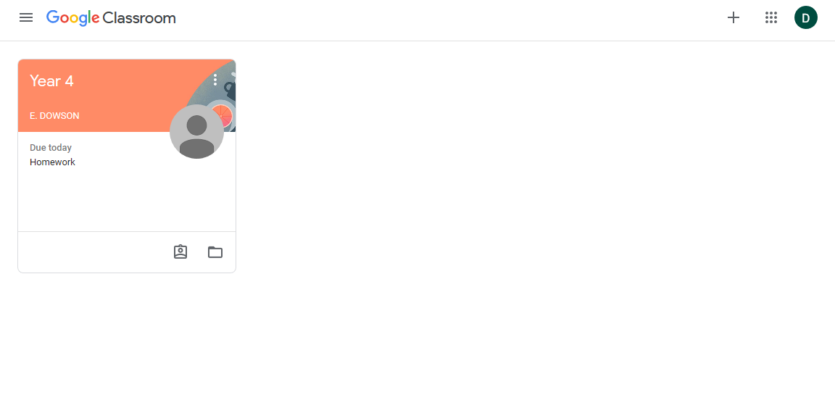

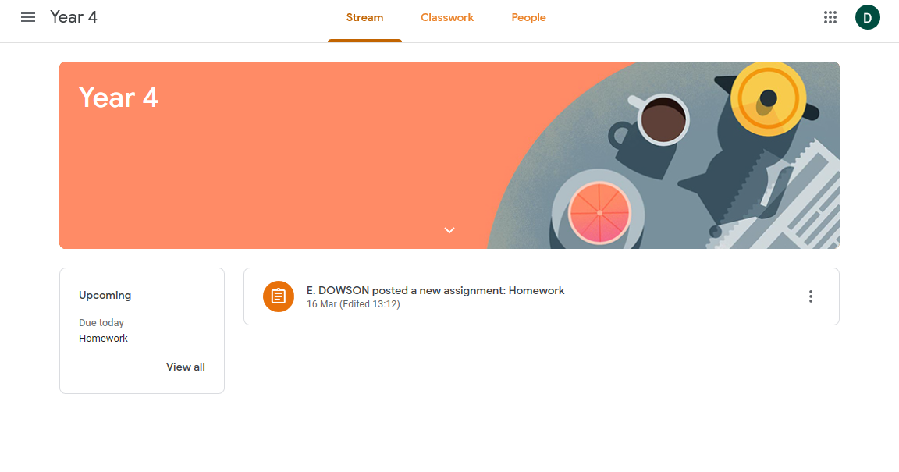
10. The activities will be listed in the order that they have been assigned by the teacher. Click on the activity that you would like to access.
10.
10. Information about what the child needs to do will be like the picture shown below:
10.

Documents that the teacher has sent to complete task
Children can add a photo or document to show the work they have completed
Instructions from the teacher
Click here when the work is finished to hand

Children can send a message to the teacher to give any answers to the work or ask questions

