Virtual Easter School Booklet.
Videos to support this work can be found at:

Day | Objective | Number Correct | Comment
1 | Addition and Subtraction | /10
2 | Multiplication and Division | /10
3 | Percentages of Amounts | /10
4 | Addition and Subtraction of Fractions | /10
5 | Multiplying and Dividing Fractions | /10
6 | Money | /6
7 | Inverse Operations | /10
8 | Properties of Number | /8
9 | Equivalent Fractions, Decimals and Percentages. | /20
10 | Recap | /10

Day 1 – Addition and Subtraction

Q1) ______ = 8,275 + 82

Q2) 5.87 + 3.123 = ______

Q3) 39 + 673 = ______

Q4) 56.38 + 24.7 = ______

Q5) 46 + 304 = ______

Q6) 7 − 2.25 = ______

Q7) 7,064 – 502 = ______

Q8) 10 − 5.4 = ______

Q9) 345 – 60 = ______

Q10) 87 – 65 = ______

Day 2 – Multiplication and Division

Q1) 9 × 41 = ______

Q2) 25.34 × 10 = ______

Q3) 785 × 23 = ______

Q4) 2,345 × 1,000 = ______

Q5) 8 × 33 = ______

Q6) 87 ÷ 3 = ______

Q7) 270 ÷ 3 = ______

Q8) 3200 ÷ 10 = ______

Q9) 180 ÷ 3 = ______
Q10) 1,210 ÷ 11 = ______

Day 3
Recap:
Q1) 24 × 86
Q2) 6 – 2.32

Day 3 – Percentages of Amounts

Q1) 20% of 3000 = ______

Q2) 35% of 320 = ______

Q3) 51% of 900 = ______

Q4) 45% of 460 = ______

Q5) 32% × 500 = ______

Q6) 20% of 1800 = ______

Q7) 6% × 250 = ______

Q8) 99% of 900 = ______

Day 4 – Addition and Subtraction of Decimals

Q1) $\frac{1}{5}+\frac{3}{4}=$ ______

Q2) $\frac{8}{9}-\frac{1}{4}=$ ______

Q3) $2\frac{1}{2}+\frac{3}{4}=$ ______

Q4) $\frac{9}{11}-\frac{2}{11}=$ ______

Q5) $\frac{4}{5}+\frac{4}{10}=$ ______

Q6)$2+\frac{2}{5}=$ ______

Q7) $3-\frac{7}{10}=$ ______

Q8) $2\frac{1}{5}-\frac{3}{4}=$ ______

Day 5
Recap:
Q1) 165 ÷ 5
Q2) 21% of 300
Day 5 – Multiplication and Division with Fractions.
Q1) $\frac{1}{4}÷2$ = ______

Q2) $\frac{4}{6}×\frac{3}{5}$ = ______

Q3) $1\frac{1}{4}of40$ = ______

Q4) $\frac{4}{5}÷4$ = ______

Q5) $\frac{5}{8}÷2$ = ______

Q6) $1\frac{1}{2}×30$ = ______

Q7) $2\frac{2}{3}of15$ = ______

Q8) $\frac{2}{5}×40$ = ______

Day 6 - Money
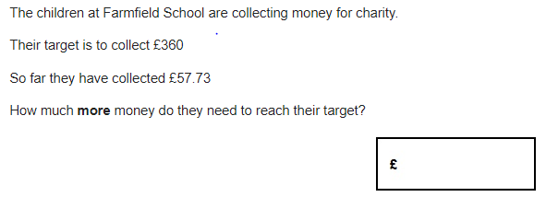
Q1)

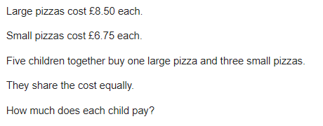
Q2)

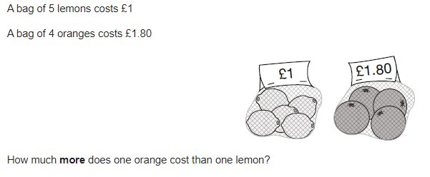
Q3)

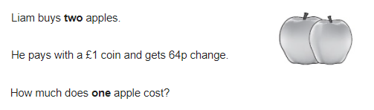
Q4)

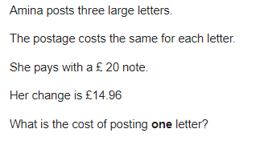
Q5)

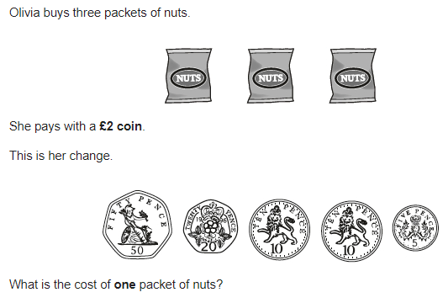
Q6)

Day 7
Recap
Q1) $1\frac{1}{2}×\frac{3}{4}$ = ______
Q2) 90% of 240 = ______
Day 7 – Inverse Operations
Q1)
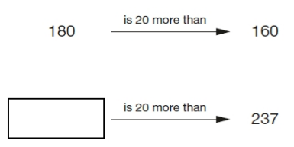
Write the missing number.
One is done for you.

Q2) Sarah had a bag of cherries.
She ate 5 cherries, then gave half of what she had left to Liam.
Liam ate 5 of his cherries, then gave half of what he had left to Amy.
Amy got 2 cherries.
How many cherries did Sarah have in her bag at the start?

Q3) Liam thinks of a number.
He divides it by 9 and then adds 25 to the result.
His answer is 36
What number did Liam start with?

Q4) Josh thinks of a number.
He adds 4
He multiplies his result by 3
Then he takes away 9
His final answer is 90
What number did Josh start with?

Q5) The numbers in this sequence increase by 14 each time.
Write the missing numbers.

Q6) Write the missing number to make this calculation correct.

Q7) Lara chooses a number less than 100
She divides it by 3 and then subtracts 11
She then divides this result by 2
Her answer is 10.5
What was the number she started with?

Day 8
Recap:
Q1) 51% of 800
Q2) 10 – 6.21
Day 8 – Properties of Number
Q1) The numbers in this sequence increase by 3 each time.
3, 6, 9, 12 . . .
The numbers in this sequence increase by 5 each time.
5, 10, 15, 20 . . .
Both sequences continue.
Write a number greater than 100 which will be in both sequences

Q2) Circle the numbers that are common factors of both 12 and 18
2 3 6 9 12

Q3) Circle the two prime numbers.
29 39 49 59 69

Q4) Put these values in order with the smallest first.
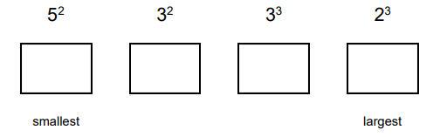

Q5) Write three factors of 30 that are not factors of 15

Q6) A number multiplied by itself gives the answer 49 Circle the number.

2 3 4 5 6 7 8 9

Q7) Find two square numbers that total 45

______ + ______ = 45

Q8) Write the two other prime numbers that multiply to make 165

______ x ______ x 5 = 165

Day 9
Recap
Q1) 1206 ÷ 9 = ______
Q2) $1-\frac{3}{8}=$ ______
Day 9 – Equivalent Fractions, Decimals and Percentages.
Complete the table, simplifying all fractions. One has been done for you.
Fraction | Decimal | Percentage
$$1/2$$ | 0.5 | 50%
 | 0.4
$$1/4$$
 |  | 35%
 |  | 80%
$$3/4$$
 | 0.08
 |  | 6%
 | 0.22
$$3/5$$
$${11}/{20}$$

DAY 10 - Recap
Q1) 4.3 + 17.84 = ______

Q2) 34 x 186 = _____

Q3) 45% of 80 = ______

Q4) $1\frac{3}{5}×\frac{3}{5}$ = ______

Q5) Amina buys some cheese that costs £1.35. Amina pays with a £2 coin.
How much change should Amina get?

Q6) $2\frac{3}{5}-\frac{1}{2}=$ ______

Q7) $\frac{3}{5}$ of 45 = ______

Q8) Liam thinks of a number. He divides it by 9 and then adds 25 to the result.
His answer is 36
What number did Liam start with?

Q9) Write down two numbers that are factors of 24 and 18. _____ & _____

Q10) $4/5$ = _____ %

