Tapestry Journal – Child’s Learning Journey and Observations.
At NCEA Trust , we use Tapestry as a way to share your child’s learning. Tapestry is an app which allows photos and observations to be shared between school and home.
When your child first begins attending, you will be asked to fill out a Tapestry permission form. We will then be able to set up an account, and start sharing your child’s learning with you. Please download the Tapestry Journal app on your phone, or you can use the website in a browser on a mobile or laptop.
Once logged in, you can view photos and observations that have been uploaded by Staff and you can also upload your own photos and observations from what your child has been doing at home.

Setting up your account.
- You will receive an email to set up your account. Click the create your password link. If you do not receive an email, please check your junk and spam email. If you still have not received an email, please check with staff.
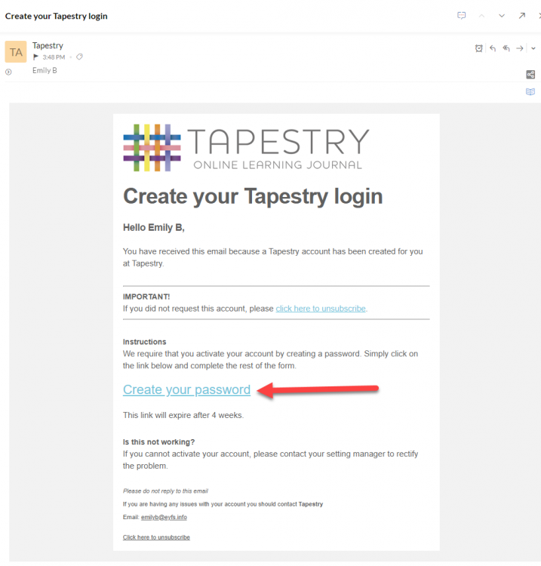

- You will be taken to a page to create your password. Your password must meet the requirements. You must also create a 4 digit number PIN.
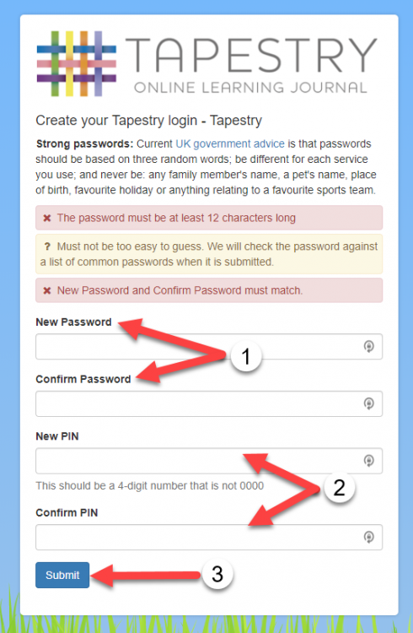

- You will then be given a screen that says you have successfully activated your account. You can now move to the App to view your observations.
Signing into the App.
- Download the app from the app store.
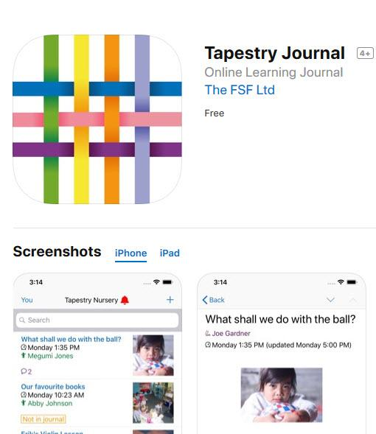

- Once downloaded, log into the app with your username and password you have just set up.
1 – Email address. 2 - Password 3 - Log in
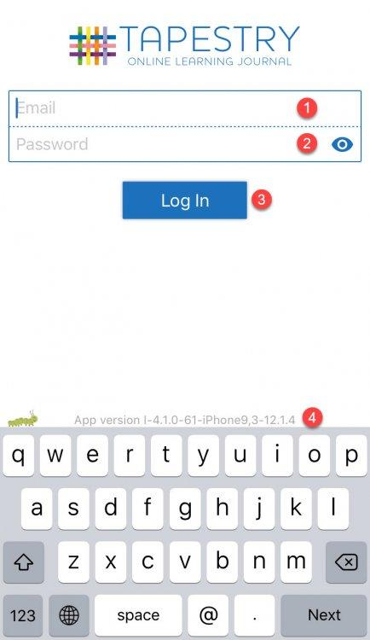

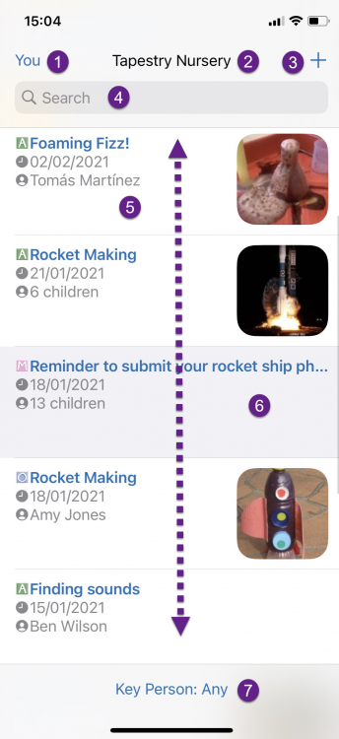
- Once you have successfully logged in you will see the interface shown. This is the main Tapestry screen.

- 'You' button: This takes you to the app settings and options screen and will allow you to go to the lock screen, change your password or PIN, and adjust other app settings.
- Notifications bell: This is visible when you have new notifications from your setting.
- Add observation button: Tap the + button to create a new observation
- Search Bar: You can search for observations.
- Main feed – this lists all of your child’s observations.

Viewing an observation
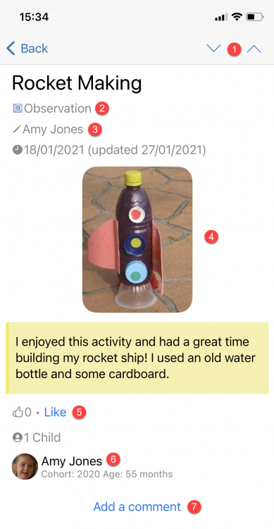
Tap the observation you want to view on the main Tapestry screen, and you will be taken to the individual view. To return to the main view just press 'Back' on your device.

- Next upload and previous upload
- Observation type
- Staff member who created observation
- Media – all videos and photos
- Like button – tap this to show you like the entry
- Child information
- Add a comment – tap this to add a comment about the observation

Adding an observation
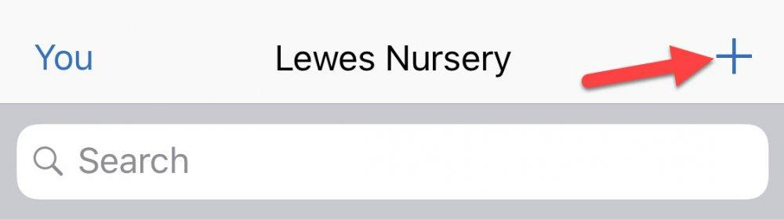
To add an observation, click the + at the top of the main page. You might like to add an observation of something your child has done at the weekend, or what they have been talking about at home.

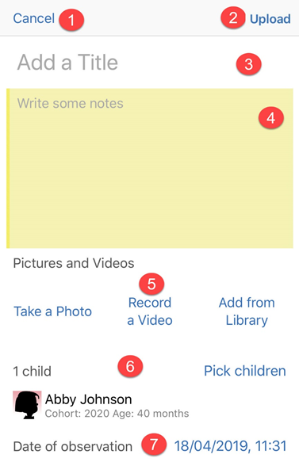
- Cancel Button
- Upload button – press this when all the information is completed.
- Add a title – you need to add a title before you can upload
- You can add text to tell us what your observation is about
- You can add pictures and media from your device. Click “add from library”
- Attach your child to the observation. You must do this before it can be uploaded.
- Date

