12th June 2024

Dear Parent/ Carer

Please find enclosed a copy of the KS5 summer mock examination timetable for all academic A Level subjects.

Please encourage and support your child at home to prepare for their upcoming exam. Teaching staff will ensure students have the materials they need to revise from. This is a great opportunity for students to assess their progress and will help them to identify their strengths and weaknesses in the topics covered. The results will also be used to ensure students are progressing onto the right courses in Year 13.

As a reminder, exam board guidelines say that students taking A-level subjects should be carrying out at least 3-5 hours independent study per subject per week.

Independent study can consist of:

·       Re-reading and re-writing class notes

·       Using notes to make mind maps or flash cards

·       Organising files

·       Carrying out additional reading or research

·       Attempting past paper questions (accessible through all exam board websites)

Thank you for your ongoing support.

Yours sincerely

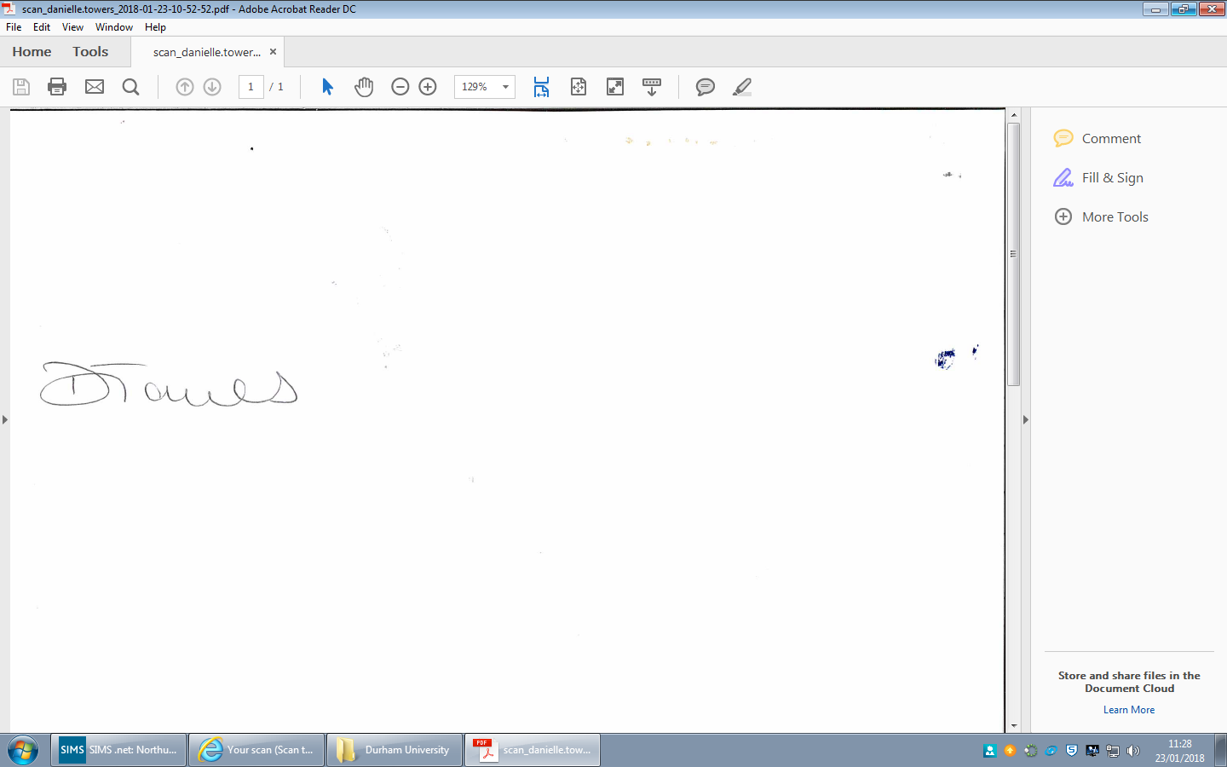

Mrs. D Towers

Head of Sixth Form & Careers