Dear Parent / Carers

Return to School Dates September 2021

Those students where consent to the Lateral Flow Test has been received will need to come to school to receive their test on the dates and times allocated to their year group as shown below.

Once students have received their test they will be able to return home, no school uniform is required for that day.

All student’s official return to school date is also in the table below.

Yr Group | Day / Date of Lateral Flow Test | Return to School Date / Full Uniform | Start Time
Y10 | Monday 6 Sep 2021 at 11.00am | Tuesday 7 Sep 2021 | 8.40am
Y7 | Monday 6 Sep 2021 at 1.00pm | Tuesday 7 Sep 2021 | 8.40am
Y8 | Tuesday 7 Sep 2021 at 9.00am | Wednesday 8 Sep 2021 | 8.40am
Y9 | Tuesday 7 Sep 2021 at 11.00am | Wednesday 8 Sep 2021 | 8.40am
Y11 | Tuesday 7 Sep 2021 at 1.30pm | Wednesday 8 Sep 2021 | 8.40am

Yours sincerely
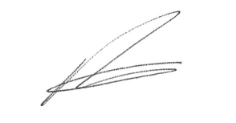
R Atkinson
Principal

