Dear Parent/Carer

Year 11 Parents’ Evening – Wednesday 13 November 2019

I am writing to inform you that there will be a Year 11 Parents’ Evening on Wednesday 13 November 2019 between 4.30pm and 6.30pm.

The Parents’ Evening will give you the opportunity to:-

- Discuss your son/daughter’s progress including his/her expected and current grades.
- Discuss any concerns you may have regarding specific subjects.
- Speak to the Key Stage Team.
The following organisations will also be present should you require any advice or guidance on higher education, careers or apprenticeships:
- FutureMe
- NCC Careers Advice
- Apprenticeship Agency

There are no specific appointment times. You will be given a sheet with the list of staff who teach your child. Please note, in order for you to have enough time to visit all of your child’s teachers, please arrive no later than 6.15pm.

It is vital that you attend and we look forward to seeing you. Please return the attached slip to the Admin Office no later than Wednesday 5 November in order for us to have your child’s information to hand upon your arrival. If you require any further information please do not hesitate to contact us.

Yours sincerely
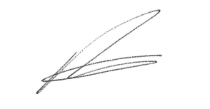
R Atkinson
Acting Principal

Duke’s Secondary School

Year 11 Parents’ Evening Reply Slip – 13 November 2019

Students Name ……………………………………………… Form ……………………

I will/will not be attending on Wednesday 13 November 2019

Signed: ………………………………………………………………..…. Parent/Carer

PLEASE RETURN TO THE ADMIN OFFICE

