Year Group  Reception | Autumn 1 (8)  Exploring the classroom and outside areas  Becoming familiar with new teachers and friends |  | Autumn 2 (7)  Walk around the local area, taking photos and creating maps. | Spring 1 (6)  Visit: Metro journey?  Visitors: Bike ability? | Spring 2 (6)  Visit:  Orchard? Fruit picking?  Broxfield Farm | Summer 1 (5)  Visit: Space exhibitions in museums? | Summer 2 (7)  Visitors:  NUFC – keeping healthy?
Theme | Who is Super? |  | Where do I live? | Why are tyres round? | Can I grow my imagination? | How can we look after our planet? | What makes you run fast?
Enquiry | How do you feel?  Do you have to be a Superhero to help people?  What is special about you?  God as Creator  Which occupations are based on helping others?  What can your body do (senses and movement)? |  | Where do I live?  Could the witch live in England?  How is Rama and Sita’s home different to mine?  Do koalas and polar bears live in the same place?  Where does God Live?  Where was Jesus born? | How do I get to school?  Can I build a bike with construction toys?  How can I get to China?  How did people travel a long time ago? | What can I grow?  Which creatures are real?  Where do fairies live?  What can I imagine?  How do things change as they grow?  What do plants and animals need to be able to grow? | What is good/ bad for the planet?  What are alien words?  How can we look after our Earth?  Could we live on another planet?  What is Space like? | How can I be safe in the summer holidays?  What do I need to do and to consume, to be healthy?  How do you learn to run fast?  What are the Olympic Games?
Topic Story  Stimulus | Super Duper You  Think Big  The Lion inside (C of EL)  The Good Samaritan (RE) |  | Room on the Broom  Divali (Sat 14th Nov) (RE)  You Choose  The Koala Who Could (C of EL)  Snow Bear’s Surprise  Nativity (RE) | The Jolly Postman  Follow That Map (non fiction)  Noah’s Ark (RE) (C of EL)  Chinese New Year (Friday 12th February) (RE) | Zog  Jack and the Beanstalk  Egg Drop  Easter (Sunday 4th April) | Whatever Next  Somebody swallowed Stanley  Look up/ Clean up | Oliver’s fruit/ vegetables  Now wash your hands  The Gingerbread Man
Poetry | Nursery rhymes  The Poetry Basket (Autumn poems) |  | Number rhymes e.g 5 currant buns  Christmas poems | The Poetry Basket  (spring poems) | Imaginative/ monster poem | The Poetry Basket  (summer poems). | Food poems
Non Fiction | Information: Different jobs people do. |  | You Choose – information recording Local area (Lynemouth)) | Follow that map  labels | Instructions: how to grow a beanstalk | Posters-looking after the environment | Recount/ News report:The Gingerbread man
Reading Focus Intent:
The more that you read, the more that you will know. The more that you learn the more places you will go.
Dr Seuss
We want to develop a love of reading in every child’s mind set through a story -based curriculum. We strive to offer along with this first- hand experiences that enhance their understanding about what they read and what is read to them so that they understand the world around them.
Characteristics of Effective Learning Progression – story focus.
 | Playing and Exploring. |  |  | Active Learning |  |  | Creating and Thinking Critically
Reading spine for Reception to encourage effective learning. |  | I like to explore, just like the ‘Bear Hunt’ family.  I like to try new things, like The Very Hungry Caterpillar.  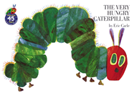  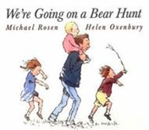 | We like to use our  imaginations to pretend, just like Baby Bear.  Mrs Large has a ‘can do’ attitude. We keep going even when things get tough!  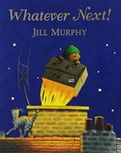  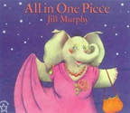 | Gerald kept trying and never gave up.  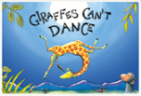  We do too! | Like Harry, I like meeting challenges for their own sake: I’m proud of how I achieve things.  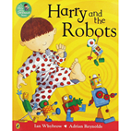 | I’m not easily distracted. Just like the ladybird, I show attention to details.  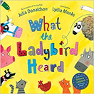 | We try different ways of doing things, like Mr Bear in Peace at Last.  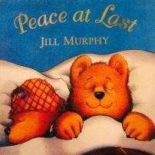  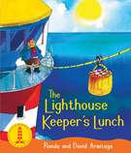  I test out my ideas and make links in my learning like Mr and Mrs Grinling.
EYFS Progression  7 areas | Autumn 1 |  | Autumn 2 | Spring 1 | Spring 2 | Summer 1 | Summer 2
Listening, Attention and Understanding | Can show some listening skills  Follow simple instructions  Initiate conversations with peers in their play  I know when to ask for help  Respond to stories that are read to me through gesture and facial expression |  | Listen with more interest and respond to stories with refrains.  Describe where something is using prepositions  I talk about home, other people in my world and characters in familiar stories. | I can show my understanding during an activity  I can Iisten to simple instructions so that I complete an activity  Understand some humour | Listen attentively in different situations  Able to follow a story without pictures or props  Beginning to Understand how and why questions but find what questions easier to answer. | Listens to stories and responds to peers ideas  Listen to more complex instructions  Able to express themselves being aware of the listener  I offer reasons and explanations in response to how and why questions. | - Listen attentively and respond appropriately when being read to and during whole class discussions and small group interactions;  Make comments about what they have heard and ask questions to clarify their understanding;  - Hold conversation when engaged in back-and-forth exchanges with their teacher and peers.
Speaking | Can talk about what has happened  I use talk to engage others and share my thoughts and experiences  I join in with familiar rhymes and show an interest in favourites. |  | Using and/because in sentences  Use new language to support role play  I take turns to talk in a smaller group  I play with rhyming words in whole class and group situations  I use talk to sequence, organise and clarify my ideas. | Ask questions  Extend vocabulary and use new vocabulary in role play and other play situations.  I take turns to talk in a larger group with a prop to support turn taking in conversation.  I experiment with words that rhyme in my talk  I can talk about what will or might happen.  I order sequences of information into an order which makes sense to a listener. Longer descriptions and recounts may still be jumbled. | Use intonation  Link statements in an organised way  I take turns in conversations and alter what I say according to what the other person has said.  I sequence information in longer sentences in explanations and recounts. | Respond to ideas of others  Use tenses correctly.  Create a personal narrative.  I respond well to questions that need me to explain when something is going to happen. I use terms such as last week, tomorrow and yesterday. | Participate in small group, class and one-to-one discussions, offering their own ideas, using recently introduced vocabulary;  - Offer explanations for why things might happen, making use of recently introduced vocabulary from stories, non-fiction, rhymes and poems when appropriate;  - Express their ideas and feelings about their experiences using full sentences, including accurate use of past, present and future tenses and making use of conjunctions, with modelling and support from their teacher.
Personal, Social and Emotional | Forming good relationships and including others in play i.e. sharing and turn taking.  Selecting own resources  Communicating with peers and listening  Being aware of boundaries and class rules  I put my own coat on and can make lunch time choices. I can separate from my parents. I can wash my hands. Turn attention to familiar instructions that are given. |  | Explains their own knowledge and asks questions.  Takes on responsibility  Confident in different social situations such as intervention groups, assemblies and library time.  I have a go at new activities  I understand expectations of behaviour when moving around school and working in other areas such as the library.  I can talk about my preferences relating to snack and lunch. I can name some healthy foods.  I can dress and undress myself for PE. | Find a compromise with peers  Confident to speak about their own needs and opinions  Understand the impact of their actions on others  I embrace new experiences and begin to show perseverance when working on an activity or challenge. I can express my own needs. I can practise a wider range of hygiene measures such as using a tissue, coughing into my elbow. | Take turns  Express preference of activity with reasoning  Know that some behaviour is unacceptable  I can work independently on an activity and overcome challenge when I face it.  I acknowledge the needs of others.  I begin to talk about healthy meals and how this helps to make me healthy. | Include others ideas in their activities  Can say when they need or don’t need help  Adjust their behaviour to different situations and can adapt with a new routine. follow more than one instruction and focus attention to what is being asked. I understand the importance of healthy teeth. I know that some foods are better for me than others. | Be confident to try new activities and show independence, resilience and perseverance in the face of challenge;  - Explain the reasons for rules, know right from wrong and try to behave accordingly;  - Manage their own basic hygiene and personal needs, including dressing, going to the toilet and understanding the importance of healthy food choices.  - Work and play cooperatively and take turns with others;  - Form positive attachments to adults and friendships with peers;  - Show sensitivity to their own and to others’ needs.
Physical Development  (gross and fine Motor) | Moves freely using suitable spaces and speed  Draws lines and circles  Dresses with support  Knows equipment needs to be used safely  I can complete a threading card and operate nuts bolts and washers. I can use tweezers and tongs to complete a sorting activity. Write some letters and write my name. |  | Move freely in a variety of different ways  Use scissors and other tools safely  Show a dominant hand  Make anticlockwise movements  Stand on one foot  Catch a ball  I track objects, pictures and text with my finger from left to right.  Write more letters and copy print. Such as I can write my friends name from their drawer label or use a key word mat to help label my picture. | Experiment with different ways of moving and jumps and lands safely.  Manages own risk  I hold a pencil using a conventional grip.  I can button and unbutton. I cut on a line continuously  I can write set 1 letters and begin to control the size of my letters. | Good control and coordination in large and small scale movement  I copy triangles, squares and other simple shapes.  I can form and write most letters accurately and control the size of my writing. | Demonstrates increasing control over objects  Use tools to change materials  Move confidently  I can trace with detail.  I coordinate shoulder, wrist and finger movements to write, moving across and down the page. | Negotiate space and obstacles safely, with consideration for themselves and others;  - Demonstrate strength, balance and coordination when playing;  - Move energetically, such as running, jumping, dancing, hopping, skipping and climbing.  Hold a pencil effectively in preparation for fluent writing – using the tripod grip in almost all cases;  - Use a range of small tools, including scissors, paint brushes and cutlery;  - Begin to show accuracy and care when drawing.  Sports and physical activities using a variety of equipment.  Move confidently in a range of ways, negotiating space.  Handle tools effectively, especially for writing
Writing | Give meaning to the marks they make. |  | Write own name and simple captions  Write simple words | Write own name and captions  Write simple words by identifying the sounds in them and attempt to write sentences with support. | Attempts to write short sentences independently in meaningful contexts and show awareness of finger spaces. | Writing some irregular common words  Write sentences that can be read by others and are phonetically plausible. | Write recognisable letters, most of which are correctly formed;  - Spell words by identifying sounds in them and representing the sounds with a letter or letters;  - Write simple phrases and sentences that can be read by others.
Comprehension | Have some favourite rhymes, poems and stories |  | Know that a story has a beginning middle and end | Be able to explain what happens first next and finally in a story that they are familiar with. | Recall key events in a story and show an interest in new vocabulary that they are exposed to. | Anticipate some events  Use new vocabulary in my play  Retell stories using props | Demonstrate understanding of what has been read to them by retelling stories and narratives using their own words and recently introduced vocabulary;  - Anticipate – where appropriate – key events in stories;  - Use and understand recently introduced vocabulary during discussions about stories, non-fiction, rhymes and poems and during role-play.
Reading  RWI | Being aware of alliteration and rhyme.  Aware of the structure of stories  I know that there is a word within a longer word, eg foot in football. Orally blend CVCC/ CCVC words, eg hand/flag |  | I can sort by short initial phonemes.  I can detect the word that is an odd one out in alliterative rhyming word string. Begin to read simple words  CVC CVCC/CCVC  Set 1 sounds and word time 1 2 3 4 5 | I generate a string of alliterative words or suggest an idea when you make a mistake. I independently sort by long or short initial phonemes.  Predict stories  Describe different elements in stories  Continue a rhyming string  Use storylines in role play  Use phonics to decode and begin to read words consistent with their phonic knowledge. | I identify all final phonemes.  Children begin to read and understand simple sentences.  Use phonic knowledge to decode. They begin to learn digraphs.  Set 1 word time 6 7 ditties | Demonstrates understanding of what they have read and understand that information can be retrieved from books and computers/ I Pads. They can read at least 5 digraphs. | Say a sound for each letter in the alphabet and at least 10 digraphs;  - Read words consistent with their phonic knowledge by sound-blending;  - Read aloud simple sentences and books that are consistent with their phonic knowledge, including some common exception words.  Set 2 green purple books
Mathematics  (White Rose progression)  https://whiterosemaths.com/resources/schemes-of-learning/reception-sol/ | Use and show an interest in number during play  Place value – numbers to three, representing them indifferent ways  sorting sets  Subitising objects |  | Place value – comparing groups  Addition and subtraction – change within 5.  Measurement – time/ seasons. Day and night  Circles and triangles  shapes with 4 sides | Addition and subtraction – numbers to 5  Place value – numbers to 10 | Addition and subtraction to 10  Geometry - shape | Geometry – exploring patterns  Addition and subtraction – count on and count back  Place value numbers to 20 | Have a deep understanding of number to 10, including the composition of each number;  - Subitise (recognise quantities without counting) up to 5;  Automatically recall (without reference to rhymes, counting or other aides) number bonds up to 5 (including subtraction facts) and some number bonds to 10, including double facts.  Count on and back to solve addition and subtraction  Doubling and halving  Count confidently beyond 20, recognising the pattern of the counting system;  - Compare sets of objects up to 10 in different contexts, considering size and difference;  - Explore and represent patterns within numbers up to 10, including evens and odds, double facts and how quantities can be distributed equally.
Understanding the world | Comments about what they have seen / discovered in the world  Understand growth and decay  Show concern for living things  Have some favourite story characters |  | Understand recognise and describe special events and join in with them.  Understand changes in weather and seasons.  Have a good understanding of where they come from and own culture. | Knows that information can be found from a computer  Completes a simple programme on a computer  Investigates toys that use ICT or have moving parts  Recall key characters from stories explored  Know about some other cultures and religions  Shows an interest in maps | Look at patterns and change in the environment  Understand that technology is all around us  Shows an awareness of similarities and differences between different communities, cultures and religions. | Explore changes in things that grow and record findings. Encourage children to make predictions and evaluate outcomes and talk about processes.  Talks about places that surround Ashington ie Northumberland , Newcastle and know some key figures relating to those areas. Such as Grace Darling. | Talk about the lives of the people around them and their roles in society;  - Know some similarities and differences between things in the past and now, drawing on their experiences and what has been read in class;  - Recall some important narratives, characters and figures from the past encountered in books read in class.  Describe their immediate environment using knowledge from observation, discussion, stories, non-fiction texts and maps;  - Know some similarities and differences between different religious and cultural communities in this country, drawing on their experiences and what has been read in class;  - Explain some similarities and differences between life in this country and life in other countries, drawing on knowledge from stories, non-fiction texts and – when appropriate – maps.  Explore the natural world around them, making observations and drawing pictures of animals and plants;  - Know some similarities and differences between the natural world around them and contrasting environments, drawing on their experiences and what has been read in class;  - Understand some important processes and changes in the natural world around them, including the seasons and changing states of matter.
Expressive arts and design | Learning new songs  Simple construction  Using simple tools  Familiar role play |  | Moving to music  Exploring colour/texture to make pictures  Explore the sounds that instruments make  Join in with a wider variety of role play | Repeated rhythms  Move to music  Learn a wider variety of songs  Construct with a purpose.  Express themselves in art/ drama or dance | Create different textures  Select a wider range of tools  Introducing storylines in their play | Adapting work when necessary  Develop a narrative  Experiment with different textures  Children creating their own songs and adding their own music  Create their own art pieces and explaining them Represent their own ideas, thoughts and feelings through design and technology, art, music, dance, role-play and stories. | Draw and paint using a range of materials, tools and techniques, experimenting with colour, design, texture, form and function;  - Share their creations, explaining the process they have used;  - Make use of props and materials when role playing characters in narratives and stories.  Invent, adapt and recount narratives and stories with peers and their teacher;  - Sing a range of well known nursery rhymes and songs;  - Perform songs, rhymes, poems and stories with others, and – when appropriate – try to move in time with music.

Curriculum
In order to develop our Early Years curriculum we have used a range of sources to determine the right progression of skills for children at Bishops Primary School. The skills have been carefully sequenced and tailored to the needs of our children and the skills that we recognise they need in order to meet the ELG and be ready for KS1 at the end of Reception. It is sequenced from our 2 year old provision through to the end of Reception and we have used the expertise of our EYFS team to decide on the content. On each campus, staff work together to develop topic enquiries that use stories as a stimulus to the declarative knowledge we feel is important for our children to learn and embed during their time spent in our EYFS. This may differ from campus to campus due to differing needs and localities of our schools, but have all been developed with our EYFS and whole school vision in mind.

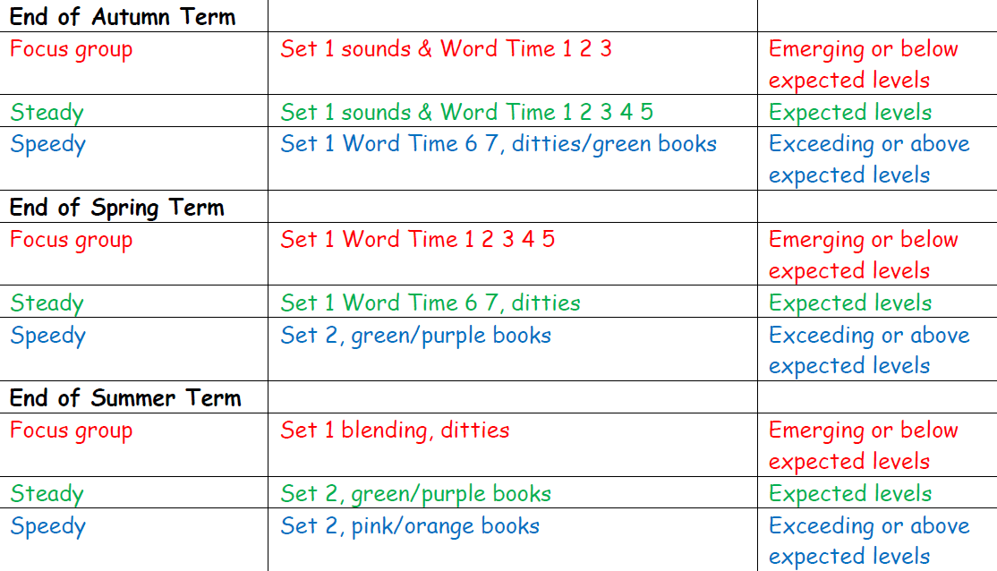
Reception RWI progression – Emerging, Expected and Exceeding

