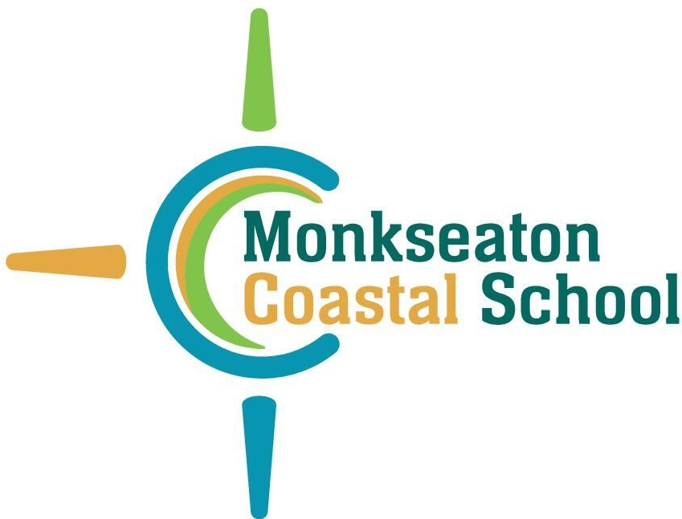

Monkseaton Coastal School

IN-YEAR APPLICATION FORM

Please read the School’s Admission Policy which is published its website before completing this form.

In education law, the definition of a ‘parent’ includes the biological parents irrespective of residence, contact or parental responsibility, as well as other persons with care of and/or parental responsibility for the child. Only one parent’s details must be stated in this form.

The application will be processed and the outcome notified within a maximum of 15 school days of receipt.

PART A – CHILD’S DETAILS:

Full legal name:

Date of birth:

Current age

Home address:

(see Admission Policy for definition)

PART B – PARENT’S DETAILS (one parent only):

Full legal name:

Address:

([if different to the child’s address)

Email address:

Contact number:

PART C – OVERSUBSCRIPTION CRITERIA

(Please refer to the Admission Policy for definitions and/or other requirements before answering the questions below)

1 | Is the child a looked after or previously looked after child: | Yes |  | No
2 | Does the child live in the catchment area of Monkseaton Middle School? | Yes |  | No
 | See the Catchment Area Map published on the School’s website to confirm.
3 | Does the child have a sibling at Monkseaton Middle School at the time of application who will still be on the roll at the time of their admission? | Yes |  | No
 | If ‘yes’, complete the information below:
 | Sibling’s full name:
 | Sibling’s date of birth:

PART D – SIGNATURE AND DATE

Signed:

Date:

This completed form and any supporting documents must be sent or hand-delivered to:

Admissions Manager, Monkseaton Coastal School, Vernon Drive, Monkseaton, Whitley Bay, Tyne and Wear, NE25 8JW

or by email: admin@monkseatoncoastalschool.org

