Turn in an assignment on a Computer
You can attach one or more files to your work.
- Go to classroom.google.com.
- Click the class > Classwork.
- Click the assignment > View assignment.
- To attach an item:
  - Under Your work, click Add or create > select Google Drive Link , or File .
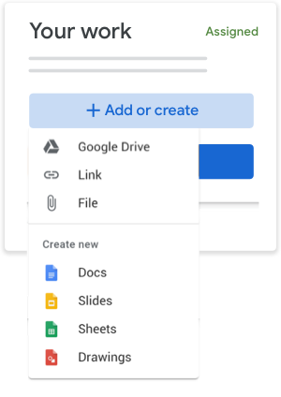
  - Select the attachment or enter the URL for a link and click Add.
- (Optional) To remove an attachment, next to the attachment's name, click Remove .
- (Optional) To add a private comment to your teacher, under Private comments, enter your comment and click Post .
- Click Turn In and confirm.
The status of the assignment changes to Turned in.
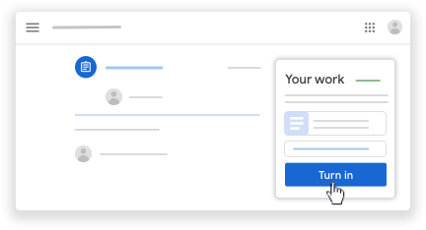
Important: If you get an error message when you click Turn in, let your teacher know.

Turn in a quiz assignment
- Go to classroom.google.com.
- Click the class > Classwork.
- Click the assignment > View assignment.
- Click the form and answer the questions.
- Click Submit.
If the form is the only work for the assignment, the status of the assignment changes to Turned in.
- If there's more work to do for the assignment, click Open assignment.

Turn in an assignment with a doc assigned to you
If your teacher attached a document with your name in the title, it’s your personal copy to review and edit. As you work, your teacher can review your progress before you click Turn in.
- Go to classroom.google.com.
- Click the class > Classwork.
- Click the assignment > View assignment.
- Click the image with your name to open the assigned file.
- Enter your work.
- On the document or in Classroom, click Turn in and confirm.
The status of the assignment changes to Turned in.
Important: If you get an error message when you click Turn in, let your teacher know.

Mark an assignment done
Important: Any assignment turned in or marked done after the due date is recorded as late, even if you previously submitted the work before the due date.
- Go to classroom.google.com.
- Click the class > Classwork.
- Click the assignment > View assignment.
- (Optional) To add a private comment to your teacher, under Private comments, enter your comment and click Post .
- Click Mark as done and confirm.
The status of the assignment changes to Turned in.

