**Turn in an assignment on an iPhone or iPad.**

You can attach one or more files to your work.

1. Tap Classroom 
2. Tap the class > **Classwork** > the assignment.
3. On the **Your work** card, tap Expand .

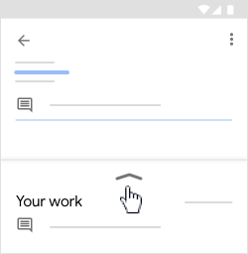

1. To attach an item:
2. Tap **Add attachment.**
3. Tap Drive , Link Link, File ,  Pick photo , or Use camera .
4. Select the attachment or enter the URL and tap Add.
5. To attach a new doc:
6. Tap **Add attachment.**
7. Tap New Docs, New Slides, New Sheets, or New PDF.

* For a new document, presentation, or spreadsheet, enter your information and tap Done
* A new PDF opens as a blank file where you can [write notes or draw images](https://support.google.com/edu/classroom/answer/7080036) on it. When you're done, tap Save.

Note: You can attach or create more than one file.

1. (Optional) To remove an attachment, tap Remove X and confirm.
2. (Optional) To add a private comment to your teacher,  tap **Add private comment** >enter your comment > tap Post .
3. Tap **Turn In** and confirm.

The assignment status changes to **Turned in.**

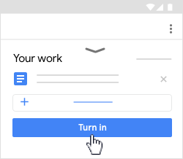

Turn in a quiz assignment on an iPhone or iPad.

1. Tap Classroom 
2. Tap the class > **Classwork** > the assignment.
3. Tap the quiz file and answer the questions.
4. In the form, tap **Submit**.
5. In Classroom, tap **Mark as done** and confirm.  
   The status of the assignment changes to **Turned in.**

