Turn in an assignment on an Android Device

You can attach one or more files to your work.
- Tap Classroom
- Tap the class > Classwork > the assignment.
- On the Your work card, tap Expand .
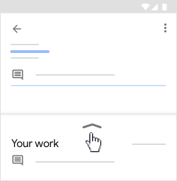

- To attach an item:
  - Tap Add attachment.
  - Tap Drive Link , File , Take photo , or Record video
  - Select the attachment or enter the URL and tap Select.

Note: You can attach or create more than one file.

- (Optional) To remove an attachment, tap Remove X and confirm.
- (Optional) To add a private comment to your teacher, tap Add private comment > enter your comment > tap Post .
- Tap Turn In and confirm.
The assignment status changes to Turned in.

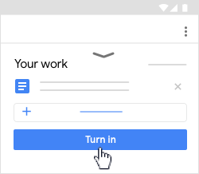

Turn in a quiz assignment on an Android device
- Tap Classroom
- Tap the class > Classwork > the assignment.
- On the Your work card, tap Expand ∧ .In the quiz, tap Submit.
- In Classroom, on the Your work card, tap Expand ∧.

- (Optional) To add a private comment to your teacher, tap Add private comment > enter your comment > tap Post .
- Tap Mark as done and confirm.
The assignment status changes to Turned in.
