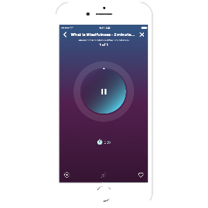
How to look after yourself (and keep busy!) whilst school is closed:
Apps for wellbeing & organisation:
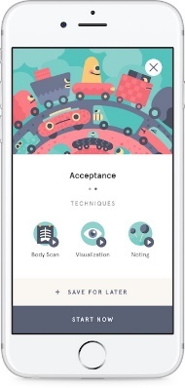
Headspace/Calm/Smiling Mind
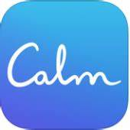
These apps provide daily meditations which will help to calm any anxieties. Just 10 minutes a day is proven to help clear your mind. This could help to mark a transition between your virtual school day and your own free time in the evening.
Calm also provide a series of ‘sleep stories’ to help you unwind before you go to bed.

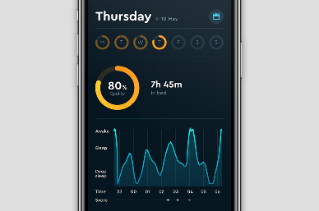
Sleep Cycle
It’s so important to get plenty of sleep and go to bed at a sensible time whilst you’re off school! This app tracks the quality of your sleep and will wake you up in the lightest part of your sleep cycle, making you less groggy in the mornings!
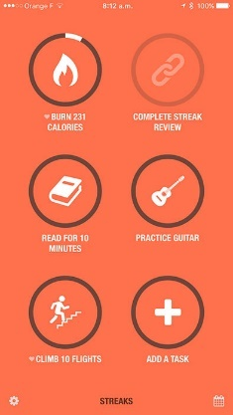

Streaks
Streaks is a to-do list that helps you form good habits and holds you accountable to your goals. The app allows you to track up to twelve tasks you want to complete each day and the goal is to build a streak of consecutive days.
Plant Nanny
Keeping hydrated is really important. This app makes tracking your daily water intake slightly more fun by prompting you to have a drink every time your plant needs to be watered.

Offtime or AppBlock
These apps allows you to block your biggest distractions – social media, games or text messages, for a set amount of time. It might be useful to download this and use it whilst you are accessing your lessons virtually.
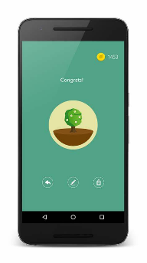
Forest
Watch a tree grow in the time that you don’t use your phone!

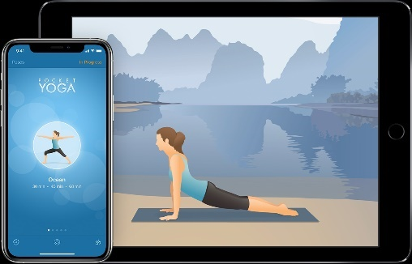
Exercise:
As well as Mrs Floyd’s virtual Games programme, these apps can help you to make sure that you undertake regular exercise throughout your week.
Pocket Yoga – allows you to practice yoga on the go and can be streamed to a number of devices.
Yoga with Adriene (on youtube) is also a great way to set yourself challenges – there are lots of 30 day tasks!
The Body Coach TV – a free channel on youtube with a number of 20/30 minute high intensity workouts
Couch to 5K – great for anyone who wants to get better at running (and out of the house, but only for a limited time!)
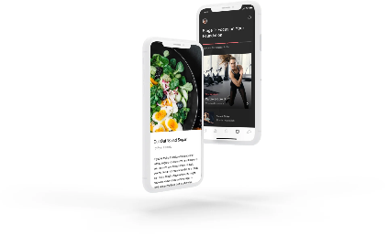
Nike Training App – a number of workouts, devised by personal trainers.

Books:
These are some of the most highly rated books for young people. Look to find these in second hand bookstores or at the library. You could probably borrow them on kindle if you have a membership too.
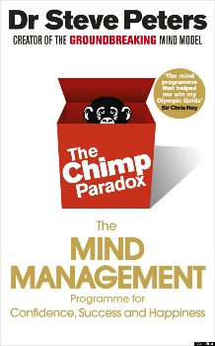
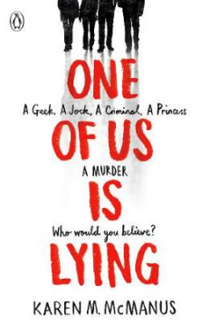
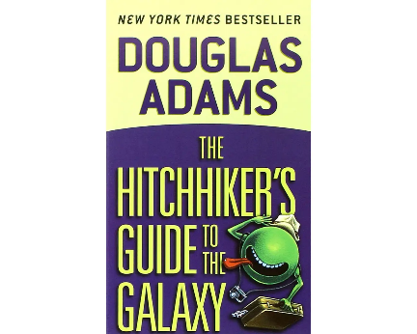
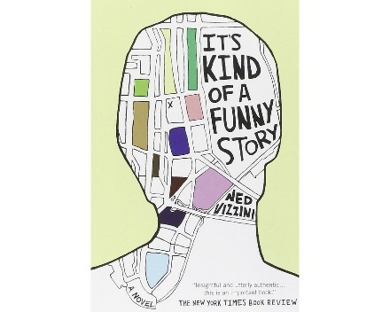

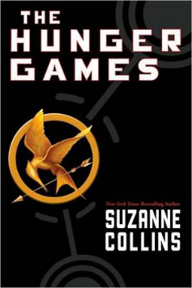
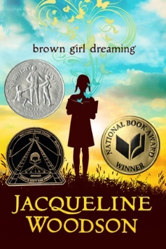
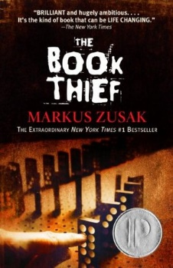
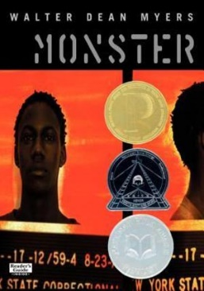

Podcasts
BBC Sound
Radio, music & podcasts, all in one app!

The Psych Files - https://thepsychfiles.com/ - podcasts on a number of different topics
Radio 4 - https://www.bbc.co.uk/programmes/p02nrss1/episodes/downloads

Other opportunities:
https://www.open.edu/openlearn/free-courses - study something new for free with the Open University
Practice playing an instrument – you could really improve over the next few weeks. If you don’t yet play an instrument, why not learn one?
Tour a virtual museum! https://www.top10.com/virtual-museum-tours
Check out Cokethorpe Art on Pinterest for a variety of projects that you can do at home

Practice (or learn!) a language:
Lyricstraining , Learn Spanish Podcast – Espanol and Audiria are all useful apps to help you practice your Spanish.
https://www.marmiton.org/ - learn to cook in French!
Learn about news and culture - https://www.newsinslowfrench.com/ or https://www.newsinslowspanish.com/
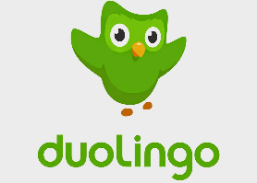
Duolingo – learn as many different languages as you can!

