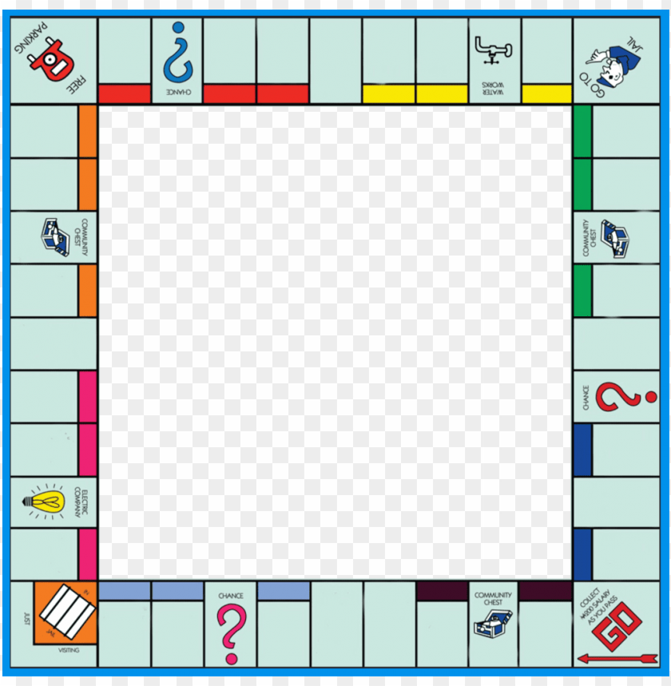

**Monopoly Fitness:**

The aim of the game is to get around the board in the shortest length of time possible.

You can play against yourself (eg set a time and then try to beat it) or with a parent/sibling.

How to play:

You will need a stopwatch (most phones have one of these).

You are to complete each exercise on the board and time how long each exercise takes you to complete.

You then need to write the time down.

At this point, you rest – if playing against yourself have 30 seconds rest before starting the next exercise, if playing against someone else you rest whilst they take their turn.

You then complete the next exercise on the board, until you have completed the entire board.

If playing against yourself, add up all of your times. Repeat the board again another day and see if you can get complete the board in less time!

If playing against someone else, add up your own time and then add up their time. Whoever got the shorter time is the winner!