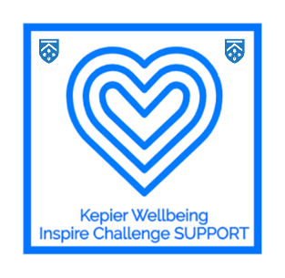
Learner Wellbeing at Kepier

What are we doing as a school to support learner wellbeing?
- Kepier learner website page including:
- Themed weekly resources
- General knowledge quiz
- Designated page for year 7 and 8 and Year 9 and 10
- Parent page
- Question submission page
- Assemblies
- Wellbeing/PSHCE resources
- Weekly Newsletter posted on the website and Facebook pages
- A learner wellbeing Instagram page
- A parental updates/resources
- Coach contact every two weeks

The new website page – How do you find it?
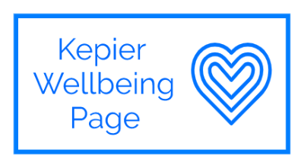
Take a look at the new web page on the kepier site -
Learners can access all resources through their real smart login on the learner hope page – look for the following image and it will take you to everything you need.
Parents

Parents/Carers can access the specific resources via www.kepier.com/wellbeing

Our Wellbeing Instagram page and daily programme

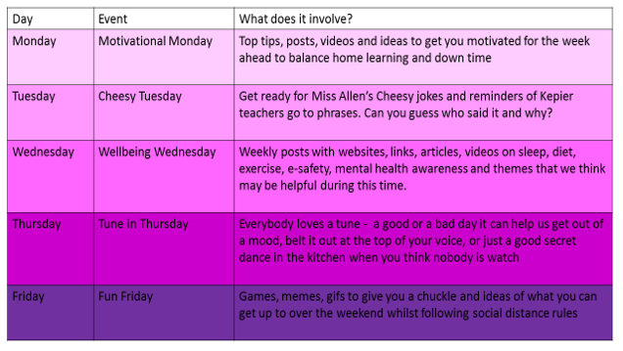
www.instagram.com/kepierwellbeing

