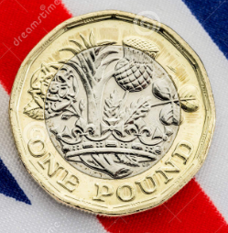
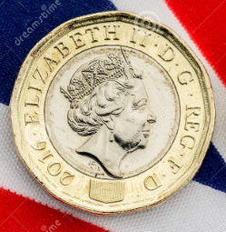

20 star JUMPS | 15 MMOUTAIN CLIMBS
20 PRESS UPS | 10 BURPEES
20 SIT UPS | 60 SECOND PLANK
20 SQUATS | 30 JUMPING SQUATS
20 TRICEP DIPS | 30 TRICEP DIPS
40 HIGH KNEES | REST
20 LUNGES | 20 JUMPING LUNGES
10 PRESS UP SHOULD TAPS | 20 PRESS UP SHOULDER TAPS
10 BOX PRESS UPS | 10 WALK OUT PRESS UPS
REST | 60 HIGH KNEES

