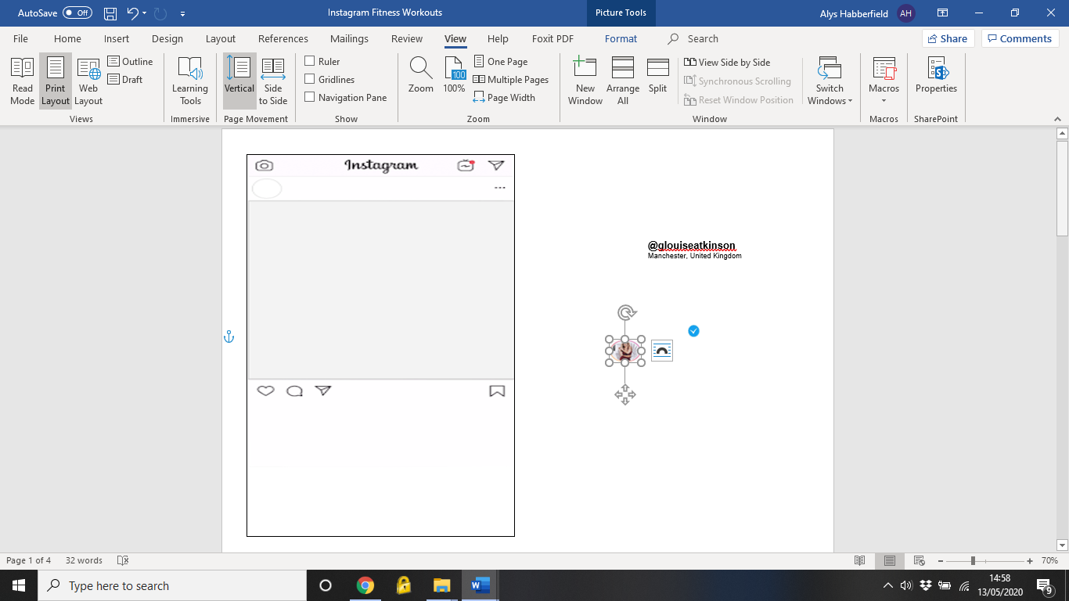

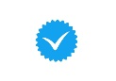

**@mynameisjessamyn**

North Carolina, USA

**@amandabisk**

Perth, Western Australia

Woman in Lotus Position: Medium-Light Skin Tone Emoji (U+1F9D8, U+ ...

Yogability

Downward Dog

Standing Forward Fold

Garland Pose

Crescent Lunge

Pigeon Pose

Eye of The Needle Pose

Hold each pose for 1 minute. After 30s breathe deeply and try and push further into the pose for a greater stretch. Complete twice

#namaste #flexibility #mobility

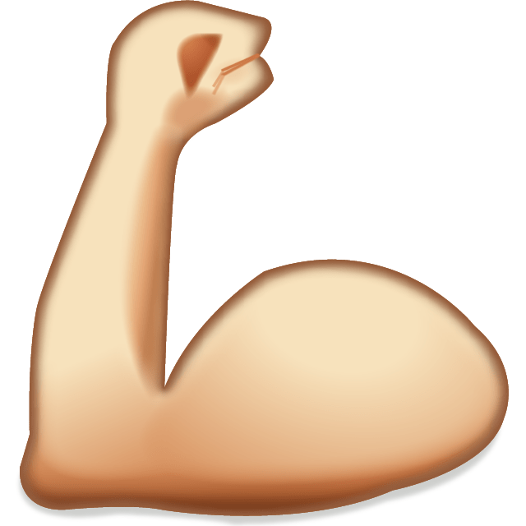Woman in Lotus Position: Medium-Light Skin Tone Emoji (U+1F9D8, U+ ...

Did you know Yoga helps develop strength too?

High Plank

Downward Dog

Chair Pose

Warrior 1

Warrior 2

Side Angle Pose

Boat Pose

Hold each pose for 1 minute. Complete twice

#namaste #strengthinbodyandmind

C:\Users\Alys\AppData\Local\Microsoft\Windows\INetCache\Content.MSO\8E9BF2A.tmp

C:\Users\Alys\AppData\Local\Microsoft\Windows\INetCache\Content.MSO\8E9BF2A.tmp



**@alexlight_ldn**

London, United Kingdom

**@katiecrewe**

Toronto, Canada

Beauty & the Barbell

A1: Back Squats x 8

A2: Weighted Lunges x 6 (each leg) (Ax3 rounds)

B1: Deadlifts x 8 (Bx3 rounds)

C1: Push Press x 8

C2: Barbell Rows x 8 (Cx3 rounds)

Choose a heavy weight as you are working strength (low reps, high weight). Take a 90s rest between rounds!

#girlswholift #strongnotskinny

Pin on emojis !!!

Love your legs & all the SQUATS 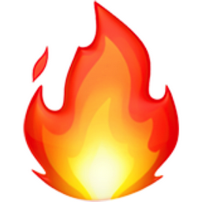 30s on, 15s off

Squats

Cossack Squats

Pop Squats

Sumo Squat Pulses

Narrow Squats

Eccentric Goblet Squats

Sumo Squats

Squat Hold

 Rest 90 seconds after the circuit and repeat 4 times

emoji emojiiphone Sticker by Lizzy Skapolinesia 🥀



**@jgreenewod**

Dunedin, New Zealand

**@katrintanja**

Reykjavik, Iceland

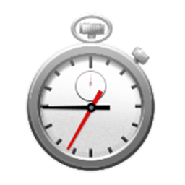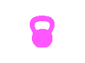Dengpao Media | 灯泡咨询 | China-facing marketing, localisation ...

Today’s WOD: Run-It-Work-It

200/400m Run

20 Kettlebell Swings

200/400m Run

20 Med Ball Cleans

200/400m Run

20 Burpees

200/400m Run

20 Lunges

400m Run

20 Leg Raises

#CrossFit #FittestonEarth

Today’s WOD: Cindy 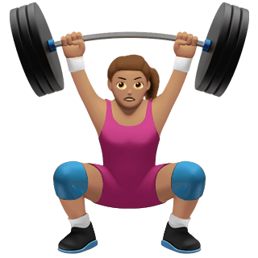

Repeat the following continuously for 20 minutes. Note down the number of times you complete a round

5 Pull Ups

10 Press Ups

15 Squats

#CrossFit #benchmark

Pin on emojis !!!Fire Emoji (U+1F525)



**@choosingchelsea**

Monterey, California, USA

**@candicehuffine**

Washington, USA

Two Women Holding Hands Emoji (U+1F46D)

Today we’ll be using the same base hold for all movements

30s on, 15s off. Rest for 90s & repeat 3-4 times!

High Plank Hold

Press Ups

Mountain Climbers

Plank Get Ups

Kick Throughs

Bear Crawls (4 steps forward, 4 back)

Spiderman Plank

Plank Saws

Feel your abs and shoulders burn #simplebuteffective

BESTIE PAIR WORKOUT

Pick your bestie, can you complete this “You Go, I Go” challenge?

Ladder Challenge: Complete 1 rep of each exercise, then 2, 3 etc. until 20minutes is up!

Squat

Burpee

Sit Up

Press Up

#pairup #bestiegoals #teamwork



Fire Emoji (U+1F525)



**@felicityrosina**

London, United Kingdom

**@katiegrayfit**

London, United Kingdom

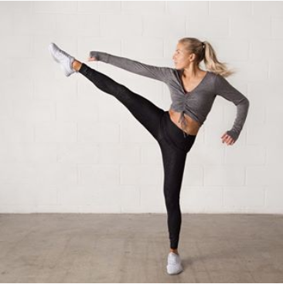

TABATA

We’re working at a 20s work, 20s rest rate. Go maximal in the work time & control your breathing during the rest!

Squat Jumps

Shoulder Taps

Mountain Climbers

Jump Lunges

Sit Ups

Press Ups

High Knees

Burpees

 Rest 90 seconds after the circuit and repeat 5 times

Fire Emoji (U+1F525)Glowing Star Emoji (U+1F31F/U+E335) | Star emoji, Emoji, Glow stars

Pick yourself a plate and let’s get to work!

Squats

Ground to Overhead

Overhead Press

Deadlifts

Heartbeats

Overhead Lunges

Rainbows

Squat Hold

Complete 30s of work with 15s rest. Take 90s between each circuit & repeat 4 times!





**@fittybritttty**

Los Angeles, California, USA

**@rozannapurcell**

Dublin, Ireland

Woman Walking Emoji (U+1F6B6, U+200D, U+2640, U+FE0F)

WE LOVE TO WALK (but with an added challenge)

You’ll need something to time yourself and a little bit of weight!

Walk/Jog for 1 minute

10 Squats

Walk/Jog for 1 minute

10 Lunges

Walk/Jog for 1 minute

10 Overhead Press

Walk/Jog for 1 minute

10 Heartbeats

Repeat for 20-25 minutes

24 MIN LOWER BODY

45s on, 15s off. 30s rest between rounds only! 4 rounds in total

* Pulse Squat x 2 into Jump Squat
* Plank Jacks
* Jumping Lunges x2 into Low Squat
* Gorilla Burpees
* Kneeling Get Ups
* Pop Squats

#noequipmentlowerbody

What do the Snapchat emojis mean? | Snapchat emoji meanings

No jumping, but just as much intensity! Focus on muscle engagement in these exercises

2 x Lateral Lunge into 2 x Curtesy Lunge

Glute Bridge to Glute Walk

Plank to Squat to Plank

Walkout to Press Up

Pike Press Ups

Plank Rows

Complete 3-4 rounds of the circuit, taking 60-90s rest in between each round. Enjoy

**@tallyrye**

London, United Kingdom

Med Ball and a Mate

You Go, I Go; 30s of each exercise…

Deadlifts

Overhead Press

Squats

Ball Over Shoulder

Deadlift and Drop

Slamballs

Around the World (left)

Around the World (right)

1-minute rest between rounds – complete 4 rounds!

**@jessicajanaee**

Utah, USA