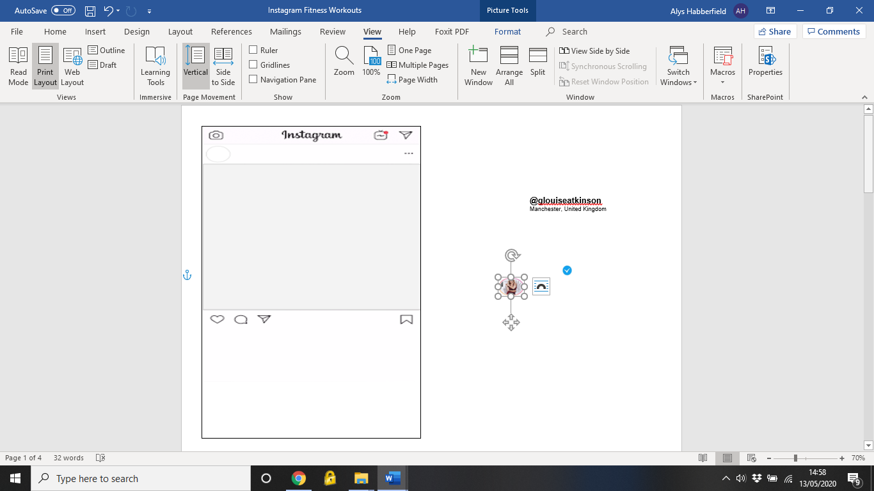

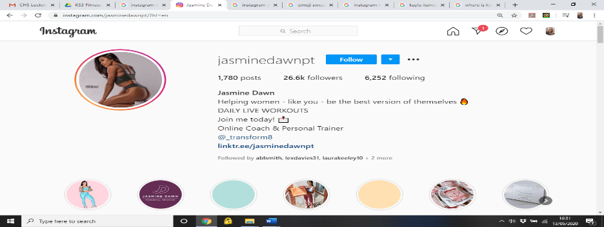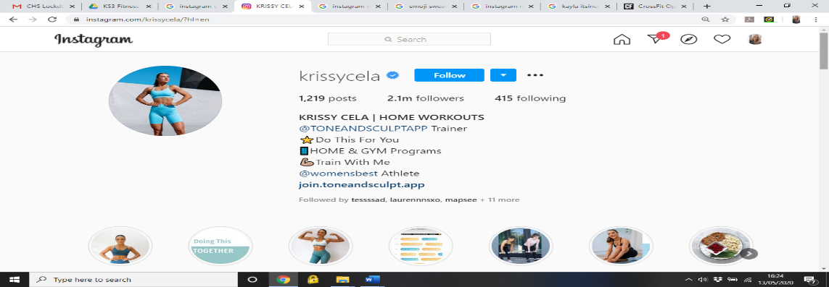

**@jasminedawnpt**

Basingstoke, United Kingdom

**@krissycela**

London, United Kingdom

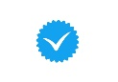

Girls, get ready for those glutes to 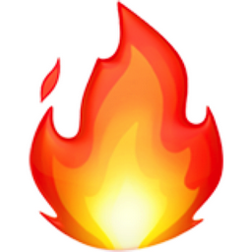 30s on, 15s off

Glute Bridge

Bridge In & Outs

Bridge Hold

Bridge Walks

Donkey Kicks (Left)

Donkey Kicks (Right)

Side Clam Kicks (Left)

Side Clam Kicks (Right)

Crab Walks

 Rest 90 seconds after the circuit and repeat 4 times

BESTIE TEAM WORKOUT 

Pick your besties, can you complete this 1000 rep challenge?

100 Tuck Jumps

100 Squats

100 Hand Release Press Ups

100 Jump Lunges

100 Cossack Squats

100 Sit Ups

100 Burpees

100 Leg Raises

100 Squat Jumps

100 Plank Jacks



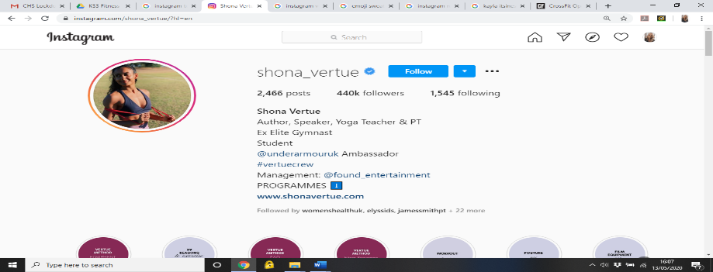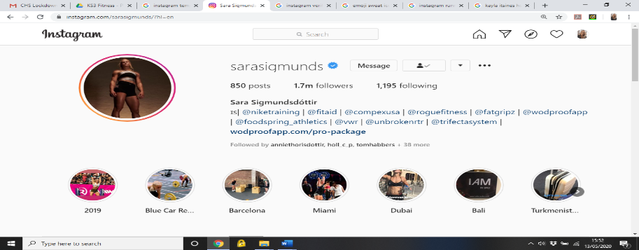

**@shona_vertue**

Sydney, Australia

**@sarasigmunds**

Reykjanesbær, Iceland

CORE WORKOUT 

30s Sit Ups

30s Toe Crunches

30s Russian Twists

30s rest

30s Dead Bugs

30sToe Taps

30s V-sit Hold

Repeat 3-5 times, 1-minute rest between rounds



#abs #core #stability

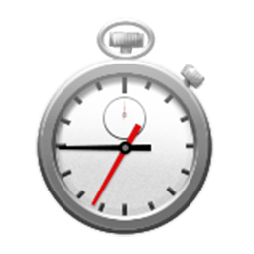

Today’s WOD: Annie 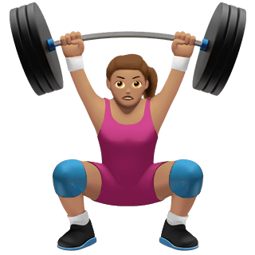

100-80-60-40-20 Skips

50-40-30-30-10 Sit Ups

Complete 100 skips, then 50 sit ups, 80 skips, 40 sit ups… time yourself!

#CrossFit #benchmark



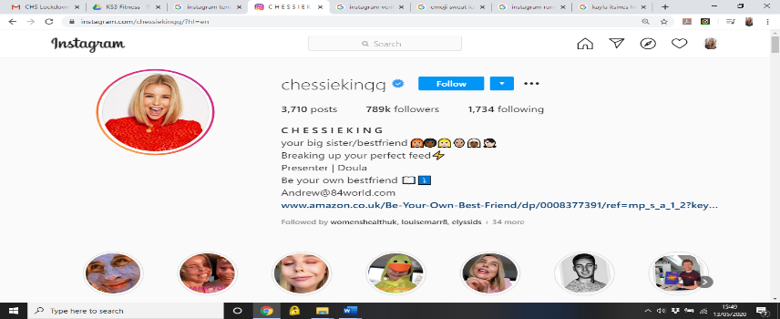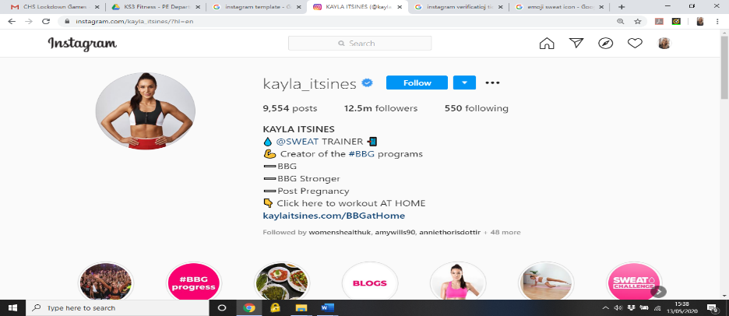

**@kayla_itsines**

Adelaide, Australia

**@chessiekingg**

London, United Kingdom

HIIT me up! Time to get our sweat on with today’s session 

Squat Jumps

Down Ups

Speed Jabs

2 Shoulder to 2 Toe Taps

Burpees

8 High Knees to 2 Jumping Jacks

Bear Crawls

2 Squats, 2 Reverse Lunges

Bicycle Crunches

30s on, 15s off. Rest 90s after round. Complete 3 rounds  #HIIT #burn

The Running Emoji You've Been Waiting for Is Here | Runner's World

Let’s go, CARDIO!

20 Shoulder Taps

20 Jumping Jacks

20 Plank Jacks

30 High Knees

30 Mountain Climbers

50 Skips

Repeat 3-5 times, 1-minute rest between rounds

#cardio #fitness #training





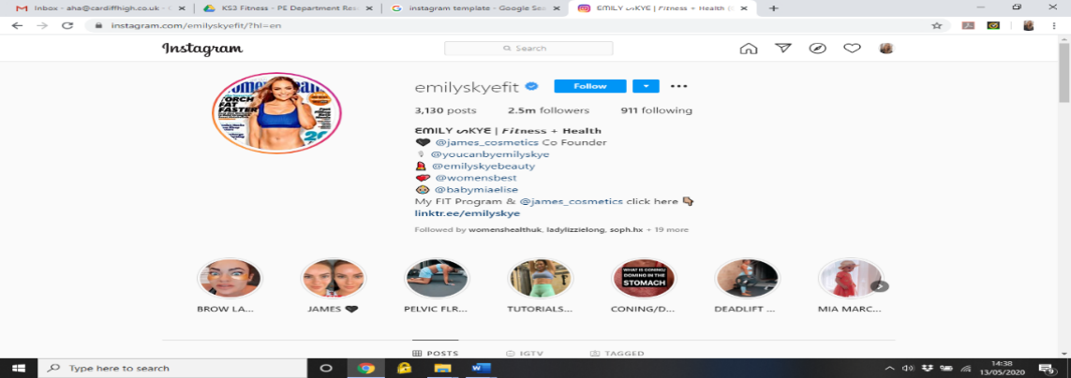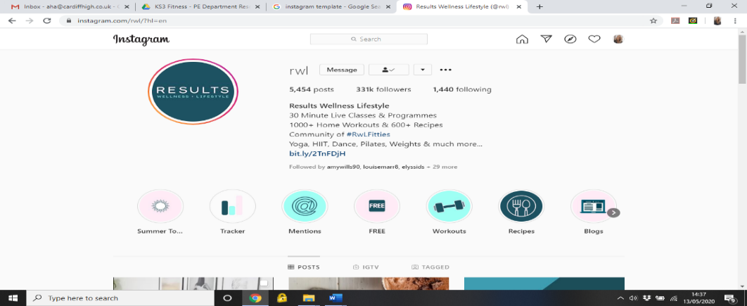

**@rwl**

London, United Kingdom

**@emilyskyefit**

Gold Coast, Queensland

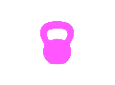

Today’s workout: KETTLEBELL KILLER!

Grab yourselves a kettlebell & let’s go…

20 Kettlebell Swings

20 Goblet Squats

20 Deadlifts

20 Goblet Lunges

20 Kettlebell Hold Leg Raises

Repeat 3-5 times

#kettlebell #lowerbody

RWL: Legs, Bums & Tums

A: 30s Squats, 30s Squat Pulses, 30s Squat Hold

30s Rest

B: 30s Reverse Lunges, 30s Glute Bridge, 30s Bridge Hold

30s Rest

C: 30s V-Sits, 30s Dead Bugs, 30s V-Sit Hold

Complete the whole circuit as above. Rest for 1-minute after the whole circuit. Repeat 3-5 times 

#legsbumstums #RWL





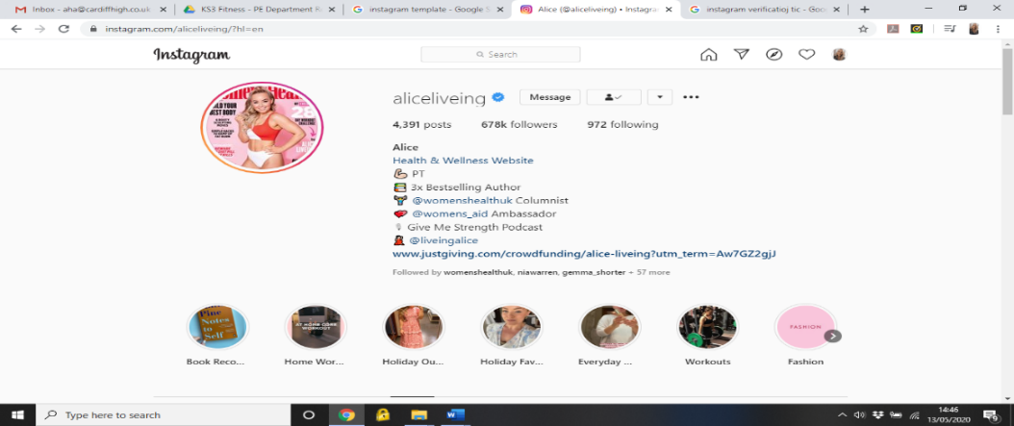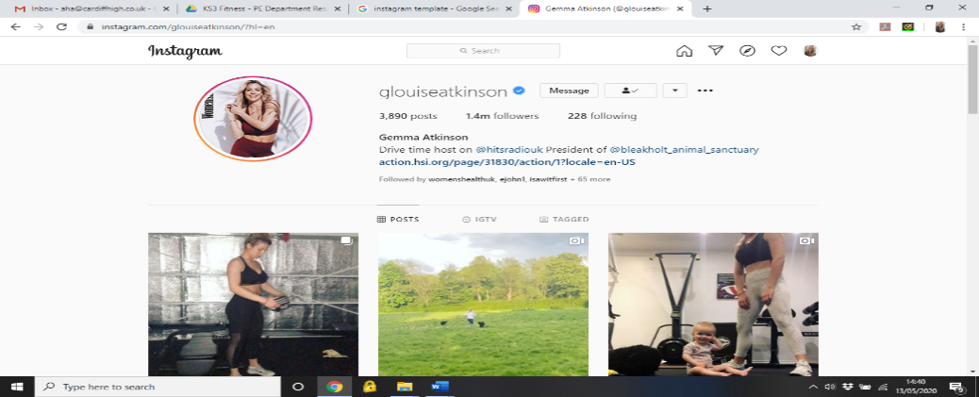

**@glouiseatkinson**

Manchester, United Kingdom

**@aliceliveing**

London, United Kingdom

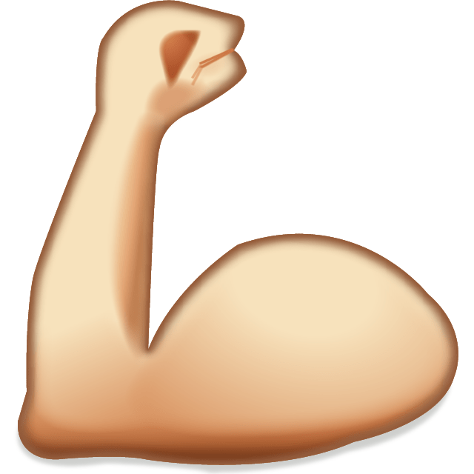

UPPER BODY WEIGHTS

A: 20 Shoulder Press (10 each arm) 🡪 20 Rows (10 each arm)

Rest 1 minute. Repeat x 3

B: 20 Overhead Press 🡪 20 Heartbeats

Rest 1 minute. Repeat x 3

C: 20 Bicep Curls (10 each arm) 🡪 20 Tricep Curls (10 each arm)

Rest 1 minute. Repeat x 3

#girlswholift #strongwomen #upperbody

Try out this 25-minute Bodyweight AMRAP!

5 Press Ups

10 Squats

15 Burpees

20 Reverse Lunges

Keep completing the circuit continually for the time period

*Tip: If you need to rest, try and rest after each round or after a set of repetitions*

#AMRAP #bodyweight