Pupil premium strategy statement – Kelvin Grove Primary School
Before completing this template, read the Education Endowment Foundation’s guidance on using your pupil premium funding effectively and DfE’s using pupil premium guidance, which includes the ‘menu of approaches’. It is for school leaders to decide what activity to spend their pupil premium (and recovery premium) on, within the framework set out by the menu.
All schools that receive pupil premium (and recovery premium) are required to use this template to complete and publish a pupil premium statement on their school website by 31 December every academic year.
If you are starting a new pupil premium strategy plan, use this blank template. If you are continuing a strategy plan from last academic year, you may prefer to edit your existing statement, if that version was published using the template.
Before publishing your completed statement, delete the instructions (text in italics) in this template, and this text box.

This statement details our school’s use of pupil premium (and recovery premium) funding to help improve the attainment of our disadvantaged pupils.
It outlines our pupil premium strategy, how we intend to spend the funding in this academic year and the outcomes for disadvantaged pupils last academic year.

School overview
Detail | Data
Number of pupils in school | 405
Proportion (%) of pupil premium eligible pupils | 46%
Academic year/years that our current pupil premium strategy plan covers (3 year plans are recommended – you must still publish an updated statement each academic year) | 2024-2027
Date this statement was published | July 2024
Date on which it will be reviewed | July 2025
Statement authorised by
Pupil premium lead | Elizabeth Baker
Governor / Trustee lead | Ian Mearns

Funding overview
Detail | Amount
Pupil premium funding allocation this academic year | £257,655
Recovery premium funding allocation this academic year Recovery premium received in academic year 2023/24 cannot be carried forward beyond August 31, 2024. | £0
Pupil premium funding carried forward from previous years (enter £0 if not applicable) | £0
Total budget for this academic year  If your school is an academy in a trust that pools this funding, state the amount available to your school this academic year | £257,655

Part A: Pupil premium strategy plan

Statement of intent
You may want to include information on:
- What are your ultimate objectives for your disadvantaged pupils?
- How does your current pupil premium strategy plan work towards achieving those objectives?
- What are the key principles of your strategy plan?

Challenges
This details the key challenges to achievement that we have identified among our disadvantaged pupils.
Challenge number | Detail of challenge
1 | Extra Curricular Activities  Our demographic means that our families are economically challenged to provide experiences beyond their locality and therefore our children do not visit culturally rich locations, e.g. museums, theatre, countryside, historic venues etc.  The PP children may not have access to the same opportunities as their non PP peers, such as after school clubs, music lessons etc.  - £600 per class on trips  - £4140 for all year groups (PP only children)  - After school club places £7,800? (5 children only)  - Funded participation in clubs  - £1692 for a lunch time hour from September until July.
2 | Attendance  Attendance has always been a challenge. From reception to Year 6, the persistent absenteeism is 24%.  PP -3.07% on non PP. National = 94.5%  Gateshead LA = 94.8%  Kelvin Grove 91.9%  Stage 1 98/141 = 69.5% PP  Stage 2 80/107 = 74.8% PP  Stage 3 37/48 = 77.1% PP  Stage 4 1/1 = 100% PP  -Children and parents’ mental health

-Communication of legal expectations
- Poor punctuality
- Holidays in term time
  - A-Star cost
  - Attendance team half a day salary
  - ‘Teachers to Parents’ - % of pupil premium children for improved communication with parents/carers
  - Stage one and two – email and text
  - Translator costs – percentage of costs
  - Incentives for attendance: £100 term x 3 = £300, £100 voucher for the best attender for the year
  - Breakfast Club – Second person’s salary funded by PP
  - £250 allocated for equipment (including games, utensils)
  - Admin costs – communication letters (including postage) £250
3 | Improving teaching: Writing – results show that our pupils are working below national average for writing across all year groups.  We need to ensure all teachers have good subject knowledge and provide high quality teaching that responds to the needs of our pupils.  We need to be able to identify the children, through rigorous and routine assessment, who need additional support with their writing and provide intervention timely and appropriately.  - Half a day a week cover for English Lead (DHT/HLTA)  - Part of English subject funding to come from PP.  - Contribution from PP for CPD for local authority training – HLTA costs  - CPD – half a day for teachers to attend above and half a day working with Subject Lead.
4 | Targeted Support  We need to meet the growing needs of all our pupils, either cognitively or SEMH, by using targeted interventions and classroom support effectively.  This needs to monitored and its impact measured.  - Rainbows – HLTA half a day and central support costs  - Kids Safe £341 plus Pastoral cost  - TA cost £177,000 – ensure all timetables account for targeted support with TAs  - Phonics TS  - In class support  - DHT Y6 targeted support (1 day)  - Lunchtime behaviour support (see below)  - Homework support (see below)  - RISE Counselling  - Welfare Support DHT and Pastoral cost 1 day (welfare catch up and meetings)  Behaviour and SEMH support at lunchtimes  - Reflection area - teacher (behaviour), Family room (emotional support) and indoor play area (quieter playtime)  - Equipment (£500) and cost of t/a staff 1 hour (TA) and Pastoral Team.
5 | Parental Engagement  It can be difficult for parents to know or have the updated skills to support their children with their learning, especially when school was potentially challenging for them and with the changes to the curriculum over the last 10 years. We need to find ways to encourage parents to support their children with reading or homework; and their children’s learning activities.  - Translator costs – parents’ evening  - Texts and emails – Newsletter, rewards and attendance letters  - Website – update and make user friendly  - New Writing North – project with parents to develop literacy  - Coffee mornings – catering costs, Pastoral Team costs, admin staff costs  - Renting out space for external providers to encourage parents to come to school and build community links  - Parental support – readers and clubs – DBS checks and admin time

Intended outcomes
This explains the outcomes we are aiming for by the end of our current strategy plan, and how we will measure whether they have been achieved.
Intended outcome | Success criteria
Children will have all take part in extra curricular visits to enhance the curriculum. | -Pupil Premium children in every year group will take part in a visit or have a visitor to come to school to enhance their learning.
Pupil Premium children in KS2 will be offered peripatetic music lessons (delivered by LA) | - A percentage of PP children will be able to learn a musical instrument
Children will have free access to a range of after school clubs | - All pupil premium children will have been able to attend an after school club every year during their time at Kelvin Grove
Attendance – we will narrow the gap between the attendance percentage of our pupil premium children and non-pupil premium children  We will reduce the overall attendance gap between the local and national percentage We will reduce the number of persistent absenteeism in the school | - Pupil premium will be in line with non pupil premium children  - Our overall attendance will be in line with national and local authority level  -Our children will understand the important of good attendance in schools  -The number of term time holidays will be reduced  -We will improve punctuality at school  - We will reduce the gap between the percentage of persistent absenteeism so that it is at least in line with national figures.
We will improve the standard of teaching and learning of writing in all year groups. Teaching of English will be at least good across all classes. | We will narrow the gap between the percentage of children working at the expected level and above in writing.  We will ensure that the percentage of children are working at the expected level is
Children will be confident, creative and competent independent writers.  All teachers will have a good grasp of where each of their children are (using the writing GAP) and have strategies to support children to address any barriers to them improving their writing. | in line with or above the national percentage.
Improving the personal development programme for our children to ensure that we meet the needs of all our pupil premium children regarding their welfare.  Introduce extra social and emotional learning provision in school to meet the growing socio economic and mental health needs of our pupil premium children. | --Children’s behaviour during unstructured times will improve with a reduced number of incidents recorded on CPOMs (les learning time wasted sorting out issues during playtime).  -Children who need additional support with their behaviour or social -emotional well being receive targeted intervention during the same academic term of being identified.
We will improve the relationships with all pupil premium community by ensuring they have a voice and allow them opportunities to be part of their child’s learning journey and contribute to the wider life of school.  Parents and staff will find a good balance of communication so that children feel supported both at home and in school with their learning and well-being. | -Established effective communication policy  - Regular events for cares/parents to come into school.  - Workshops for parents to empower them to support their children with their learning. -More clubs/in school support using our community’s skills

Activity in this academic year
This details how we intend to spend our pupil premium (and recovery premium) funding this academic year to address the challenges listed above.

Teaching (for example, CPD, recruitment and retention)
Budgeted cost: £46,647
Activity | Evidence that supports this approach | Challenge number(s) addressed
Local authority CPD for teachers to improve the quality of teaching and learning in English. | EEF  Effective Professional Development  Schools should focus on building teacher knowledge and pedagogical expertise, curriculum development, and the purposeful use of assessment. This could include the selection of high quality curriculum materials or | 2 and 3
Allocation of time to English lead to monitor teaching and learning in English lessons, visit similar |  | 2 and 3
schools, support teachers in the delivery of English lessons and with planning. | investment in the use of standardised assessments.
Organising moderation of pupils’ work to improve assessment and the  identification of pupils’  gaps requiring intervention | investment in the use of standardised assessments. | 2 and 3

Targeted academic support (for example, tutoring, one-to-one support, structured interventions)
Budgeted cost: £197,257
Activity | Evidence that supports this approach | Challenge number(s) addressed
Teaching assistants to support in class, working with smaller groups.  Need to look at how teaching assistants are used effectively during whole class teaching and independent work to reduce over reliance on support and improve attainment for PP children.  -CPD  -Shared planning - Assigned time for TAs to fully understand the planning and | EEF Paper - Making Best Use Of Teaching Assistants New focus on:  4. Ensure TAs are fully prepared for their role in the classroom  To consider creative ways of ensuring teachers and TAs have time to meet include adjusting TAs’ working hours (start early, finish early), using assembly time and having TAs join teachers for (part of) Planning, Preparation and Assessment (PPA) time.  3. Use TAs to help pupils develop independent learning skills and manage their own learning  Research has shown that improving the nature and quality of TAs’ talk to pupils can support the development of independent learning skills, which are associated with improved learning outcomes (CPD for teaching assistants)  7. Ensure explicit connections are made between learning from everyday classroom teaching and structured interventions4 | 2,3 and 4
reflect on lessons.

Targeted intervention for groups in -writing  -phonics  -reading  -maths | EEF Paper - Making Best Use Of Teaching  Assistants  5. Use TAs to deliver high quality one-to-one and small group support using structured interventions  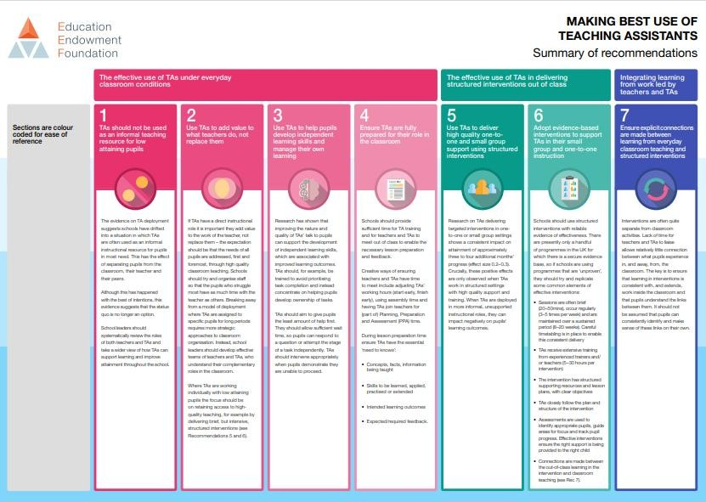  TA_Recommendations_Summary.pdf  (d2tic4wvo1iusb.cloudfront.net) | 2, 3 and 4
Purchase of licences for  TTRS/Numbots and Literacy Shed for homework – spelling and number fluency |  | 3, 4 and 5

Wider strategies (for example, related to attendance, behaviour, wellbeing)
Budgeted cost: £55,850
Activity | Evidence that supports this approach | Chall enge numb  er(s)  addre ssed
Attendance Initiative  - Supporting breakfast Club Salary of TAs and costs of equipment | The EEF’s trial of Magic Breakfast in 106 schools found that providing a universal free breakfast club had an impact of two additional | 2,4

(supplemented by Greggs) | months’ progress on children’s outcomes at Key Stage 1 and Key Stage 2  In school evidence that children’s attendance improves when they can have access to BC.
More consistent rigorous monitoring and intervention for low attendance.  Weekly meeting between  DHT, Pastoral Support and  Admin  Improved communication regarding consequences of poor attendance.- through emails, texts, referrals, home visits, coffee mornings.  Revise attendance policy. | EEF Supporting school attendance  Focus on  In attendance terms, the headline data doesn’t give us enough information to suggest a solution: we need to dig deeper into the individual and contextual factors affecting pupil attendance. Greater knowledge and understanding of the specific barriers to attendance can help you to identify potentially effective approaches that are targeted to the needs of your pupils.  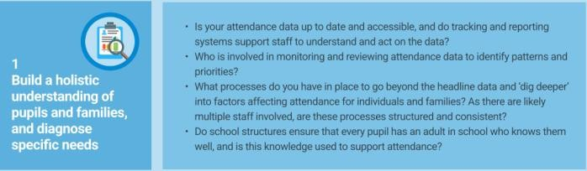 | 2 and  5
Targets SEMH support:  - Rainbows  - RISE counselling  - Kidsafe  - Access to pastoral support throughout the school day | In school feedback for Rainbows and RISE through pupil voice.  Rainbows (based on issues raised in the government paper: Promoting children and young people’s mental health and wellbeing. September 2021)  Rainbows training and programmes argue that if loss and bereavement are not acknowledged there may be a negative impact on a young person’s emotional health and well-being which in turn may harm their cognitive development and learning. Rainbows programmes directly support and promote all of the identified eight principles for promoting mental health and well-being.  RESEARCH DOCUMENTS - Rainbows  Bereavement Support GB (rainbowsgb.org)  RISE: The research on resilience is incredibly well established. While there are dozens of areas which affect a child's resilience, the RISE programme has focused on 8 key areas (i.e. 7Cs & E) of resilience. These have been shown to have the biggest impact on resilience, and are also those which we can actively support children to develop.  EdPsychEd | The home of RISE: Resilience in  Schools and Education CPD | 2, 3 and 5
Parental Engagement  - Translator costs – parents’ evening  - Texts and emails – Newsletter, rewards and attendance letters  - Website – update and make user friendly  - New Writing North – project with parents to develop literacy  - Coffee mornings – catering costs, Pastoral costs & admin staff costs.  - Renting out space for external providers to encourage parents to come to school and build community links  - Parental support – readers and clubs – DBS checks and admin time | Using text message prompts to improve parental engagement and pupil attainment – EEF study  EEF: Working With Parents To Support  Children’s Learning  EEF_Parental_Engagement_Summary_of_rec ommendations.pdf  (d2tic4wvo1iusb.cloudfront.net)  - Tailor school communications to encourage positive dialogue about learning  - Offer more sustained and intensive support where needed  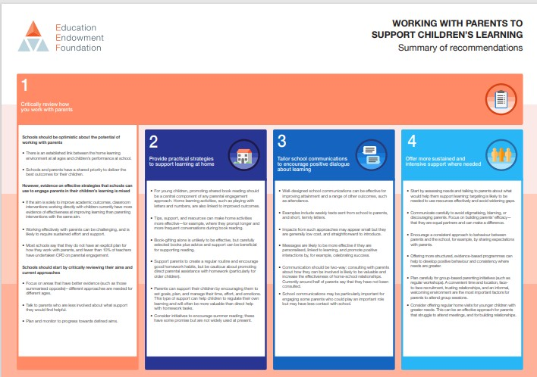 | 2,3 and 5
Introduction of music lessons at lunchtime, targeting the PP pupils  (Music has been shown to enrich school life, improve behaviour, and develop important skills such as resilience and teamwork. By giving children the chance to learn an instrument in a group, you not only boost academic achievement, but give them the right environment to improve wellbeing and confidence too). | Playing an instrument can help young people to reduce anxiety, gain control of emotions, and focus attention – by altering the behaviour-regulating and motor areas of the brain (long-term study, 232 children, 6 years, University of Vermont College of Medicine).  Music To My Brain: Could Music Training Be  Used to Improve Adolescent Brain  Development? Guido K W Frank, Journal of the American Academy of Child and Adolescent Psychiatry (2014) | 1,2,3 and 4
Children to be offered fully funded experiences to our pupil premium children which will allow them to develop a broader understanding of the curriculum through ‘hands-on’ experiences. | Pupil Voice
Total budgeted cost: £299,754

Part B: Review of the previous academic year
Outcomes for disadvantaged pupils
2025 Outcomes
The outcomes we aimed to achieve by 2024-25 have not been fully realised; however, there is some progress.
Phonics - The phonics screen outcomes for disadvantaged children show that those children generally perform as well or even better than those children not eligible for pupil premium. 69.2% of disadvantaged children passed the phonics screen, compared to the school average of 58%. It should be note that this data does not include three children with very specific, complex needs. At the end of year 2, however, there is further evidence that disadvantaged children are attaining well, with 80.6% passing the phonics screen compared to children not identified as disadvantaged (75%).
The maths outcomes for disadvantaged children at the end of Key Stage Two (77.3%) are above the national average (74%) in 2025 for all pupils and the school average (74%).
The reading outcomes for disadvantaged children at the end of Key Stage Two (54.5%) are significantly below the national average (75%) in 2025 for all pupils and below the school’s average of 64%. However, there is evidence of some progress, with a three year improving trend from 44% in 2022. This must be a key area of focus next year.

The writing outcomes for disadvantaged children at the end of Key Stage Two (45.5%) are significantly below the national average (72%) in 2025 for all pupils and below the school’s average of 62%. This must be a key area of focus next year.
Attendance
Attendance of disadvantaged pupils at Kelvin Grove is below the national (94.84%) and school average (93.6%). However, there is a 4 year increasing trend from to 89.87% in 21/22 to 90.66% in 24-25. This needs to continue to be a focus.
Extra curricula/enrichment
All children in year 6 who wanted to attend the residential were able to due to significant school funding and every child received a leavers hoodie free of charge.
Holiday clubs three times across the year were accessed by our most vulnerable and disadvantaged children.
All other trips across school were accessed by all without a charge to disadvantaged children.
20 disadvantaged children received music tuition. Extra-curricular clubs continue to be targeted for disadvantaged children.
Children who require additional support to promote positive mental-health and well- being, receive intervention, therapy and/ or nurturing approaches within school.
Family engagement continues to be a priority in terms of attendance
Of the 40 children who accessed breakfast club during the academic 2024-25, 85% were entitled to PP funding.

Externally provided programmes
Please include the names of any non-DfE programmes that you used your pupil premium (or recovery premium) to fund in the previous academic year.
Programme | Provider
A Star Attendance | A Star Attendance
Little Wandle Phonics | Little Wandle Phonics

