 | Autumn | Spring | Summer  Local History Study
Year 1 | Toys: Past and Present | Superwomen! Florence Nightingale & Mary Seacole | The Great Fire of London / Gateshead
Year 1 | Beamish Museum (Box to loan)  Discovery Museum  Toy Shops  Artist- Andy Warhol-Prints- Toy prints  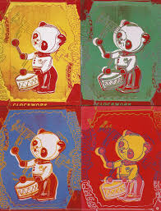  Andy Warhol Andrew Warhola; August 6, 1928 – February 22, 1987) was an American artist, film director, and producer who was a leading figure in the visual art movement known as pop art. His works explore the relationship between artistic expression, advertising, and celebrity culture that flourished by the 1960s, and span a variety of media, including painting, silk screening, photography, film, and sculpture. Some of his best known works include the silkscreen paintings Campbell's Soup Cans (1962) and Marilyn Diptych (1962), the experimental films Empire (1964) and Chelsea Girls (1966), and the multimedia events known as the Exploding Plastic Inevitable (1966–67). | That History Bloke  Visitors – NHS Nurses  Beamish Museum  Artist- Maria Sibylla Merian (1647 – 1717 seventeenth century) a Swiss Naturalist, an Entomologist and a Botanical Illustrator and is rated as being one of the greatest ever botanical artists. One of her principal claims to fame is that she is one of the first naturalists to have studied insects. She recorded and illustrated the life cycles of 186 insect species. | St Mary’s Heritage Centre  Newcastle Castle  That History Bloke  Artist- Van Gogh-Colour Mixing  Vincent Willem van Gogh (Dutch: 30 March 1853 – 29 July 1890) was a Dutch post-impressionist painter who is among the most famous and influential figures in the history of Western art. In just over a decade, he created about 2,100 artworks, including around 860 oil paintings, most of which date from the last two years of his life. They include landscapes, still lifes, portraits and self-portraits, and are characterised by bold colours and dramatic, impulsive and expressive brushwork that contributed to the foundations of modern art. He was not commercially successful, and his suicide at 37 came after years of mental illness, depression and poverty.
Year 2 | Gunpowder Plot | Regal Royals: Queen Elizabeth I, Queen Victoria & current monarch | George Stephenson & the Railway
Year 2 | Visitors – Local MP  St Chads Church  Artist-  Henry Perronet Briggs (1793–1844) was an English painter of portraits and historical scenes. He was born at Walworth, County Durham.  The Discovery of the Gunpowder Plot and the Taking of Guy Fawkes, circa 1823 Laing Art Gallery. | Newcastle Castle  Costume Hire: Little Theatre  Self Portraits- 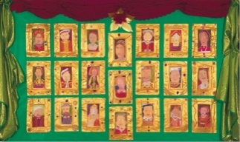 https://www.tes.com/teaching-resource/self-portraits-6445556  https://www.theschoolrun.com/what-your-child-can-learn-doing-self-portrait  5 Artists Who Have Painted Her Majesty  Chris Levine, Equanimous, 2012. Nicky Philipps in her studio.  Christian Furr, Her Majesty The Queen, 1995. Hugo Rittson Thomas and Prince William ©Harriet Turney. Isobel Peachey, Princess Anne.  Chris Levine and The Queen by Nina Duncan.  Queen Elizabeth I https://www.npg.org.uk/research/programmes/making-art-in-tudor-britain/case-studies/the-queens-likeness-portraits-of-elizabeth-i | Box of Delights (George Stephenson)  Stephenson Steam Railway  National Trust: G.S Birthplace, Wylam  Visit: ttps://stephensonsteamrailway.org.uk/  Artist- X 2  Richard David Shepherd CBE FRSA FGRA was a British artist and one of the world's most outspoken conservationists. He was most famous for his paintings of steam locomotives and wildlife, although he also often painted aircraft, portraits and landscapes.  Terence Tenison Cuneo CVO OBE RGI FGRA was a prolific English painter noted for his scenes of railways, horses and military actions. He was also the official artist for the Coronation of Queen Elizabeth II in 1953
Year 3 | Ancient Egyptians | Stone Age to Iron Age | Romans in Britain and the North East
Year 3 | Great North Museum  Oriental Museum  4Schools – Durham University  Artist: Paul Klee  (German, 18 December 1879 – 29 June 1940) was a Swiss-born German artist. Klee was ambidextrous. He wrote with his right hand and painted with his left. This means that his watercolours were painted with one hand but signed and titled with the other. | Box of Delights (Prehistoric Britain)  4Schools-Durham University  The Bowes Museum  Oldest Stone Age Art:  1.Bhimbetka and Daraki-Chattan Cupules (290-700,000 BCE)  2. Venus of Berekhat Ram (230-700,000 BCE)  3. Venus of Tan-Tan (200-500,000 BCE)  4. Blombos Cave Engravings (70,000 BCE)  5. Diepkloof Eggshell Engravings (60,000 BCE)  6. La Ferrassie Cave Petroglyphs (60,000 BCE)  7. El Castillo Cave Paintings (Red Disk) (39,000 BCE)  8. Sulawesi Cave Art (37,900 BCE)  9. Lion Man of the Hohlenstein Stadel (38,000 BCE)  10. Venus of Hohle Fels (38,000-33,000 BCE)  Ideas: Stone age paintings / Fabric dyeing/ Pottery/ Stone Age Houses  Stone Age jewellery/ Hand Stencils and Stone Henge/ Make a replica Shigir idol-a wooden sculpture | Box of Delights (Romans: Hadrian’s Wall)  Segedunum Roman Fort  Vindolanda Roman Fort  Artist- x 3  Michelangelo Merisi da Caravaggio was an Italian painter active in Rome for most of his artistic life.  Gian Lorenzo Bernini was the dominant artist of 17th-century Rome.  Michelangelo di Lodovico Buonarroti Simoni, known best assimply Michelangelo, was an Italian sculptor, painter, architect and poet of the High Renaissance
Year 4 | Ancient Greeks | Anglo-Saxons (and the Scots) | Bensham Tram Crash
Year 4 | 4Schools – Durham University  Great North Museum  The Bowes Museum  Artists x 3-  Stephen Antonakos Greek-born American Stephen Antonakos was a sculptor known for his abstract sculptures often incorporating neon. His works have been exhibited at major international art exhibitions such as Documenta 6 in 1977 in Kassel,  Nikos Hadjikyriakos-Ghikas-Born on 26 February 1906 in Athens, Nikos Hadjikyriakos-Ghikas was a prolific painter, sculptor, engraver and writer. As a young 23-year-old, he went to Paris in 1923 to study French Literature and Esthetics at the Sorbonne University. It was there that he participated in an exhibition that took place in the Salon des Indépendants.  Chryssa -Born in 1933 in Mani, Greece, Chryssa Vardea-Mavromichali, professionally known as Chryssa, was a Greek-American artist known for her pioneering work in light art.  Ancient Greek culture was full of different types of art. Ancient Greeks decorated almost every part of their lives, from their buildings and city streets to the inside of their homes, many objects in Greek life were created with beauty in mind. Greek artists created masterpieces in painting, metal work, mosaic, sculpture, architecture, literature, and pottery.  https://theculturetrip.com/europe/greece/articles/10-contemporary-greek-artists-you-should-know/ | Box of Delights (Anglo Saxons)  Jarrow Hall  4Schools – Durham University  The Anglo-Saxons were great craft workers. They made intricate jewellery, musical instruments and homemade toys and games.  Artist-Lucie Rie (British, 1902–1995) was an Austrian-born British ceramics artist-Anglo Saxon bowls | Beamish Museum  Streets of Bensham  That History Bloke  Artist -Rob Pointon –  British urban landscape painter working in oils, he mostly works enjoys on plein air (on the easel, with the subject in front of him).  With a paintbrush in hand, a canvas before him - and a bus, train or tram to capture - Rob Pointon is in his element. The 33-year-old artist has caused a commotion among commuters spending up to eight hours a day painting scenes from tram stops and busy junctions in the city centre.  Rob Pointon has been described as one of the most exciting British oil painters producing today. Multi award winning and elected ROI member, he was awarded Artist in Residence for Manchester Airport - the first of its kind in the UK.
Year 5 | Roman Empire, Resistance & Rebellion | Vikings (Invasion & Onwards) | Normans in Newcastle
Year 5 | Segedunum Roman Fort  4Schools – Durham University  Artist- https://virtu-art.com/ancient-art/famous-roman-artists/  Publius Aelius Forunatues- was a former slave that turned to painting and lived sometime during the second century. It was extremely rare for a slave to earn their freedom and walks the streets as a citizen, but it was even more rare for a slave to become an artist, especially a famous one.  Iaia- was a popular female painter that was known for her ivory engravings. Most of her paintings were centred around woman, with one of her most famous works being of an old woman and self-portrait.  Arellius- was a painter of famous figures in Roman, and was most active in the first century before Augustus took over the empire. And although he was held in high esteem by many, much of his work also came under heavy criticism due to their subject matter. One of the criticisms that prevailed throughout much of his work was his incorporation of the faces of the women he loved the most into the faces of the goddesses he painted. | Box of Delights (Vikings)  English Heritage: Lindisfarne Priory  4Schools – Durham University  The Six Different Types of Viking Art Styles  Artists-  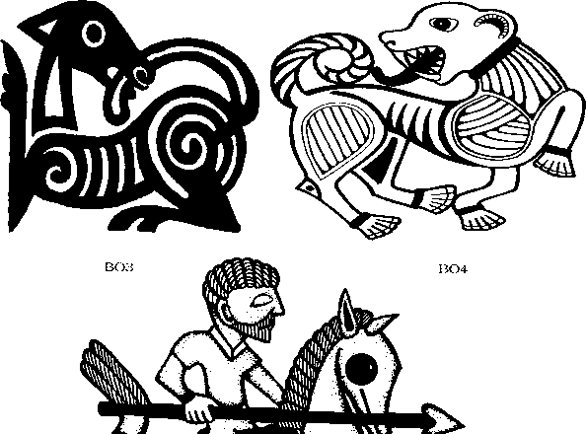  1. Oseberg -Oseberg is one of the most prolific types of Viking art style, and was prominent throughout most of the 9th century. Much of this artwork can be linked back to the earlier religion of Animism, where focus was put on beasts and their different forms. Oseberg was a popular variant that lasted around 150 years.  2. Borre -First discovered as a set of bridle mounts from a ship found in Borre, Norway, this style contains elements of both Oseberg and jelling, both of which were popular during the Viking reign. While we still see some of the beasts common in Oseberg, much of the other decoration has taken on a more angular and uniform appearance.  3. Jelling-Jelling seemingly started around the 10th century just as Oseberg was dying out, and lasted for about 75 years.The animals in jellings have a much stronger “s-shape”, and are almost always intertwined with each other. Borre and jelling share many similarities, and are often found together on the same piece of artwork.  4. Mammem-This is a direct descendent of the Jelling style, and was most common through the last half of the 10th century. The animals involved in Mammem decoration have lost most of their twisted and intricate nature, and artists opted rather for more natural-looking animals, such as lions, birds, serpents, and even some foliage patterns. The name of this style comes from an axe head that was discovered in Mammem, Denmark.  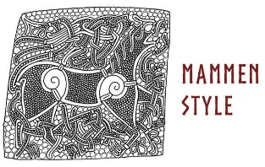  5. Ringerike-Once Mammem had come to an end, Ringerike took over, finding prominence from about the start of the 11th century.While there are still lions and foliage in Ringerike, they were also often matched with rune carvings. Animals in the Ringerike style tend to be thin and curvy, with much larger, almond-shaped eyes.  6. UrnesUrnes was the last of the art styles to emerge from the Viking era, having started around 1050 and lasting to the 12th century.It earned its name from a stave church located in Urnes, Norway. The church is covered in ornate wooden panelling that depicted a series of different animals, with snakes being quite prominent. | Newcastle Castle  Artist-  Characteristics of Norman Art  Norman art relied heavily on the Roman legacy of Western Europe. However, in areas such as southern Italy, Norman art was characterised by significant influences of Arab, Greek and Lombard art traditions. Norman mosaics, in particular, were characterised by a strong influence of classical Greek artwork.  Norman Art in England  Most of the extant samples of Norman Art in England comprise of the architecture which Normans erected following their 1066 invasion of England. An unusual and highly significant piece, however, is the Bayeux Tapestry which is often included both in the Anglo-Saxon art heritage as well as the Norman art. The Tapestry was commissioned by the Normans following the 1066 invasion but it was the handywork of Anglo Saxon artisans. It is a huge piece of embroidery art which depicts the events leading up to the 1066 invasion.  Top five examples of Norman art:  - The Tower of London which dates back to the 11th century and is an iconic example of Norman architecture.  - The Extant bronze lion statue which dates back to sometime around 1100 and is an example of Norman metalwork.  - The Bayeux Tapestry which dates back to 11th century and is an example of embroidery commissioned by the Normans.  - The Trivulzio candelabra which dates back to the 13th century and is an example of Norman artwork in Italy.  - The Christ Pantocrator mosaic in Palermo which dates back to the 12th century is one of the most magnificent examples of Norman mosaics.
Year 6 | Battle of Britain | Early Islamic Civilisation | Leisure and Entertainment in Whitley Bay/Tynemouth
Year 6 | Box of Delights (WW2-Battle of Britain)  Beamish Museum  Eden Camp  Artist- Graham Sutherland-English 1903-1980 who served as an official war artist in the Second World War. Sutherland was commissioned to design the massive central tapestry in the new Coventry Cathedral, Christ in Glory in the Tetramorph.  Also Graham Sutherland's portrait of Winston Churchill is probably one of the most famous 'lost' works of art.  Other artists-Henry Moore, Goncalo Mabunda or Laura Knight | Oriental Museum  Islamic Diversity Centre (Mosque Visit or/and Workshop)  Artist- Hassan Massoudy, born in 1944, is an Iraqi painter and calligrapher, considered by the French writer Michel Tournier as the "greatest living calligrapher", currently lives in Paris. His work has influenced a generation of calligraffiti artists.  https://octobergallery.co.uk/artists/massoudy  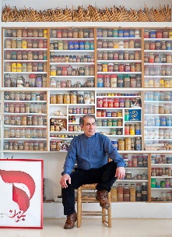 | Tynemouth Front Street & Coastal Area  Whitley Bay Spanish City/Promenade  The British seaside – from Turner to Nash to Emin  Artists throughout the ages have put brush to canvas in an effort to capture the essence of the British summer and with that, its coastline.  Artist- J. M. W. Turner  Most famous seascape painter of all time, J. M. W. Turner spent his entire life capturing the character of the sea and life on the British coast.  Joseph Mallord William Turner (1775–1851)  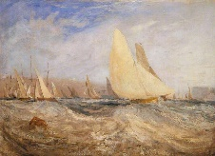  Photo credit: Tate  Sketch for 'East Cowes Castle, the Regatta Beating to Windward' No. 2 1827  Paul Nash (1889–1946)  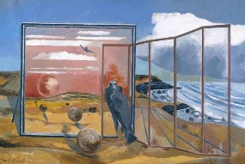  Landscape from a Dream 1936–8  Paul Nash (1889–1946)  Beryl Cook (1926–2008)  Beach at Looe  