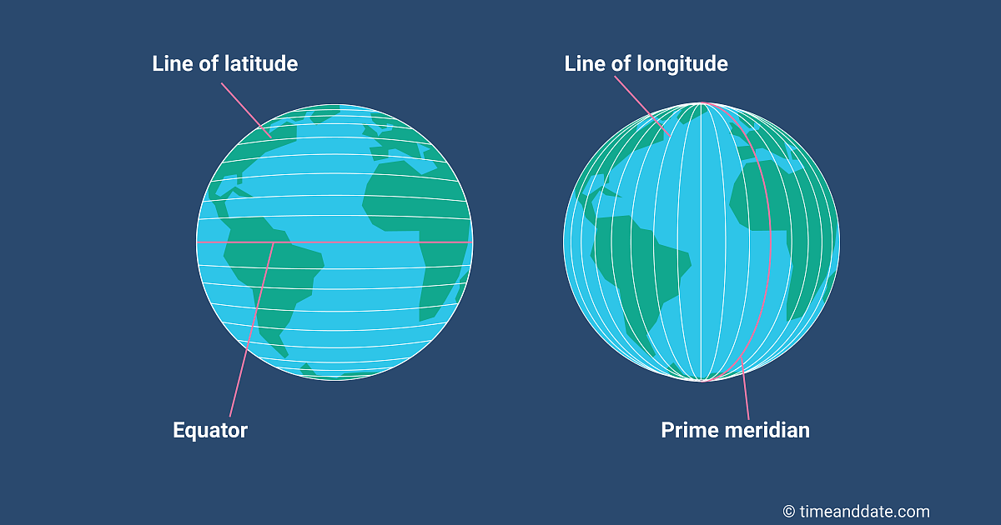Lines of latitude Lines of longitude
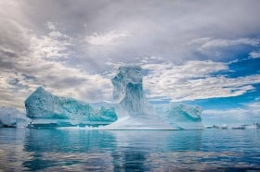Ice shelf
Key Knowledge:

Where is Antarctica? How do we locate Antarctica? Which seas and oceans surround it? What is the time difference between the UK and Antarctica?

What are the physical features of Antarctica? What is the difference between a glacier and an ice shelf?

What do people do in Antarctica? How is Antarctica useful to humans? What impact are humans having on Antarctica’s ecosystem?

What is climate change? What problems is Antarctica experiencing as a result of climate change? What problems will rising sea levels cause?

Vocabulary

Antarctica
South Pole
hemisphere longitude
latitude
Time Zone
Prime Meridian
Greenwich Meridian
glacier
climate change
global warming
ecosystem

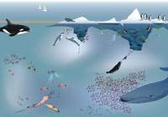ecosystem
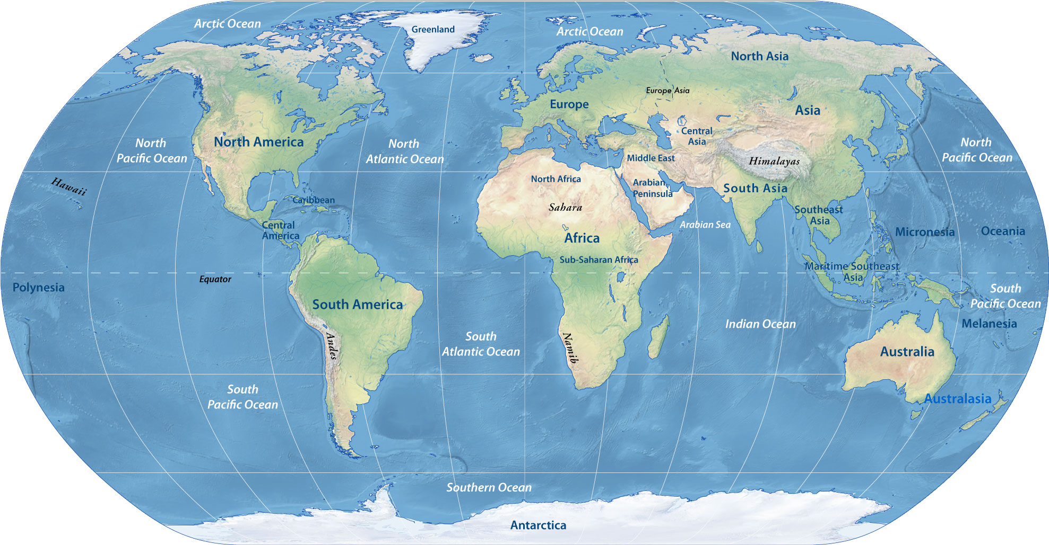Antarctica


Year 6 Knowledge Organiser: Geography
Antarctica: Exploring the Impact of Climate Change

