
seismograph
earthquake/tsunami

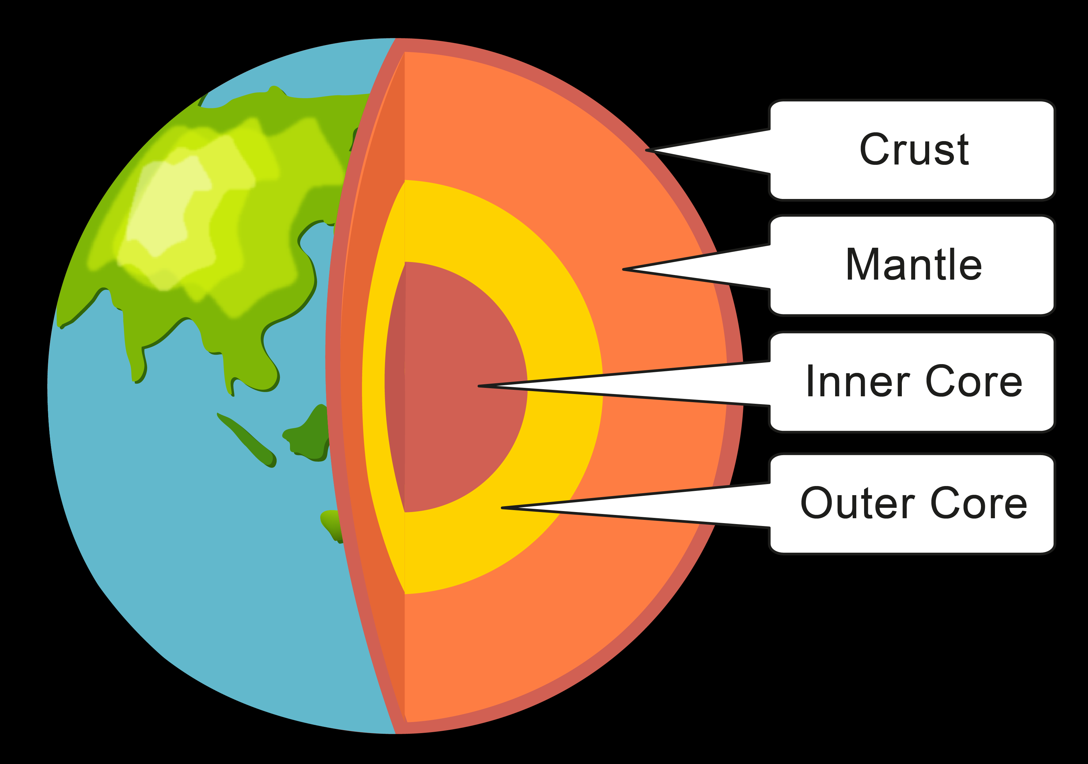
Key Knowledge:

- What are the names of the four layers of the Earth?
How do tectonic plates move?
What can they create?

- Where do earthquakes and volcanoes occur, and which part of the world do most earthquakes happen?
What causes an earthquake?

- How are earthquakes measured? How do scientists measure the strength of the waves and what is this called?
What is the scale used to measure earthquakes?

- What is a tsunami? How do tsunamis occur?
Where have significant tsunamis occurred in recent years?

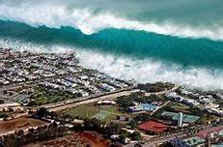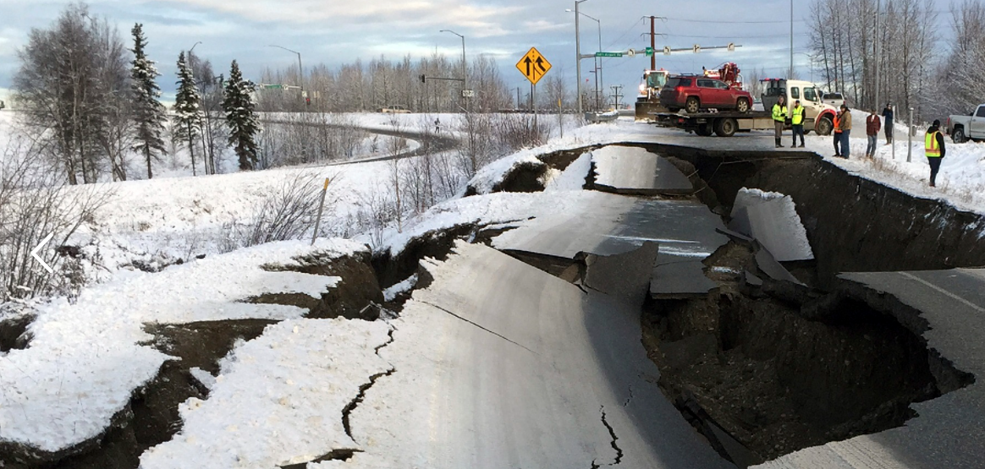

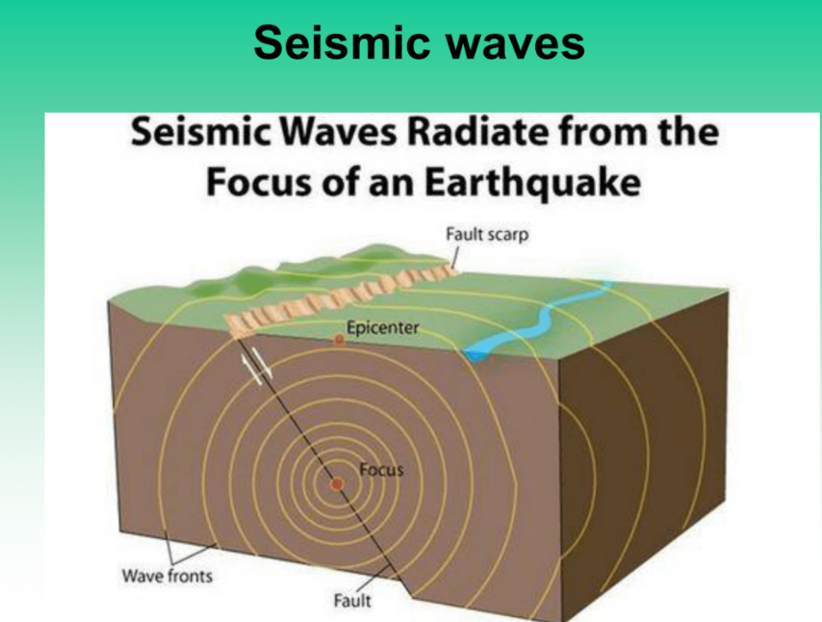
seismic waves
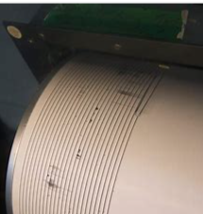
Year 5 Knowledge Organiser: Geography
Earthquakes and Tsunamis
tectonic plates
Layers of the Earth
Ring of Fire

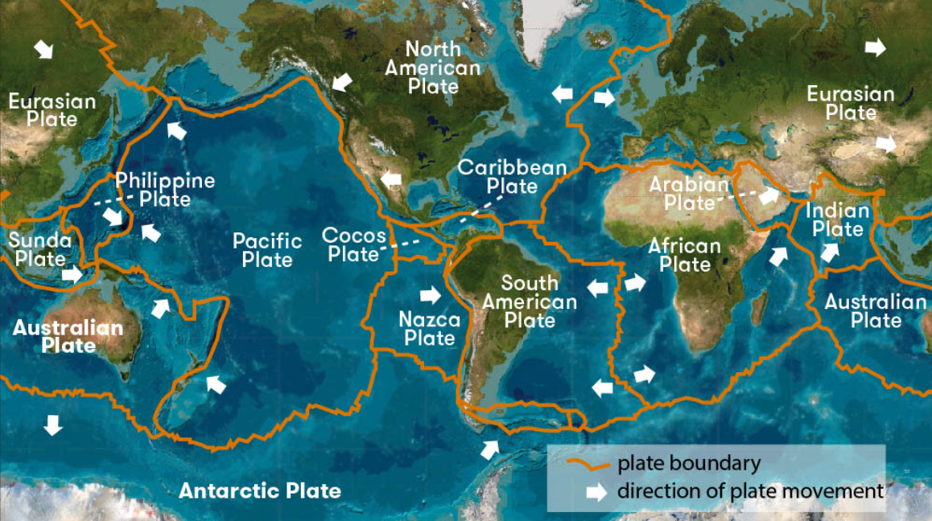
Vocabulary

plate boundary

fault line

shockwave

friction

boundary

magnitude

Richter Scale

Antarctic

Eurasian

North America

Pacific

continent

