French Alps: Physical feature
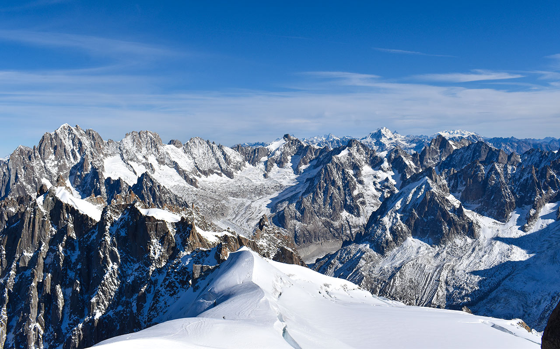
Navigable rivers
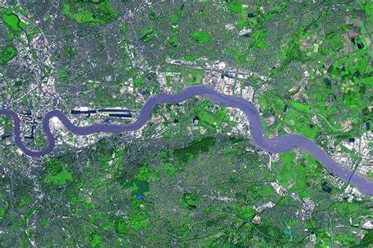
Plateau
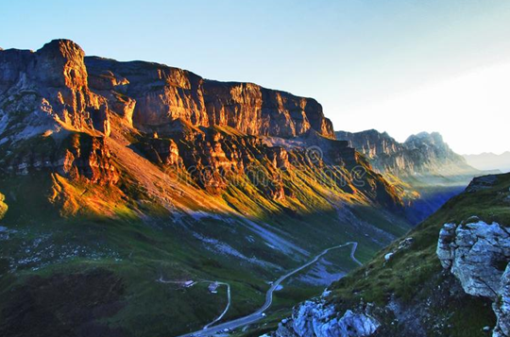
Continent: Europe
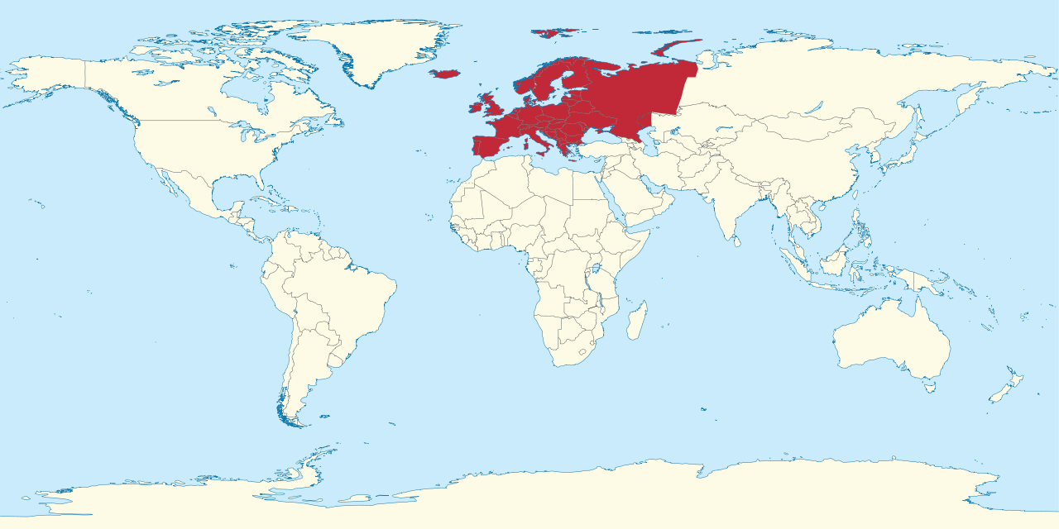
Eiffel Tower: Human feature
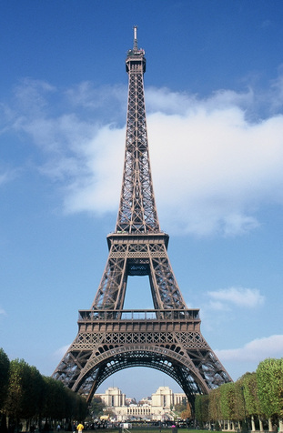
Vocabulary
Europe
Continent
Peninsula
Western Uplands
glaciation
fjords
Central Uplands,
altitude
Alpine Mountains,
Alps
Plateaus
North European Plain


Fjords
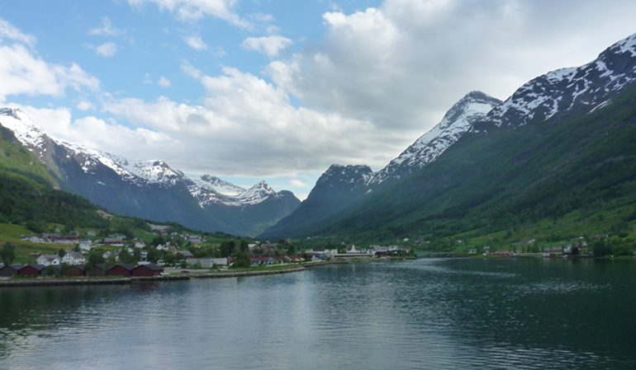

Key Knowledge:
Why is Europe classed as a peninsula? Which seas and oceans surround it? Locate some Northern European countries? Locate some Western European countries?
Name the 4 landscapes found in Europe? Name a physical feature about each landscape? Tell me an interesting fact about each landscape?
What does physical geography mean? Name 2 facts about the French Alps? Name a river which runs through France? What do you know about ‘The Paris Basin?’
What does human geography mean? Name 3 popular cities in France? Name 2 popular tourist attractions in France? What does France import and export?

Year 6 Knowledge Organiser: Geography
Europe: The North & West

