
Compass
Map of the World

Globe
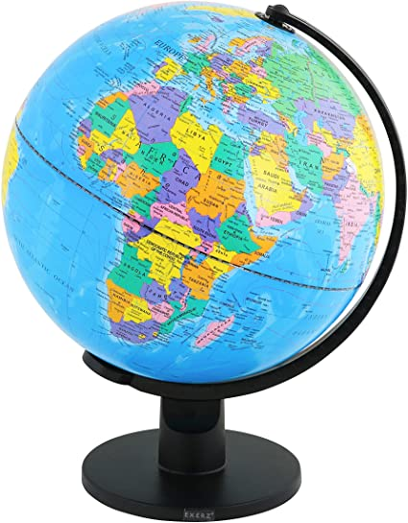
Vocabulary

- Continent:

Africa
Antarctica
Asia
Australia
Europe
North America South America

- Ocean:

Arctic Ocean
Atlantic Ocean
Indian Ocean
Pacific Ocean Southern Ocean

- Globe
- Landmark
- Atlas
- Map
- Compass

Landmark
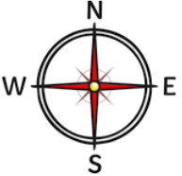
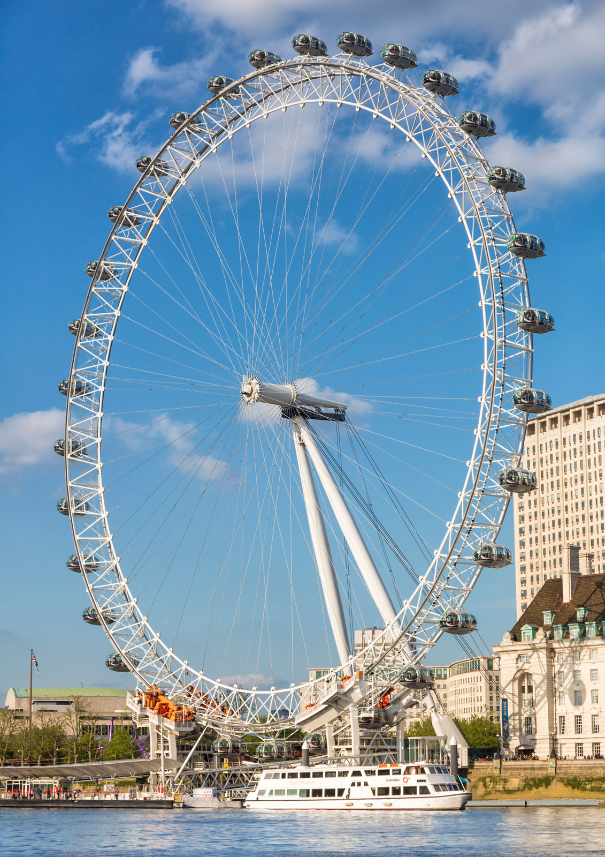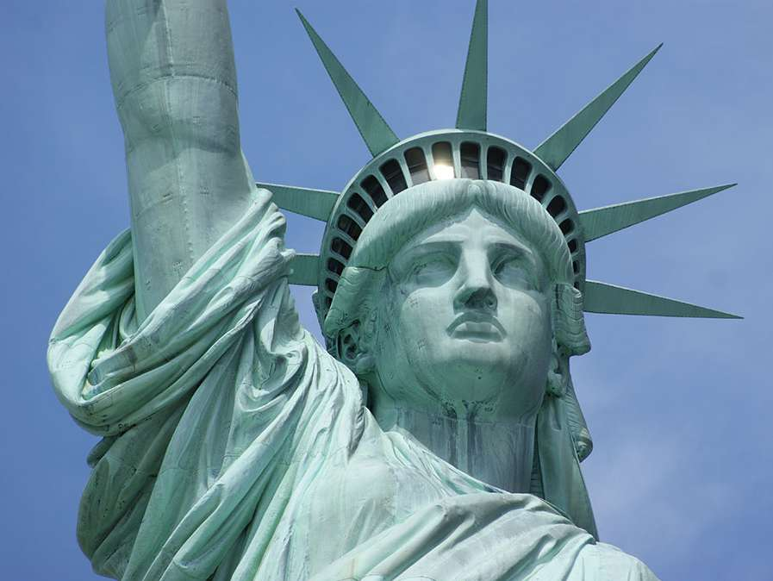
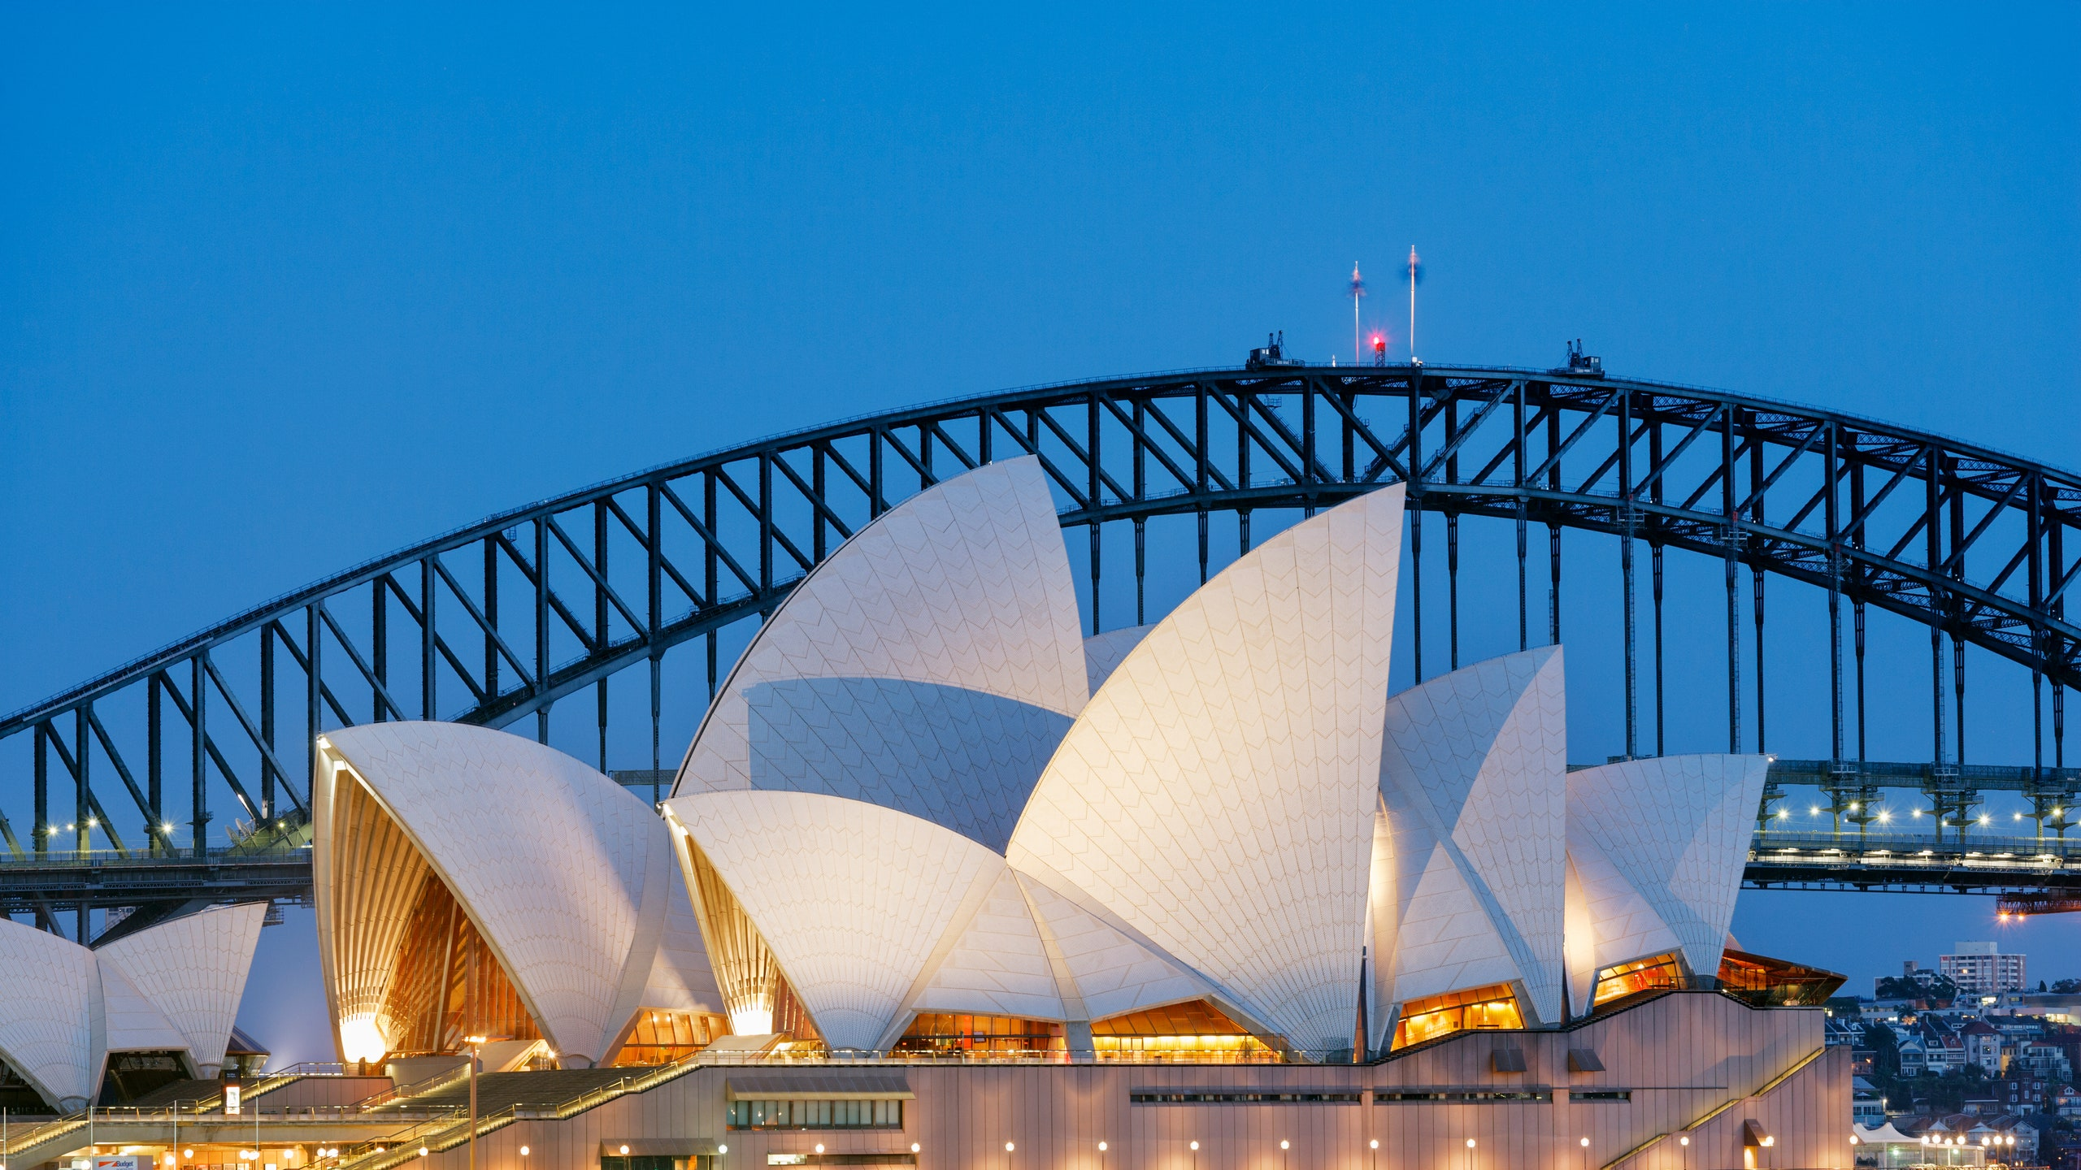
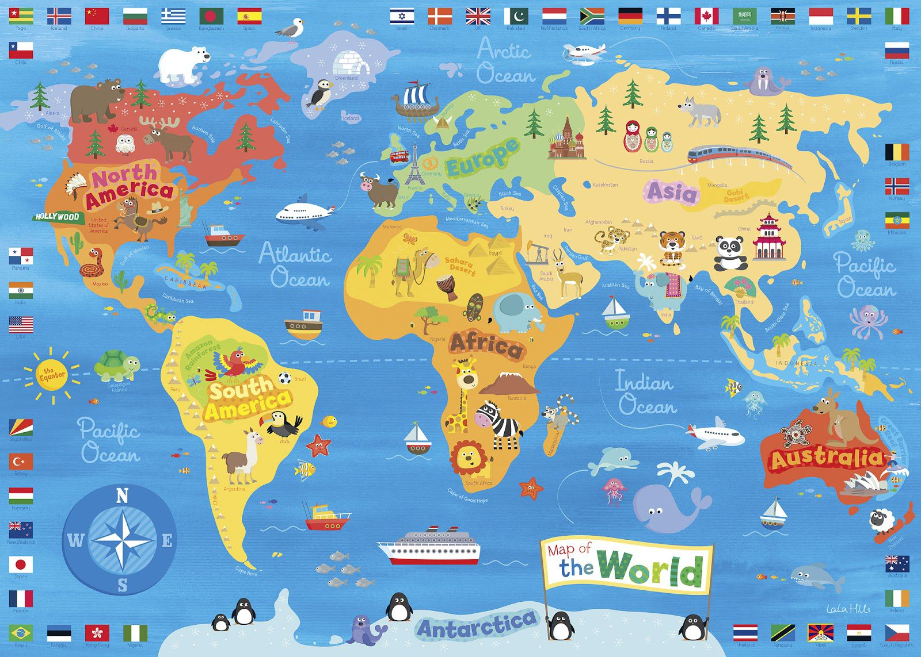
Key Knowledge:

- Geographical knowledge and skills:

- What is planet Earth made from?
- What is a continent?
- How many continents and oceans are there? Can you name them?
- What tools can help you plan a journey?

- Geographical Enquiry:

- Which famous landmarks can you see using aerial photographs?
- What features can you see? Are they natural or man-made?

- Physical Geography:

- What is the difference between the desert and a rainforest?
- Can you name any famous natural landmarks?

- Human Geography:

- Can you name any famous landmarks made by humans from around the world?

Year 2 Knowledge Organiser: Geography
Exploring the Globe

