
map
St. Chad’s Church
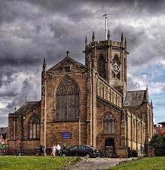
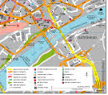
shops
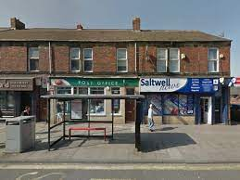
Saltwell Park
houses
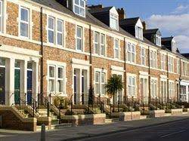
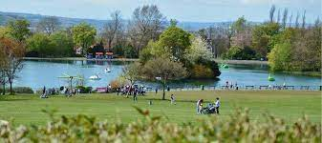
Kelvin Grove Community Primary School
Vocabulary
School
Road
Tree
House
Shop
Church
Park

Planet Earth
United Kingdom
Gateshead
Bensham
Kelvin Grove

Map
Photograph

Near
Far
Local

Physical
Human

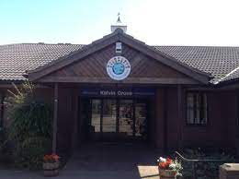
Key Knowledge:

- Geographical knowledge and skills:
- What is the name of our planet/country/town/local area/school?
- Can you make a map of the school/your journey to school? What do you see? Can you put them in the correct order?

- Geographical Enquiry:
- What features can you see using ariel photographs/maps? Can you find our school/your house?
- Are the features natural or manmade?

- Physical Geography:
- What can you see that are natural/physical features?

- Human Geography:
- What can you see that are human/manmade features?
- What are the different types of housing?

Year 1 Knowledge Organiser: Geography
Where I live (Places around the school)

