Vocabulary
Culture
Leisure
Entertainment
Decade
Whitley Bay
Spanish City
20th Century
Swinging Sixties
Redevelopment
Post war years
Concurrence
Change
Regeneration

Pleasure Gardens Whitley Bay

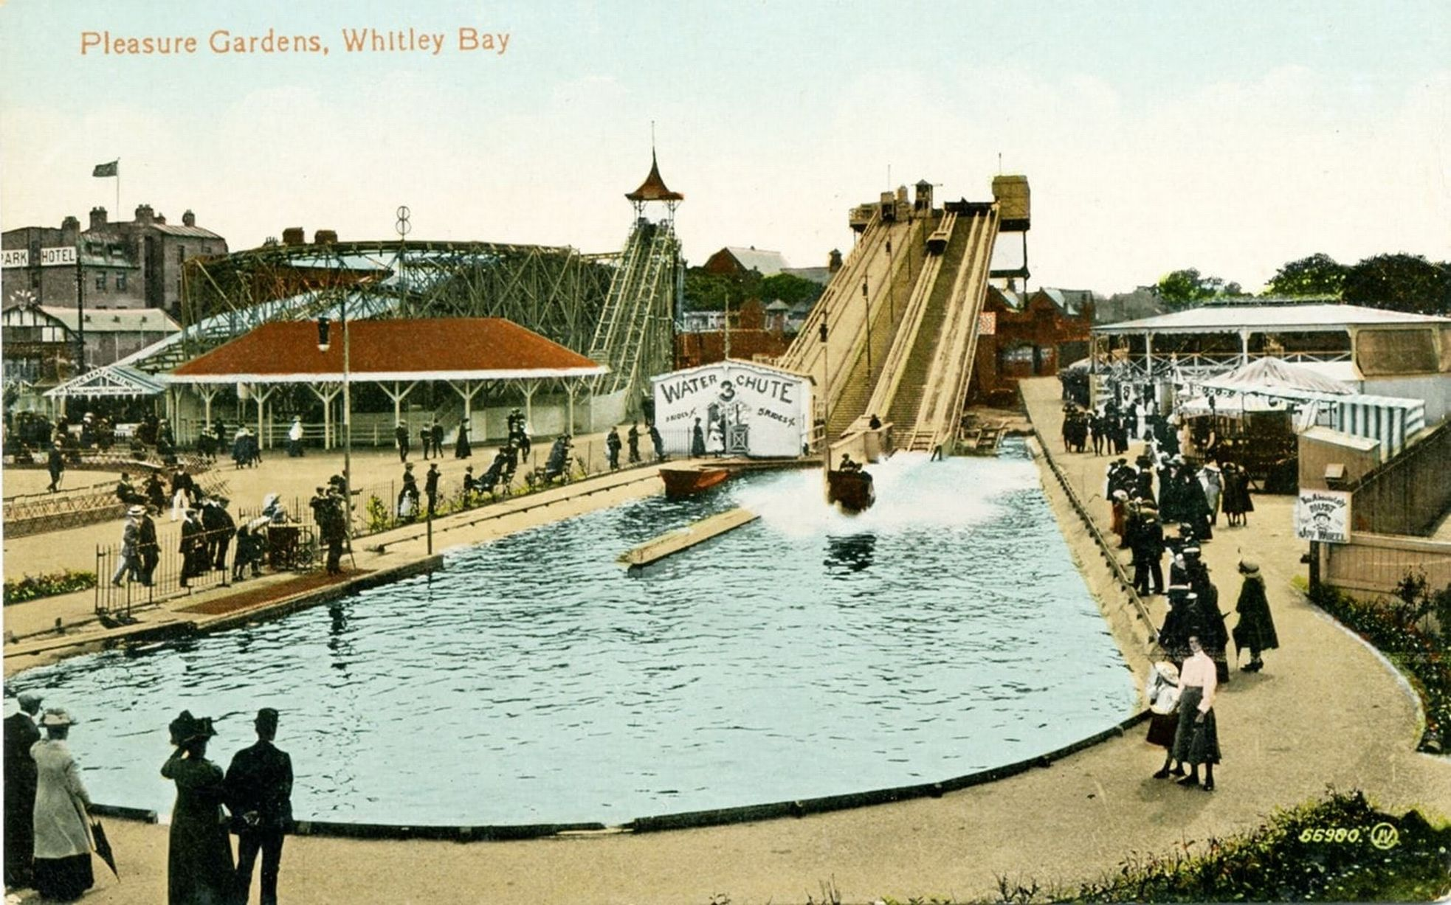

Whitley Bay Beach in 1960
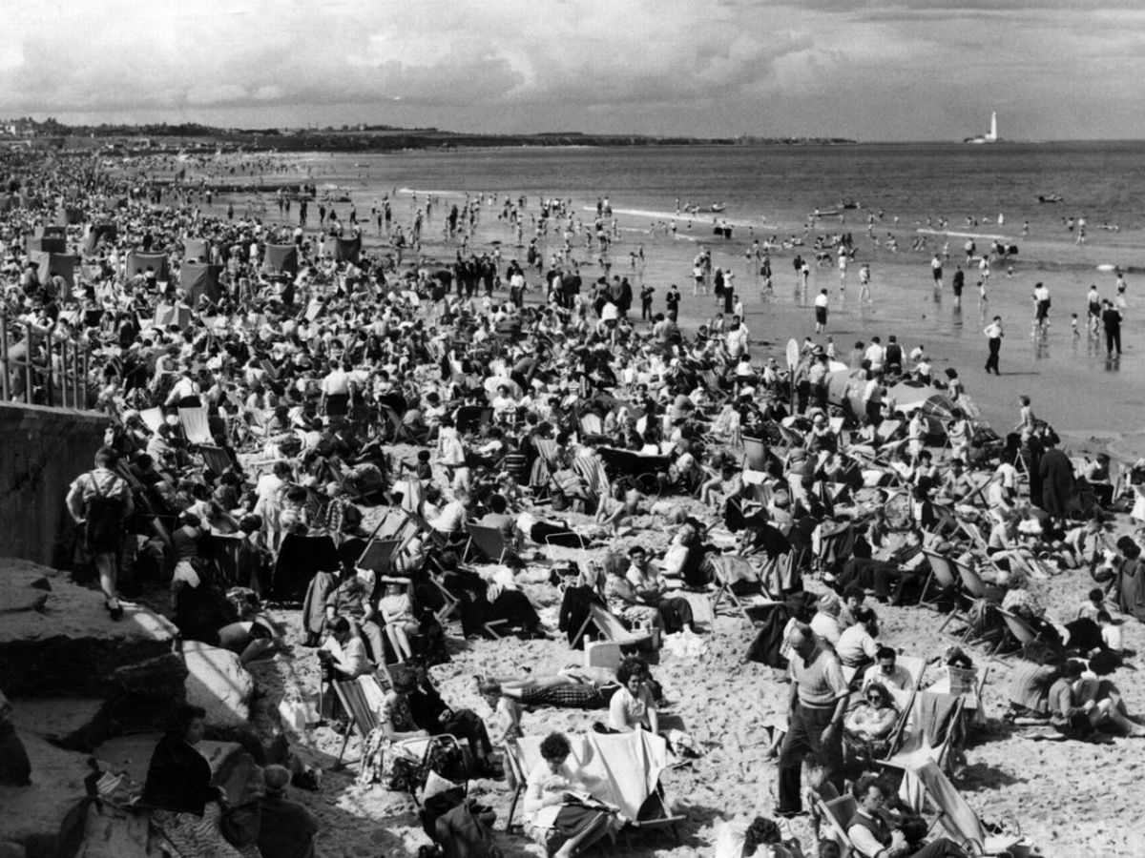

Year 6 Knowledge Organiser: History
Leisure and Entertainment in Whitley Bay
Key Knowledge:
Chronological understanding:
When did the 1960s decade begin and end? Why was the 1960s decade important? What was significant about the 1960s culture? What was happening concurrently in Vietnam?
Knowledge and understanding of events support, people and changes in the past:
Who were the “Sixties Teenage Generation”? Why were the 1960s also called the “Swinging Sixties”? What century was the 1960s in? What century are we living in now?
Knowledge and understanding of events support, people and changes in the past:
What happened to Whitley Bay in the 1960s? What type of food became popular in the coastal towns? What entertainment and leisure took place around the Spanish City and Pleasure Gardens?
Historical enquiry:
Why were the 1960s a significant period of time? How did the 1960s influence our country today? How is Whitley Bay different today to how it was in the 1960s?
Anti-war protests
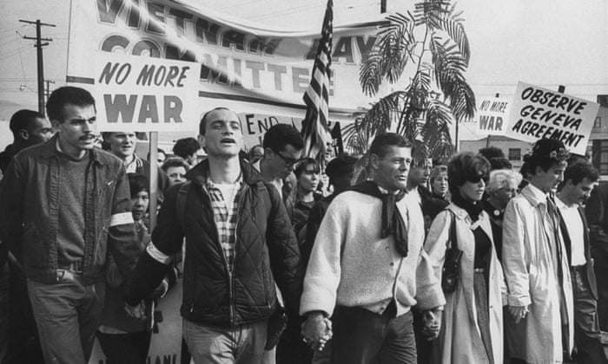

1960s fashion
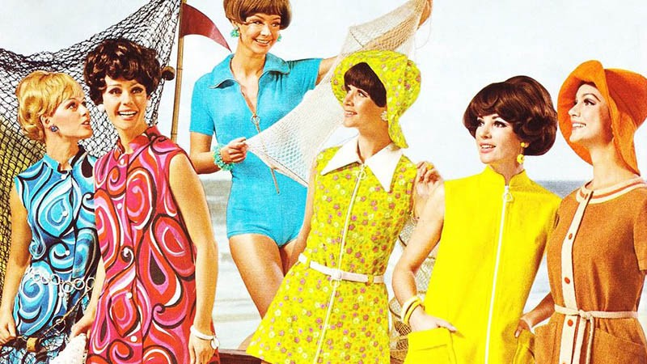

Whitley Bay Fairground
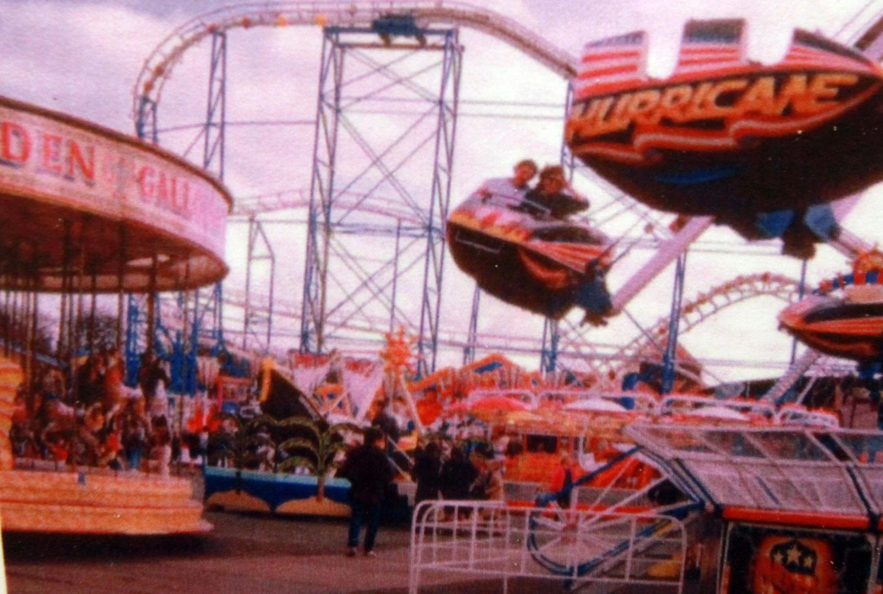

Spanish City, Whitley Bay (2022)
