Key Knowledge

What happened in the Battle of Hastings? How are the events in 1066 CE shown? Who became King of England and when?

What changes took place during the Norman Conquest and why? How long did this conquest take and why?

What was the name of the social system that was introduced in Norman Britain? In what order were these roles and what did these roles involve?

What was the purpose behind William the Conqueror building motte and bailey castles? What were the advantages and disadvantages of these castles? Which castles were built in this style in our local area?

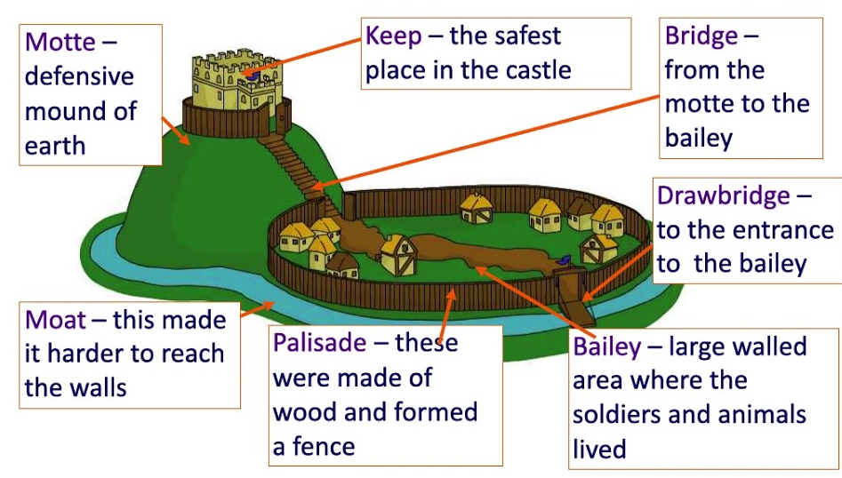
motte and bailey castle
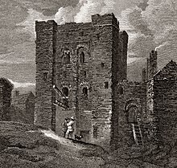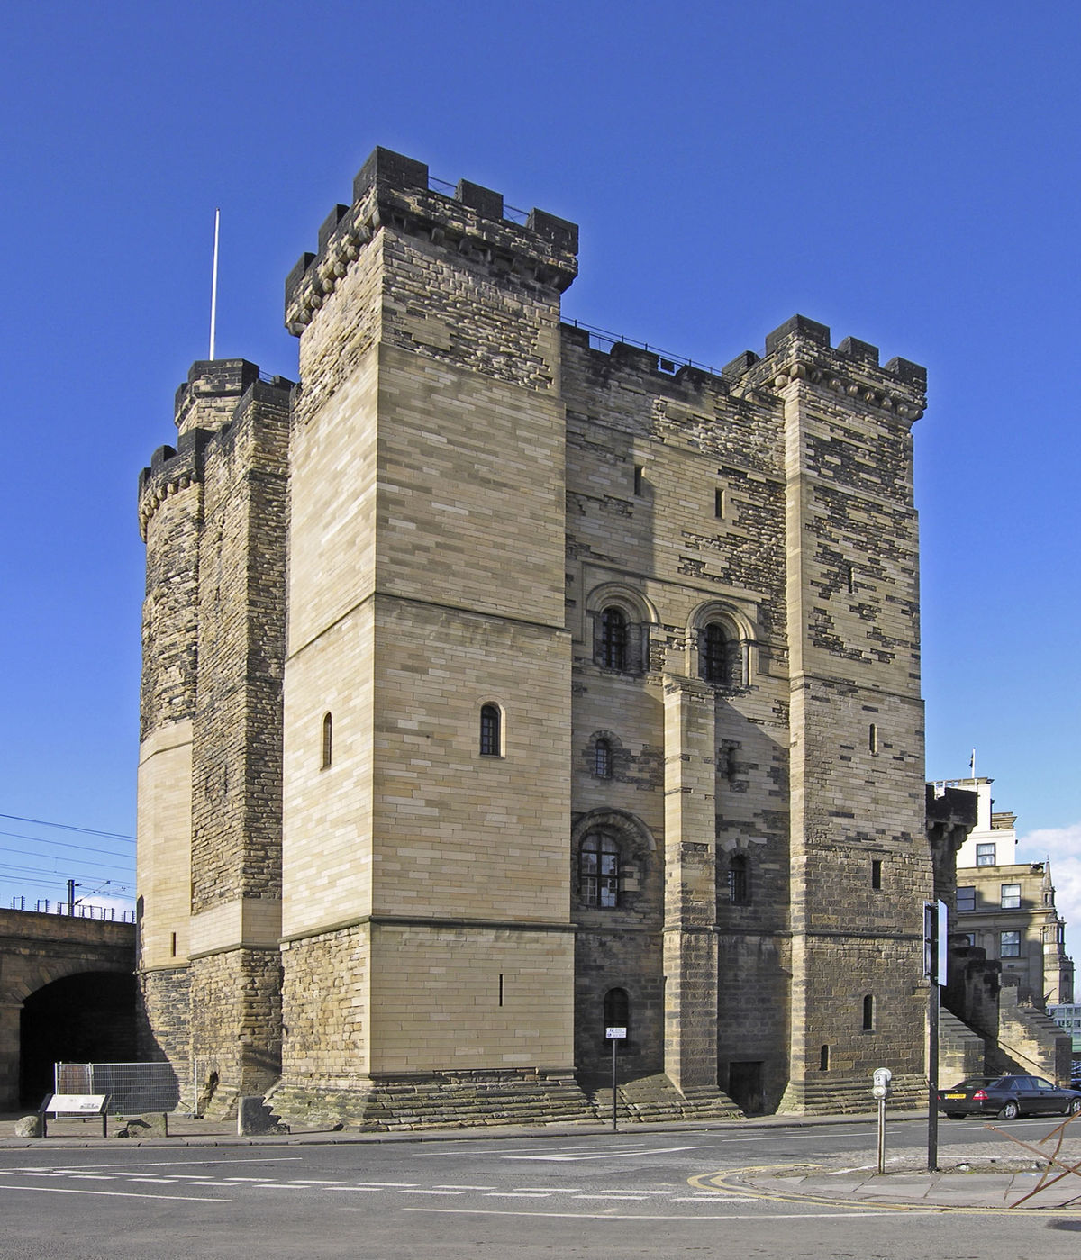
1080 CE 2022 CE Newcastle Castle
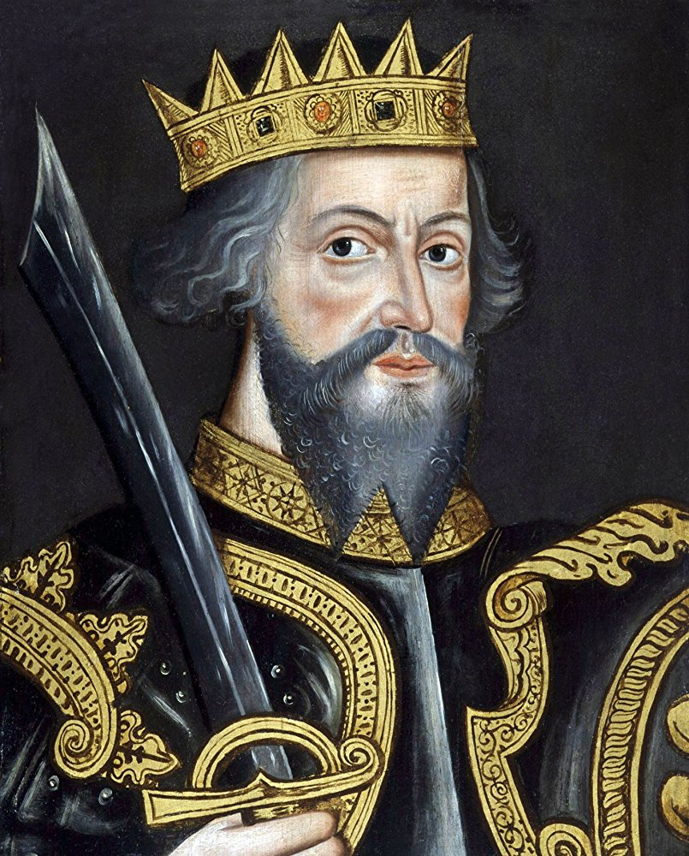
William the Conqueror
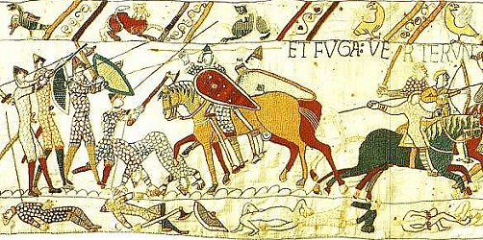
Bayeux Tapestry showing the Battle of Hastings

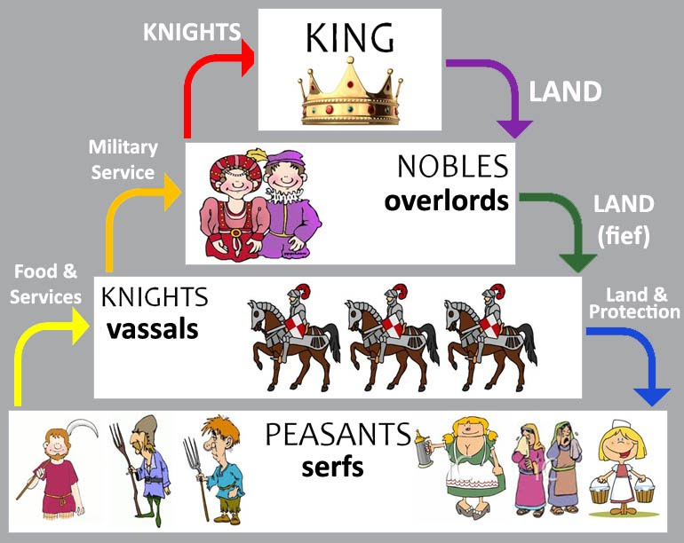
feudal system
Year 5 Knowledge Organiser: History
Normans in Newcastle
Vocabulary
Norman Conquest

Middle Ages

rebellion

resistance

artefact

social / society

hierarchy

noble(s)

baron(s) / lord(s)

knight(s)

peasants

military service

