Stephenson's Rocket
steam locomotive railway
Killingworth Colliery
coal
Vocabulary

locomotive
transport
passenger
timeline
coal mine
steam engine
machines
railway
factory
past
present
Key Knowledge:

- When did George Stephenson live? When did he design his first steam locomotive? When were the Stockton – Darlington and Liverpool – Manchester lines opened?

- What is a steam locomotive and how does it work? Where did George’s inspiration for it come from?

- How did George Stephenson’s invention change transport in the UK and abroad? How did the railways develop and what were they used for?

- What was George Stephenson life like when he was young, and how did his invention change his life? If he were alive today, how famous would he be?
George Stephenson

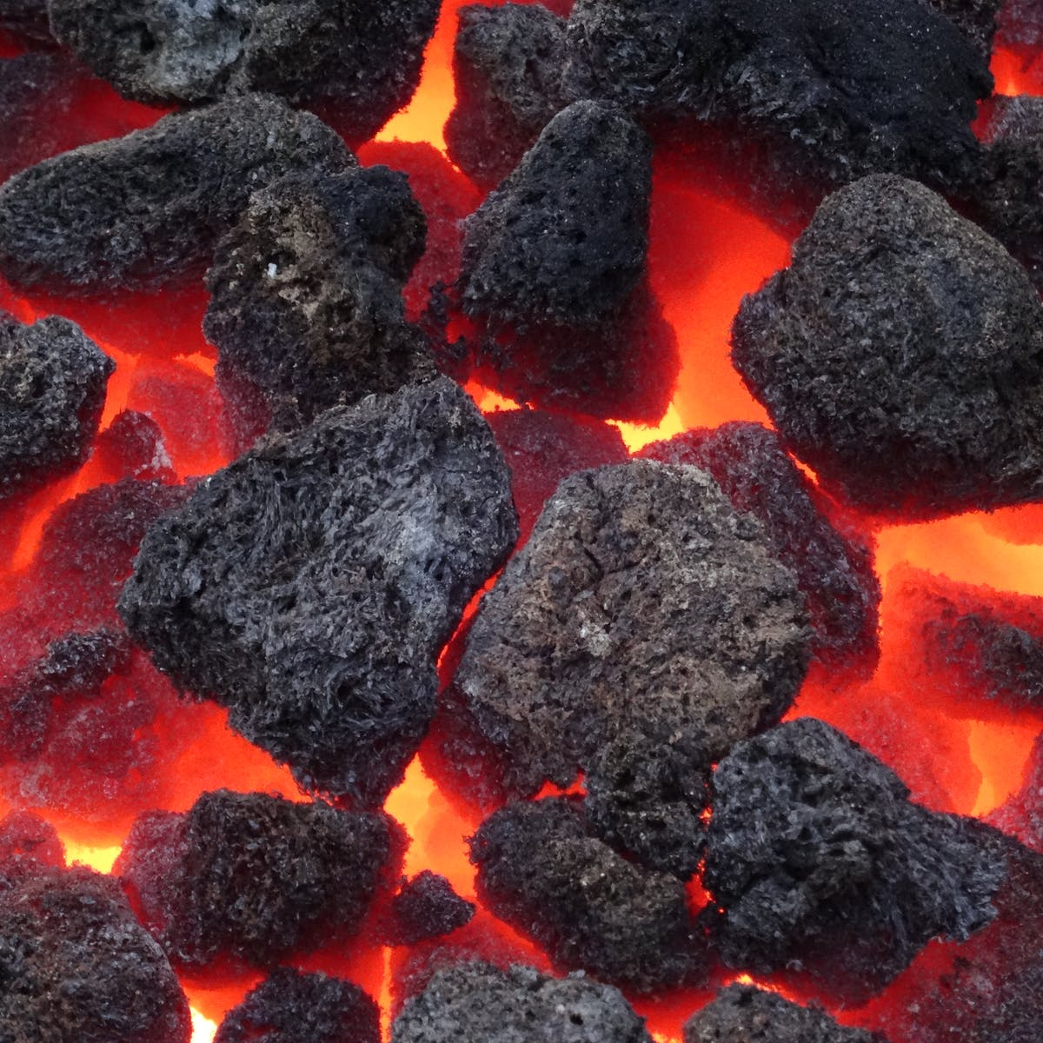
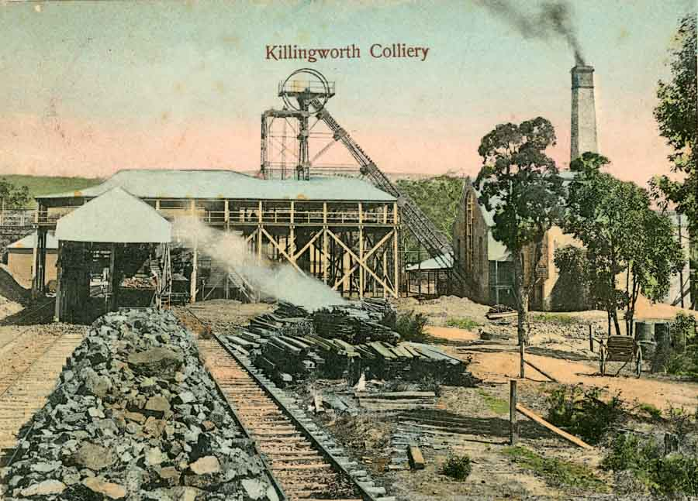
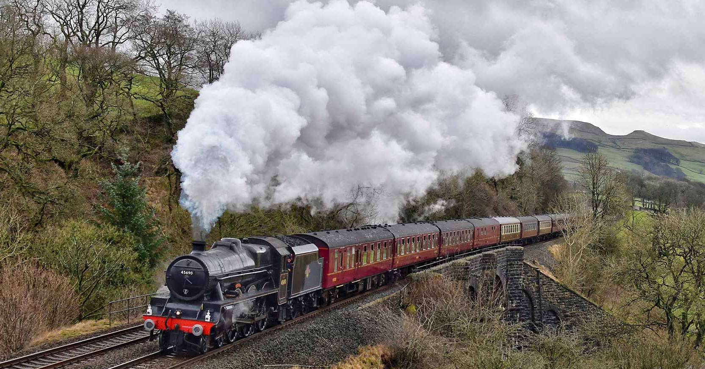
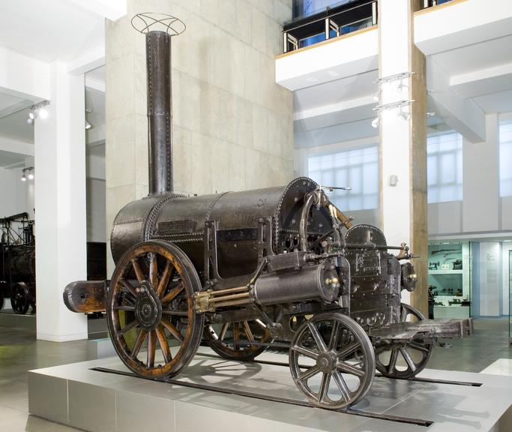
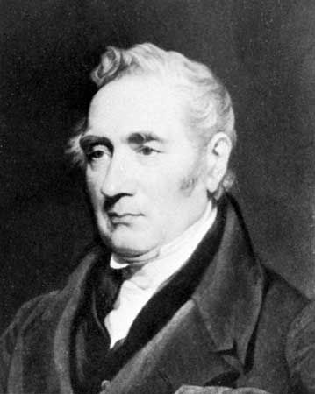
Year 2 Knowledge Organiser: History
George Stephenson and the Railway



