Vocabulary
Dark Ages
Golden Age
Baghdad
Empire
Civilisation
Caliphate
The Round City
The House of Wisdom
River Tigris
Silk Road
The Siege of Baghdad

Key Knowledge:
Chronological understanding:
When did Early Islam begin? When did the Golden Age begin? When was the Round City built? What was happening in Britain at this time? What caused the Islamic Empire to collapse?
Knowledge and understanding of events support, people and changes in the past:
What was inside the Round City of Baghdad? Who built it? Why did people want to visit this famous city? What inventions were created here?
Knowledge and understanding of events support, people and changes in the past:
What does ‘Golden Age’ mean? What does ‘Dark Ages’ mean? How was life different in Baghdad compared to Britain?
Historical enquiry:
What was the Silk Road? Why was this significant? How did Baghdad transport and receive most of their goods? Why did Baghdad and Islam flourish while Britain suffered the Dark Ages?
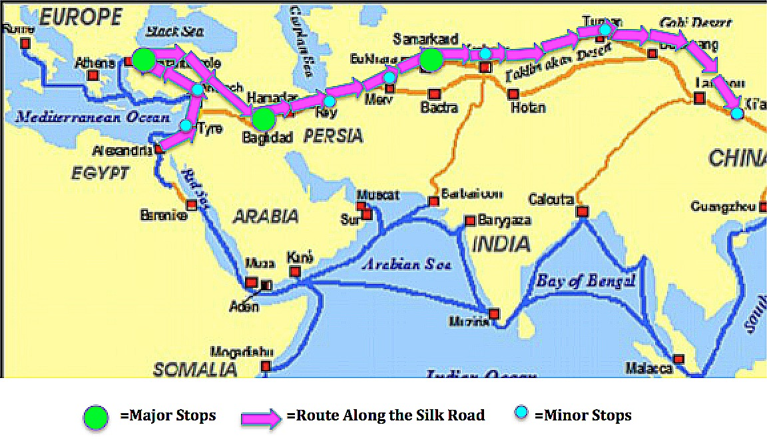The Silk Road
The Siege of Baghdad
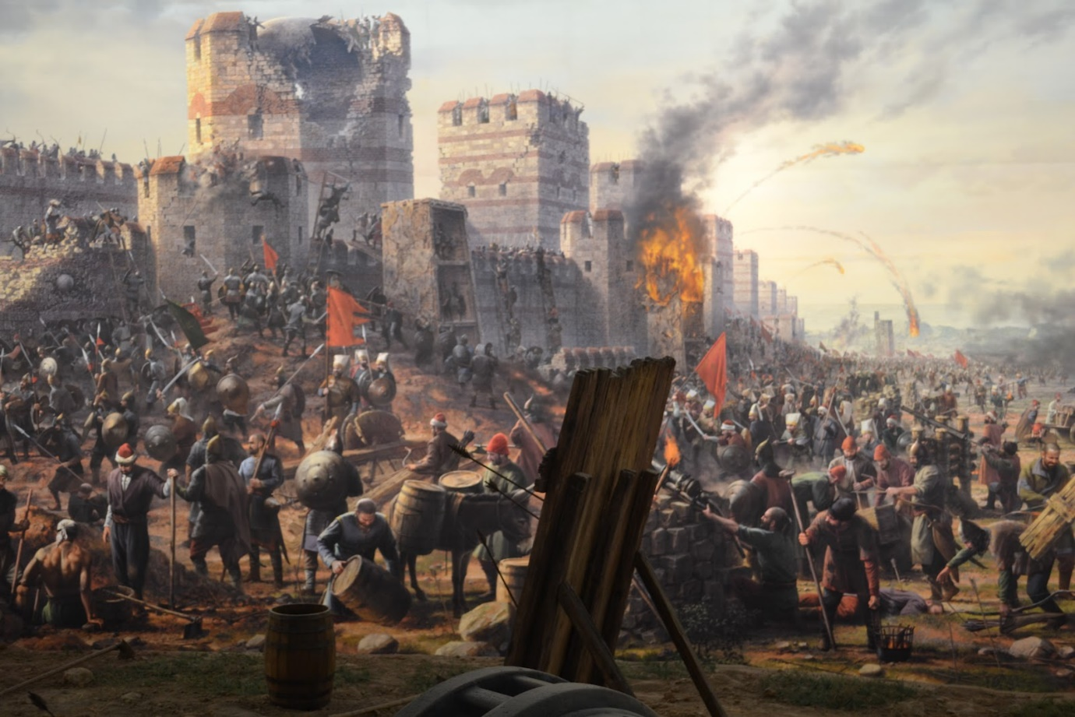
The House of Wisdom
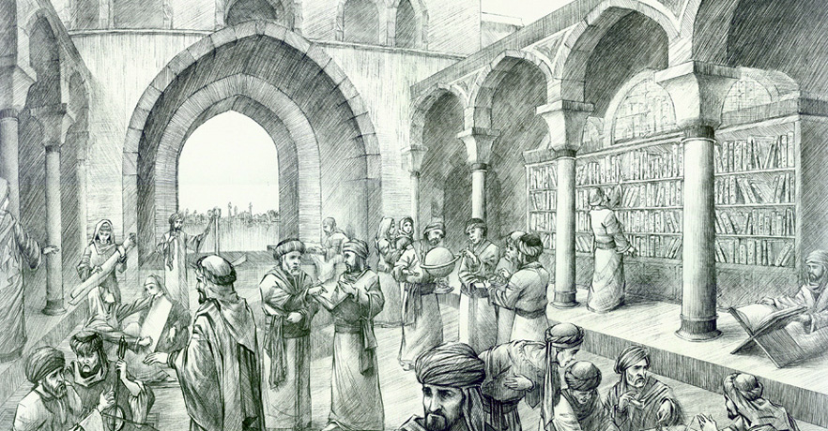
Caliph
Al-Mansur
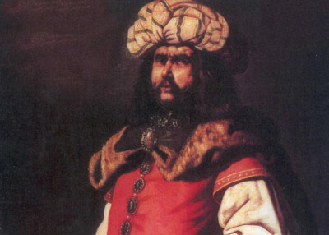
Al-Khwarizmi
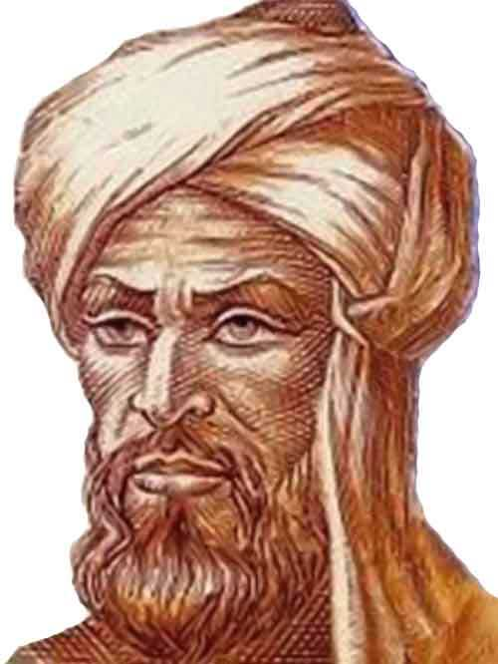
The Round City: Baghdad
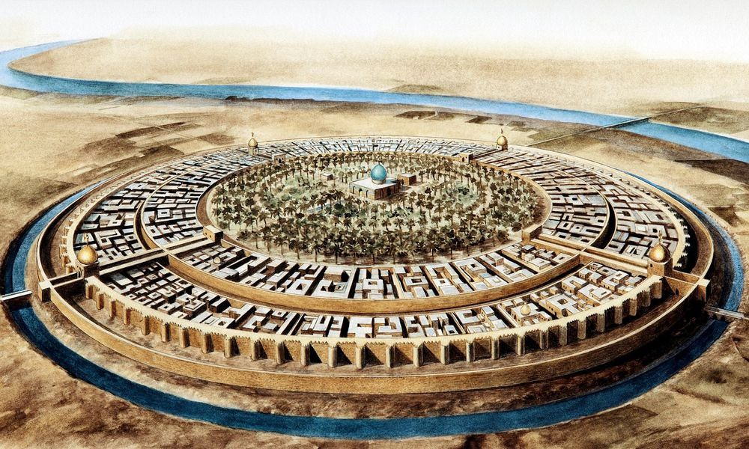
Year 6 Knowledge Organiser: History
Early Islamic Civilisation



