Vocabulary
invasion

raider

settler

Lindisfarne

Sweden

Norway

Denmark

merchant

pillaging

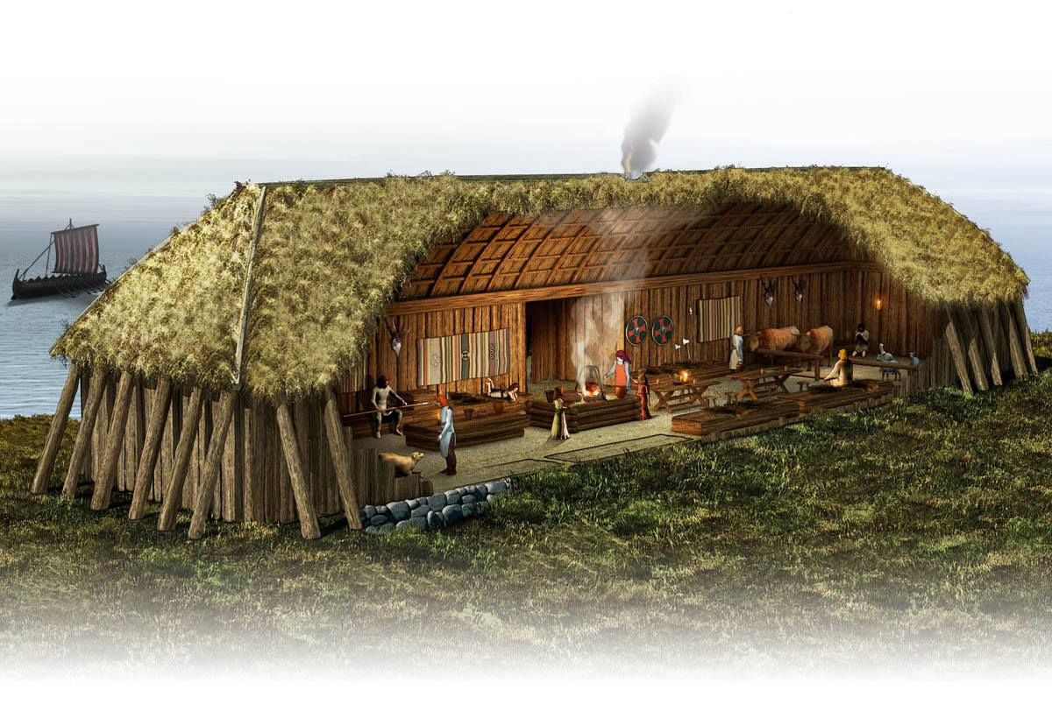
long house
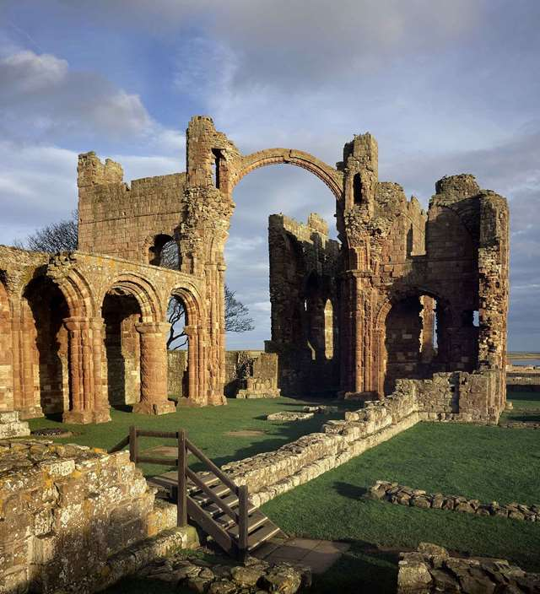
monastery

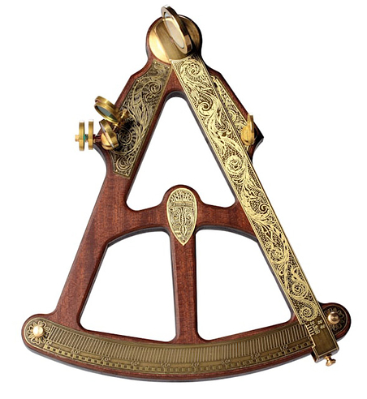
sexton
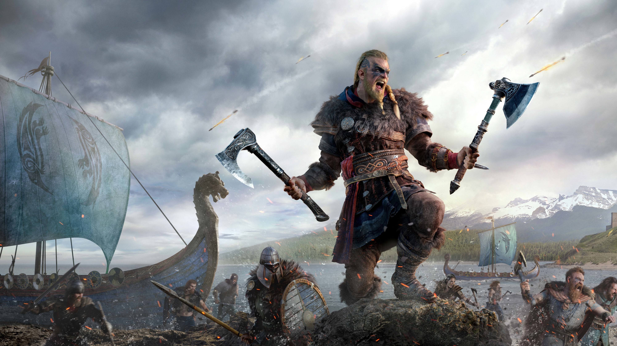
Viking warrior

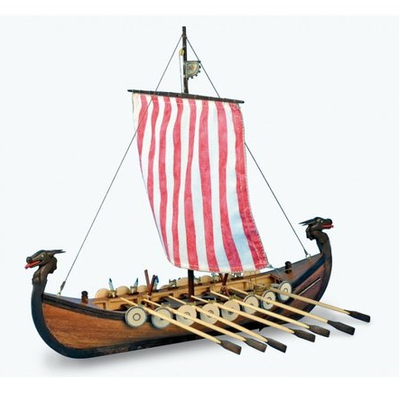
long boat
Key Knowledge:

- Knowledge and Understanding of Events, People and Changes in the Past: Which countries were invaded by the Vikings? What is happened at the Battle of Stamford? What happened at the battle of Hastings?

- Chronological Understanding: When was the Viking age? When did the Vikings invade Britain? When did the Viking era end? How did it end?

- Historical Enquiry: How did the Vikings live? Why did the Vikings invade? What were the longships? Why were stars so important to the Vikings?

- Organisation and Communication: What is the difference between a Viking raider and a Viking settler? What is the difference between Saxon England and post Viking invasions?

- Historical interpretation: Who was Harold Hardrada? Why did he want to be king? Who was better, the Viking warriors or the Viking settlers?
Year 5 Knowledge Organiser: History
Viking Invasion & Onwards
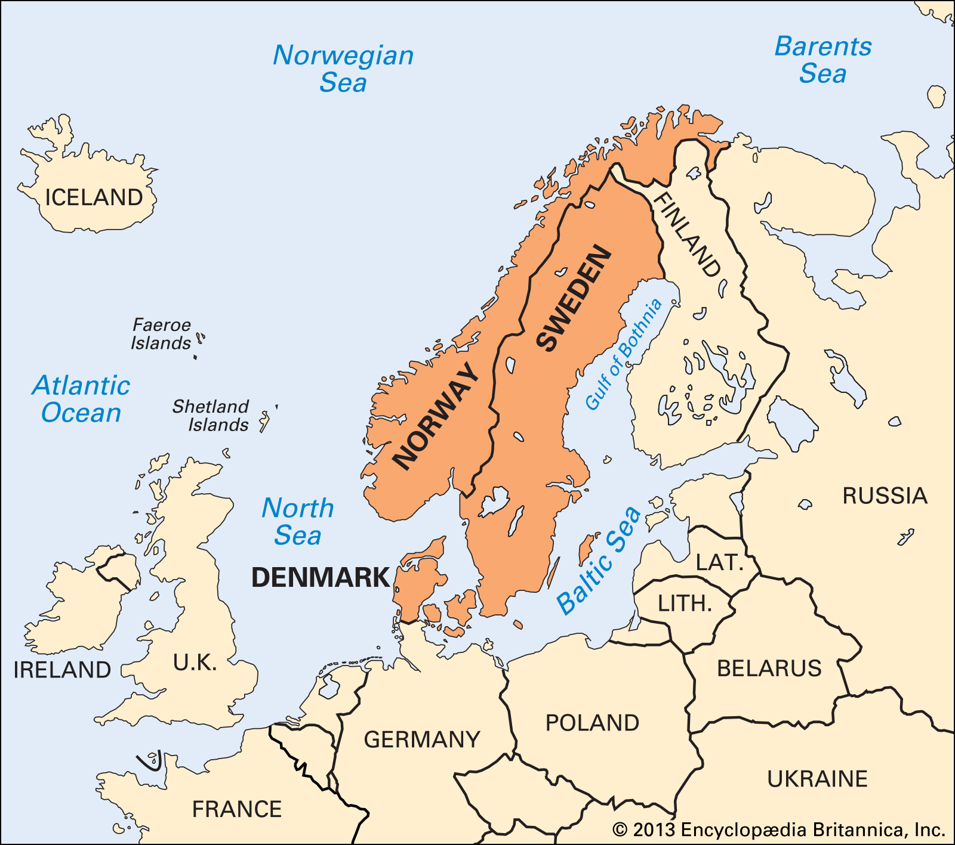
Scandanavia



